

Jason A. Petrasko
A hobbyist programmer, avid gamer, exceptional drinker, and somewhat ok guy. He runs this wicked website.

Projects
- Obscurity - A tabletop or face-to-face system for playing The Game of Shadows.
- Karbon - A roleplaying game inspired by Blade Runner and Ghost in the Shell.
- The Game of Shadows - A roleplaying game set in a mysterious, action-filled, pulp, steampunk Victorian-era England.
- Wishray Wiki - A wiki for users and friends based on Dokuwiki.
- Wishray Forum - A forum for users and friends based on SMF.
- WoodChuck - A simple Java/Groovy framework for text file conversion.

Scratch Area
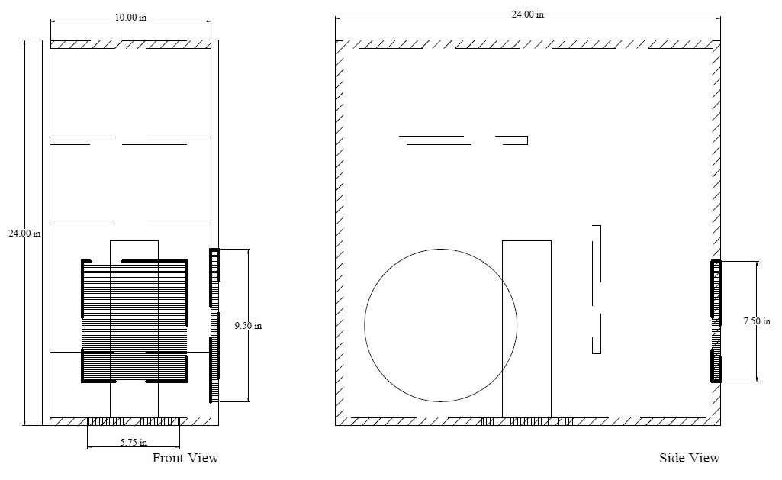
Investigative Moves For Karbon:
- Scan the collected evidence
- Go of the books
- Interrogate a suspect
- Interview a witness
- Retrieve a person of interest

Site Links
- Page Orphans/Wanted - A page that shows orphaned or wanted pages for wiki.wishray.com.
- Gaslight - A feature-rich peer to peer, portable, Java driven online gaming client backed by a wiki and forum. (defunct pages)
- Games - A private page for my gaming use.

Future Stuff Perhaps?
- PanzerPlay - A board game about high-school panzer championships, inspired by the anime: Girls und Panzer.
- Perplexity - A Roleplaying Game about the difficult choices made when colonists encroach upon the dominant species of a distant world.
- Resonance - A challenging board game focused on fostering both cooperative and collaborative play, about an alien force stomping over the Earth.

