pangledon
For the purposes of this story, there are at least two universes:
- Our world, Earth. This is the “real world.” Not a lot of magic here.
- Ge, an alternate Earth, steeped in magic.
On Earth, the ancestors of the dragons went extinct along with the dinosaurs. On Ge, they did not. Several million years ago, the modern dragon had evolved and had begun taming and breeding the local hominids. Out of this, three strains of hominid emerged as the most popular and most prevalent: we would call these the Elf, the Orc and the Ettin. These, in addition to the Changeling (created later), are the Dragonborn.
The purpose of the Elf was to be decorative. The dragons found the skin of the albino striking, and so bred for that quality. They also made the Elf immortal, because age is not an attractive quality in a decoration. Incidentally, their ears also come to a point. As there were expected to be only one or two Elfs in a household, the dragons strove to reduce the fertility of the Elf. Elf maidens only menstruate once a year. Because Dragons did not want to be bothered with the complication of Elf children, they made it such that Elf children could only be created through magical intervention.
The purpose of the Orc was to be combative. The dragons bred for claws and fangs, and selected for aggression as well. Dragons had no issue with Orcish fertility, and in fact preferred to have a lot of potential soldiers ready for them, and so many Orcish births are multiple. During peacetime, Orcs entertained dragons by fighting in gladiatorial games.
The purpose of the Ettin was to be constructive. The dragons bred for size and strength, and also selected for docility and submissiveness. Ettins were always slaves and servants. Standing almost three meters tall, Ettins sometimes walk on their knuckles.
The three Dragonborn strains were not interfertile.
At times, the various hominid breeds on Ge became dissatisfied with their lives as pets. Unhappy with being property, over time, they began the rumblings of discontent. In some places, there were uprisings - mainly Orcs and Elves, though Ettins often would participate through passive resistance. But because the Dragons dominated the entire globe while their pets were isolated, the rebellions were easily put down. Even so, a culture of discontent became constant in almost every corner of the globe.
11,578 years ago (or 9564 BC), the greatest empire on Earth, Atlantis, which held land on the Americas, Eurasia and Africa, suddenly up and disappeared. It was one of the greatest magical disasters in history - sorcerers in the capital city were trying a new ritual. Its true purpose and intent is lost to the annals of history. But its result is known.
Every citizen of the Empire of Atlantis was swept from Earth to Ge. More specifically, everyone carrying Atlantean coinage (or anything else with the empire's symbol) was carried through to the other world - this meant some foreign nationals came over, while the poorest of the empire remained behind. They found themselves in the exact locations on Ge as they were on Earth. The estimated population is around sixty million people having been brought through to Ge.
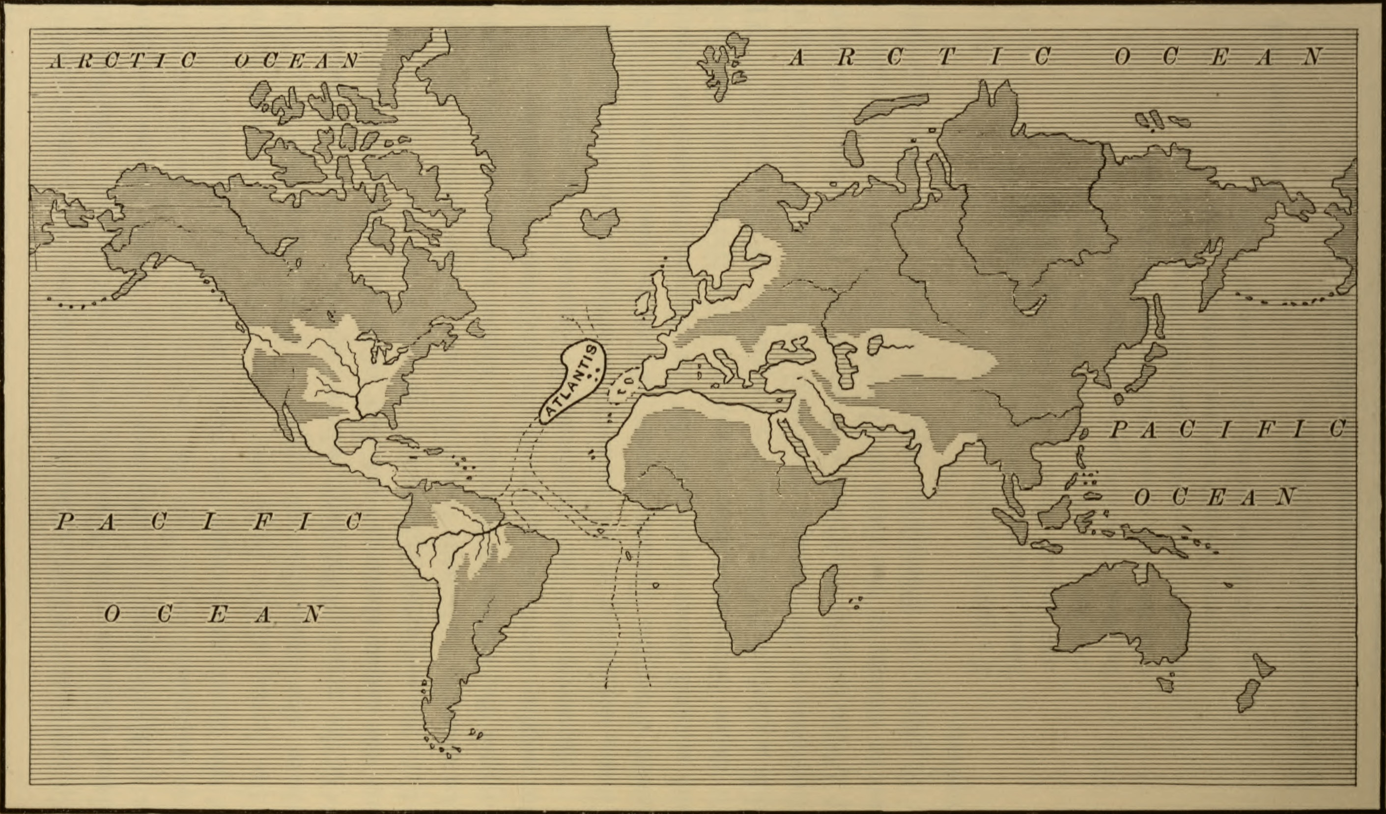
The ritual also caused another problem - in both worlds, the islands of Atlantis were utterly destroyed. This left holes between the two universes - a hole that drained the magic from Earth and deposited it in Ge. Over the course of time, Earth was made almost bereft of magic, while Ge grew into a much more magical place. While on Earth, magical creatures would eventually die out, and the casting of spells would grow more difficult until all efficacy was lost; on Ge, magical creatures thrived, and even the most common man can wield at least a few simple cantrips.
Traveling between these holes was possible for a while. The last recorded transit was made less than two thousand years ago.
When the humans from Earth arrived in Ge, their arrival sparked an almost global revolt among the other breeds against their draconian overlords. The next ten thousand years was occupied with a war against the dragons; the humans wound up allying with the Dragonborn. Eventually it was discovered that humans and the Dragonborn could interbreed, creating the sylph from the union of Man and Elf, the goblin from the union of Man and Orc, and the dwarf from the union of Man and Ettin.
It was during this extended conflict that Dragons created Changelings. Their purpose was to destablize and sow dissension among the ranks of humans.
Dragons have not yet been eradicated from the world. They still hold certain strongholds - Iceland, Australia. They inhabit the frozen wastelands near both poles.
In 2014 on Earth, it is the year 11578 on Ge. On Ge, they do not measure from the birth of Jesus - but from the arrival of Atlantis.

