Alalit is a relatively prosperous (no place in the Gamma World is truly prosperous) community that is run by the priests of the Pylon God known as CAM, who other Followers of the Voice claim is a dead god. It sits upon Horse Bay, and it's main source of food are products brought out of the bay by intrepid fishermen who have to deal with the many menaces that come up from the depths.

Priesthood

Prelate Finas the Elder
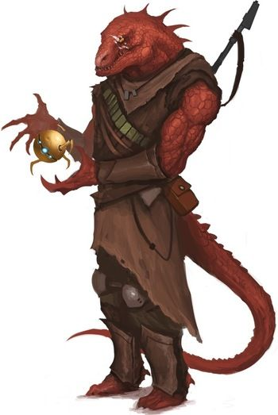
Finas is a sleeth (huge lizard-man) who is technically and ordained priest of CAM, but whose job as “Prelate” of Alalit is essentially to be the primary lawman of the town. He tends to work alone, but can call on a couple of deputies that he's mentioned, and presumably the town guard will follow his orders (though they seem to be a secular part of the town's operation in a technical sense).

Preacher Fargas
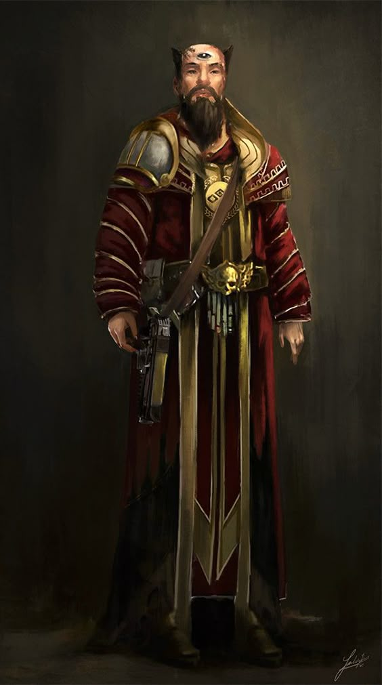
A PSH full priest (the impression is that they are not too numerous), Fargas seems to find it his business to be sure that the spiritual mores of Alalit stay centered on worship of CAM and its dogma. He's rarely seen without one or two of the cult's acolytes.
Fargas has the “Eye of Cam” emblazoned on his forehead, which is supposed to be a special blessing from Cam.

Acolyte Kron
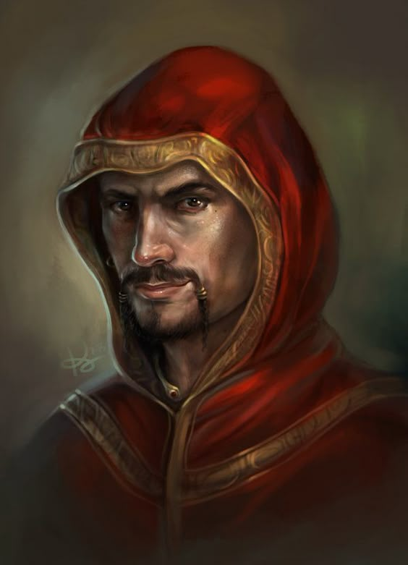
One of Fargas' usual retinue of PSH acolytes, he serves as Fargas' right-hand, trusting him to accomplish tasks independently.

The Voice of Cam
An android that apparently speaks for Cam.
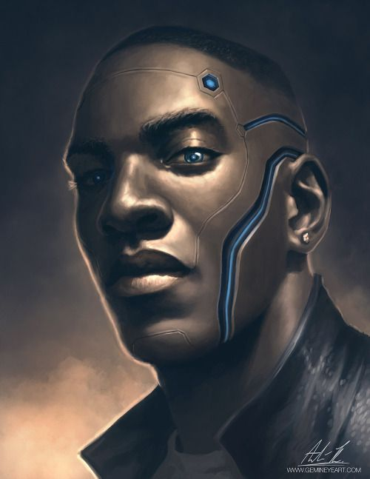

Townsfolk

Zulzan
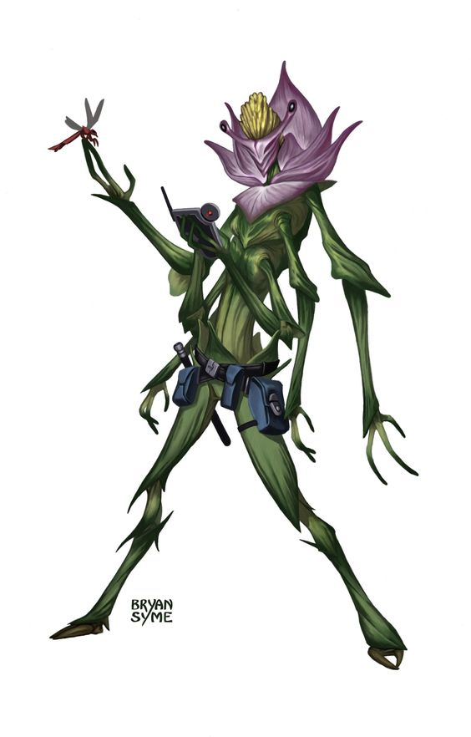
An old friend of Zin's thought missing after an attack by arks, who Zin indicated had come from the same root plant as Zin. It turns out he's been pursuing a lucrative career as a trader in Alalit.

Mazarin
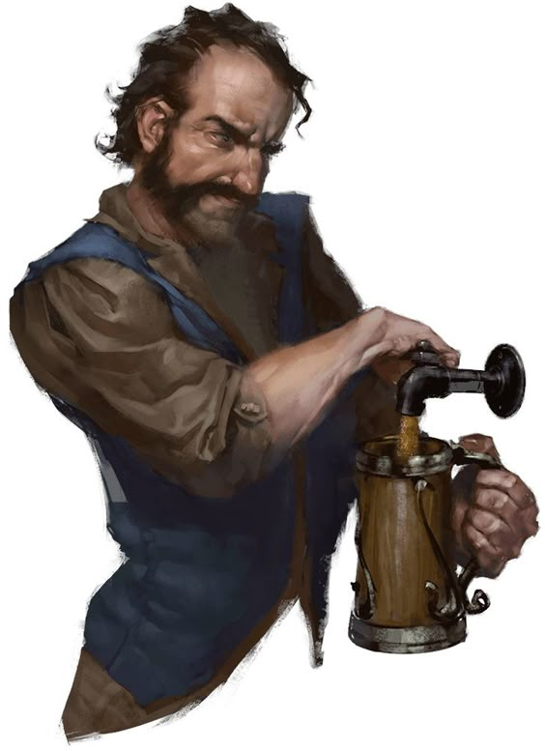
A PSH who runs the tent-saloon in the middle of town that is known only by his name. Seems fascinated with Zin for some reason. Otherwise he has a reputation as a helpful member of the community. Pictured here giving Zin the side-eye.

Lyeel
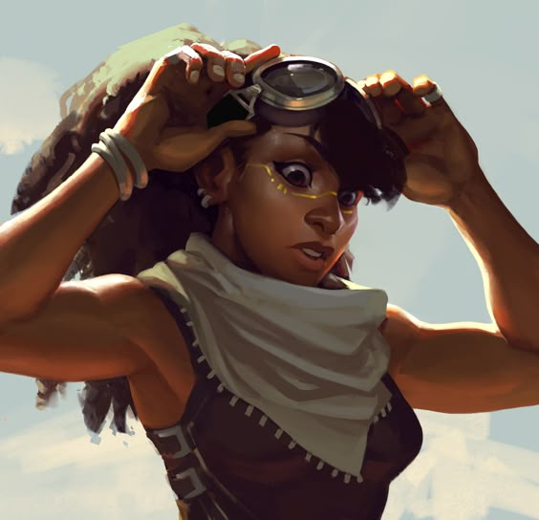
A young PSH woman, daughter of Mazarin, who seems to be fascinated with Digger, and who was carrying strange fruit to a back door of Mazarin's. She turned out to be guarding the mental emanations of the Hisser Males from Lysoos.

Tavan
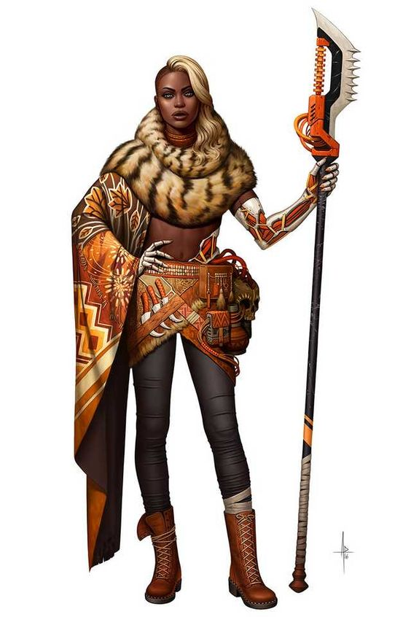
Lyeel's mother, Tavan is a gruff warrior, who apparently has been given cybernetic enhancements by Doc Potamus.

Rurik
A PSH friend of the young woman above, Rurik hired the group to have digger dig up an Irnwood tree stump that had been impossible for them to get rid of on a construction site. Apparently Rurik works with a team that does most of the building in Alalit, and he's supposed to be an expert at constructing buildings out of the giant plant pods from the plain outside Alalit. Unlike many of the folk of Alalit, he seems to be fairly well predisposed to mutants.

Guards
The town appears to be well-off enough to employ a small number of the populace as full-time guards. Mostly their duties appear to be guarding the bridge that is the only safe entrance to the town that is not over water (which is, itself, a pretty hazardous approach).

Mel
A PSH bridge guard from the day shift.

Mullork
A PSH bridge guard from the night shift who seems to have clear Purist leanings. He and his partner on the night shift directed The Show to park near the toxic black bog.

Hissers
This is the contingent of hissers looking for the males, and the leader of the missing males.

Loosis
Loosis is, from what she's said, a “princess,” of her village daughter of the “queen” that seems to be the central hive-mind source for all of the hissers, and seems to have the ability that her mother has to bind male hissers to the hive-mind, including bringing back hissers that have broken free of the hive-mind control.
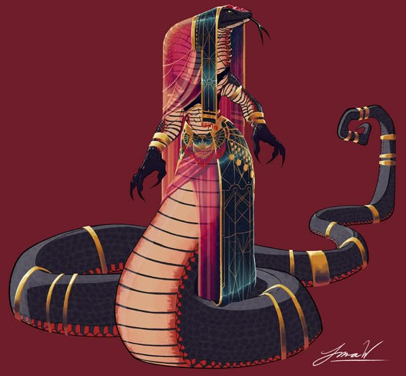

Sassas
Male hisser who seems to be Loosis' right-hand in their attempt to get the males back. Zulzan considers Sassas a personal friend.
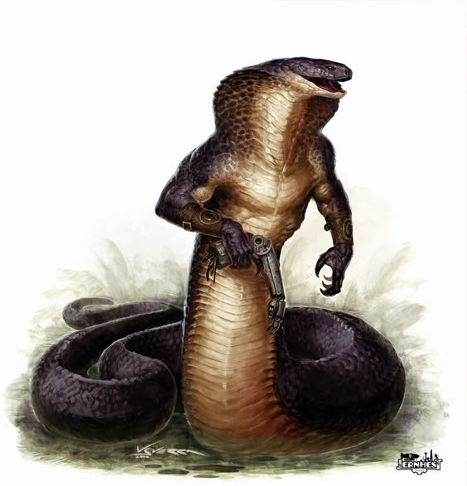

Coorsis
Male servant of Loosis, Coorsis has been tasked with helping the PCs find the males, but has broken free of Loosis' control and now desperatedly wants to be taken away from her as he fears what she'll do to him when she reads his mind, and finds out that he's told the PCs things she would not want him to tell them.
Coorsis is a mutation from the base hisser stock, with colorful crests on his head and arms.
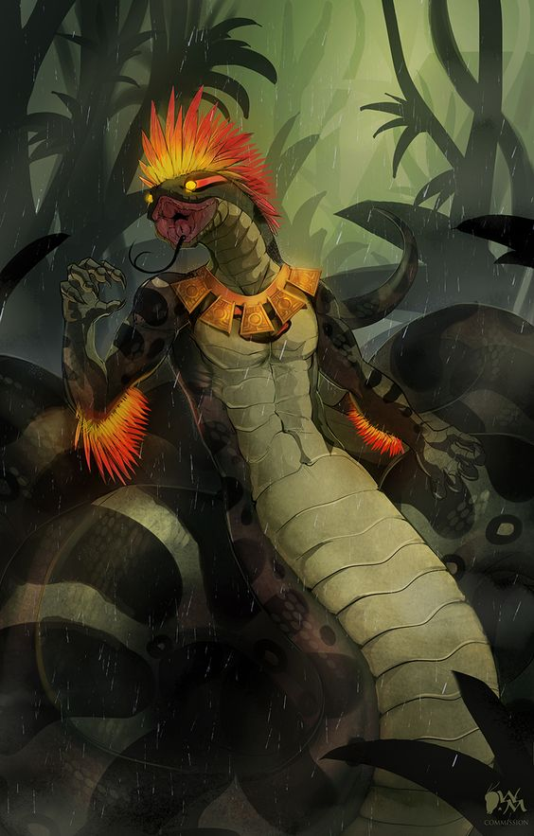

Maass
The leader of the male hissers who managed to break away from their queen. Pictured as he was first discovered, relaxing on the floor of Mazarin's basement.
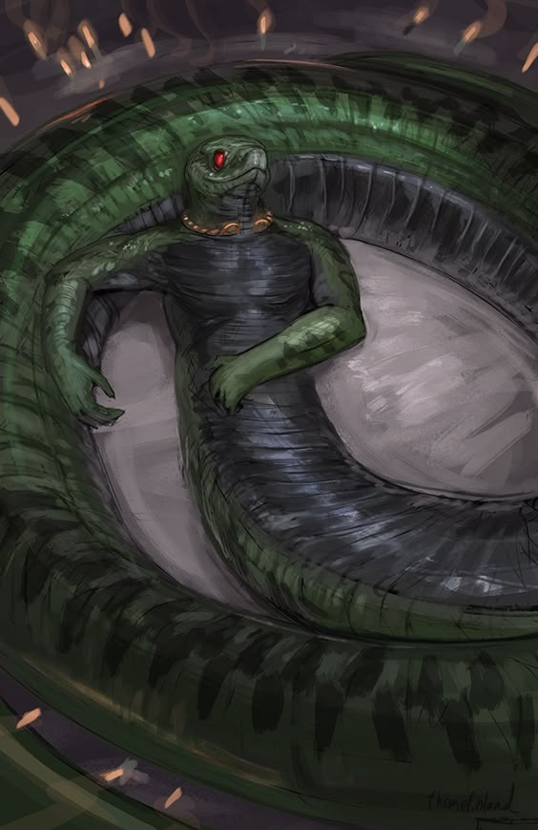

Bay Village
Located across Horse bay from Alalit on a small island near the aquatic base ruins, below are selected denizens of Horse Bay Village.

Kurzor
Previous chief of the village, and now chieftain pro tem since Ilirha disrupted their chieftain selection rites.
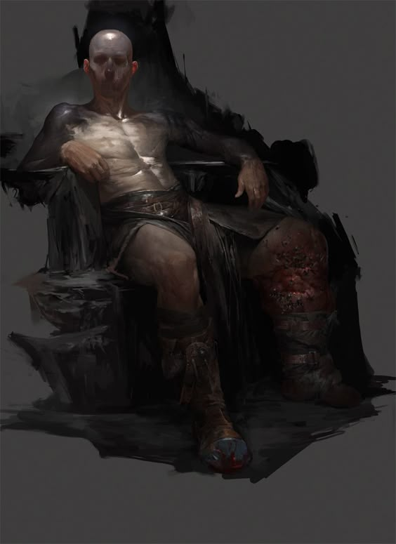

Lallana
A perennial challenger for the chief position, Lallana is thinking of joining with the crew of The Show.
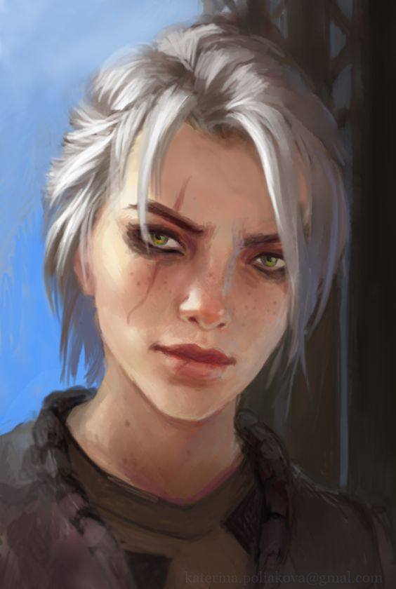

Lanu
Mutant mouse-oid, possibly an archivist, who followed the PCs into the aquatic base.
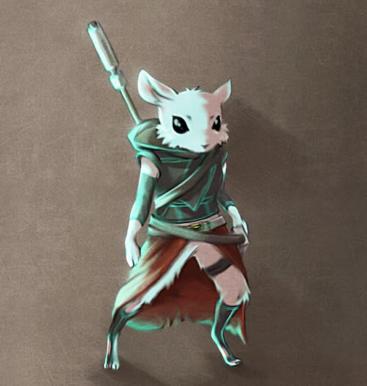

Nady
Catoid that the PCs first ran into in Bay Village.
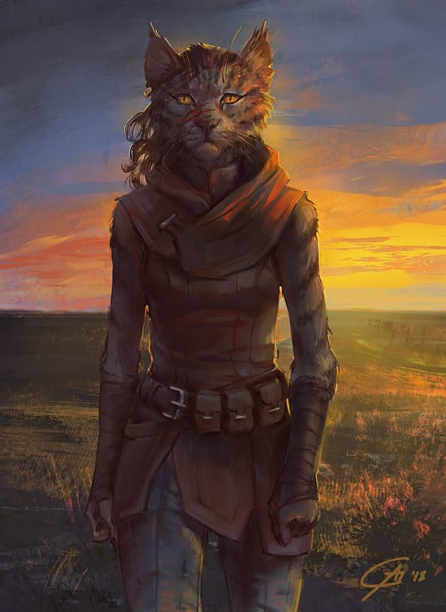

No1
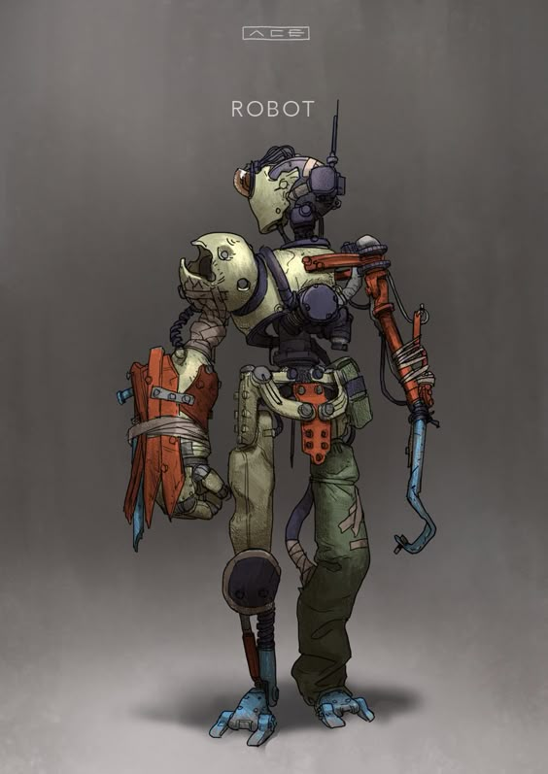
A formerly berzerk maintenance bot that Squiddy put back in operating condition, and which now works with the android “Voice of Cam” from the aquatic base, helping to run it.

