Arriving in the evening at Alalit, between the black bog, the bridge, and the town proper:
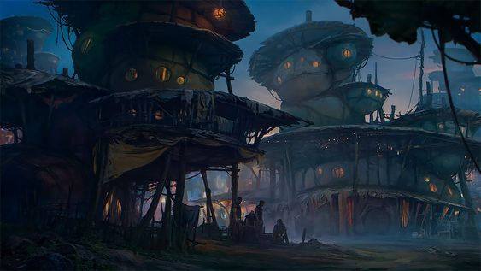
View of the ancient bridge that leads away from Alalit to the Penisula proper, across the estuary of the toxic river that leads into Horse Bay beyond, as seen from the base of the cliffs below Alalit, near the hidden entrance to the Holy Temple of Cam. A pod of obbs takes flight from the bridge.
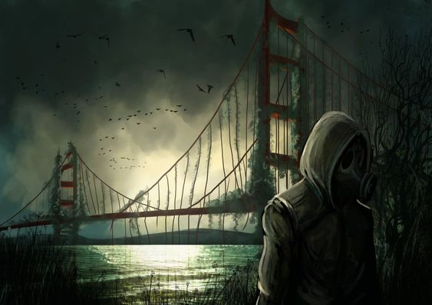
First room inside of the Holy Temple of Cam:


