Townsfolk
The townsfolk are all Pure Strain Humans (or possibly passers) unless otherwise mentioned.

Urag
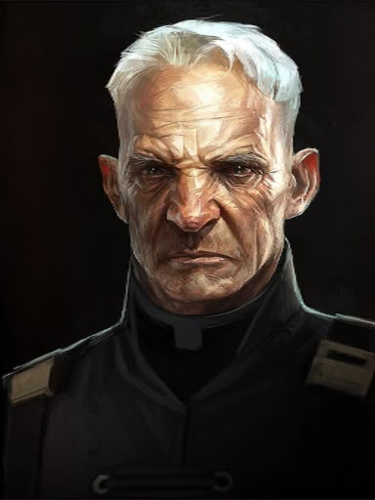
The head of the Urag family, the rulers of Grubport. While putatively run buy a council of elders of the most important families of Grubport (who make their homes upon the deck of the old ruined aircraft carrier that comprises Grubport), this family is deferred to by all of the others. According to sources, Urag is garnering weapons to create some sort of personal army.

Young Urag
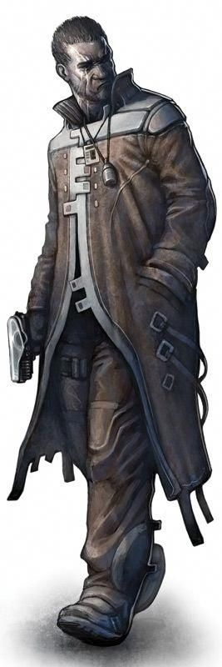
Young Urag is the son of the elder. He is clearly fond of his vices, and not a skilled gambler, having lost considerable trade chits at the gaming tables at The Famous Root and elsewhere.

Urag's Daughter

Daugher of the elder Urag, this one is cold, vapid, and grasping. Not particularly bright, her only thoughts are of her own security and comfort. She previously sought to marry Khovip to obtain the wealth of his mine.

Betsk
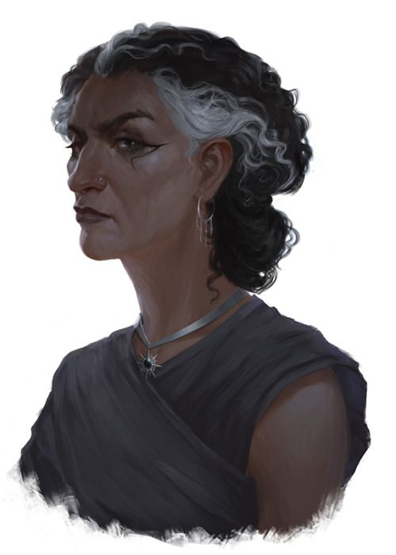
Matriarch of the Betsk clan, brought relatively low a couple of generations ago by the Urags. She is seeking help getting Urag to get Chersh to give her son a good match of a wife.

Young Betsk
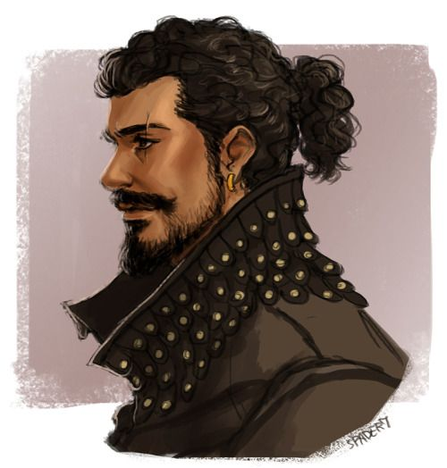
The charming son of the Betsk matriarch, he is taken a bit with Greenstream's Daughter, but worries that she may be a mutant.

Greenstream's Daughter
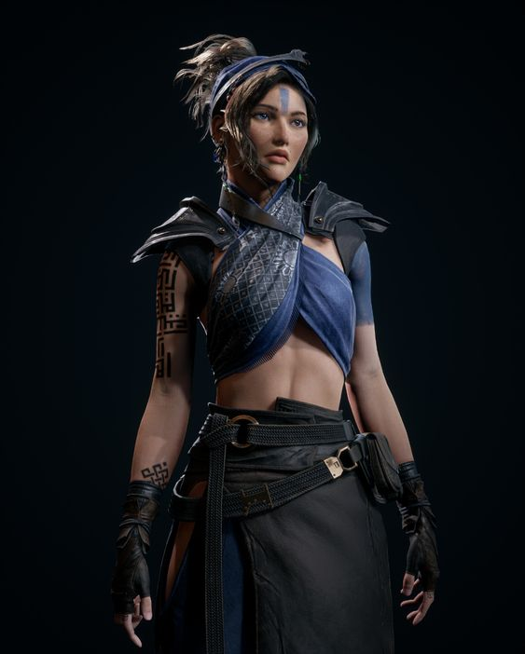
Daughter of the most important Elder of the village of Greenstream, people speculate that she may be a mutant, given that she wears paint like the painted women do.

Chersh
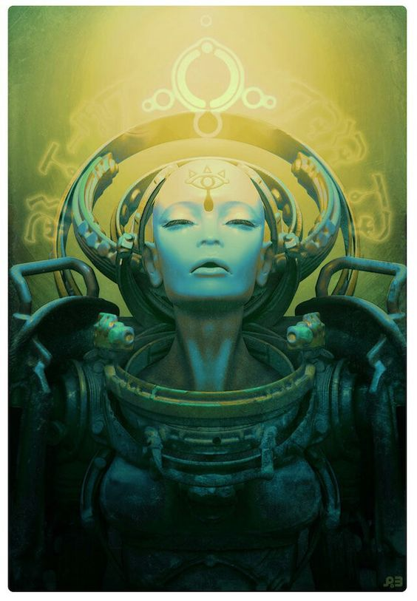
A “Sorceress” who works with Urag and the other families of Grubport to maintain order. She runs an annual matchmaking festival at which she matches members of the various families of the Peninsula Tribes together by word from Dowin. At the most recent affair she worked with the PCs to create favorable matches for a couple of families, since Dowin did not seem to be present.

A Light Keeper
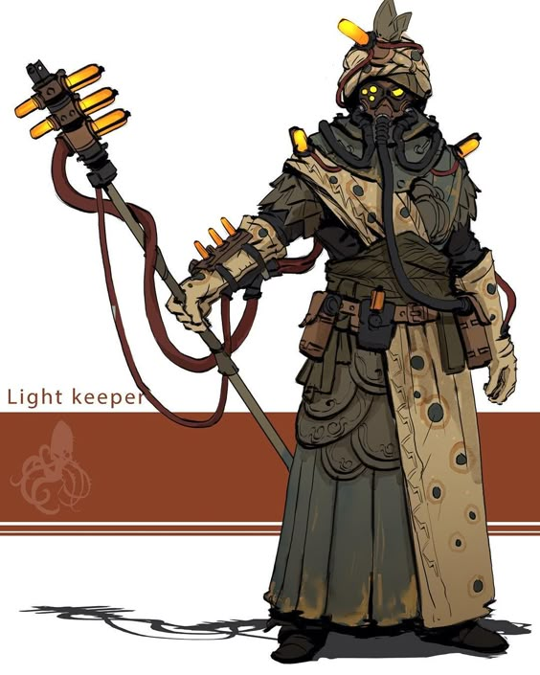
One of the priesthood of Dowin in Grubport. This one came into The Famous Root and gave a doomsaying type proclamation about the fact that Raymount's power was dwindling.

Belron
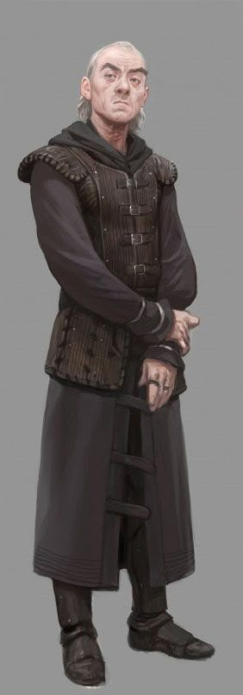
Leader of a group of Grubporters who perform religious skits at festivals and other various events. Asked if his group could play on the stage of The Show, and was manipulated by Squiddy into arguing with Herald M'kan about matters of belief. Clearly a devout Dowinite.

Alitec
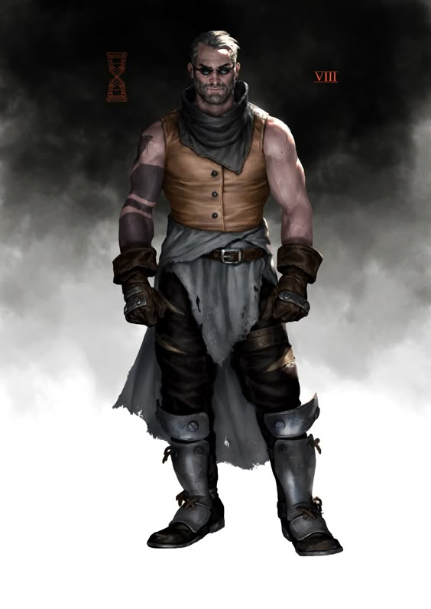
Rumored to be from Army Crossing, Alitec is suspected of being an somewhat of an agent provocatuer, or at least a criminal sent in by one of the border lords to sow chaos. Alitec is known to run games of chance, including “table-races” of small mutant animals at The Famous Root, and knows how to get in touch with Doc Potamus. Urag suspects Alitec of being involved in much more nefarious stuff than just gambling, and wants his ilk out of Grubport.

Victwor
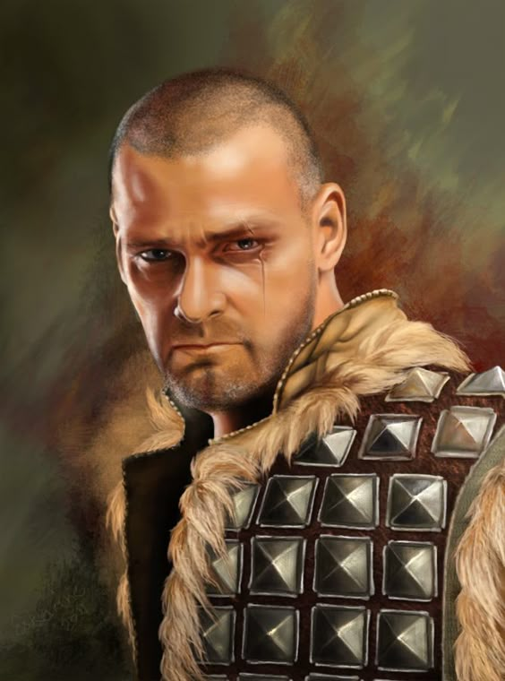
Proprietor of The Famous Root, the only drinking establishment in Grubport. Victwor's father was the only surviving member of an expedition to the ruined city in which Skybranch exists, and he returned with a huge section of root. The same root for which the bar is named, and which hangs on it's wall, dripping sap continually from which “vine wine” is made; a potent concoction that has variable effects on different drinkers, but is clearly linked to Skybranch's immense mental abilities.

Archivists
The archivists are thought to have a lair somewhere in the vicinity of Grubport.

Ferid
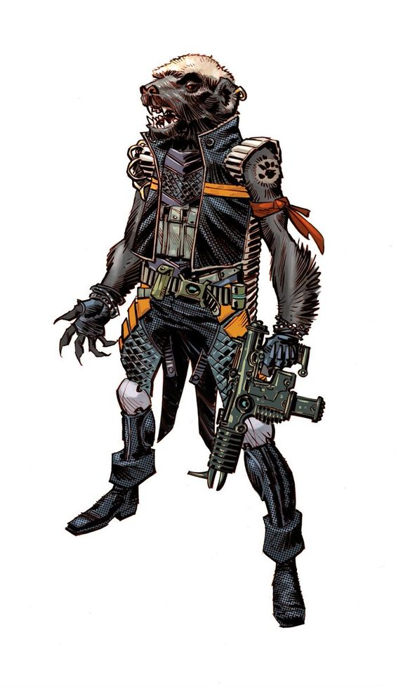
Ferid is a skunk-oid that flies a Dragonthopter, and is looking for Lanu.

Zina
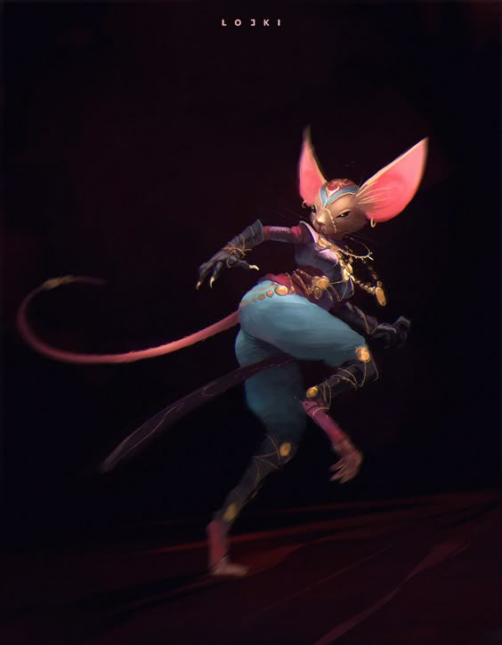
A mouse-kin (like Lanu) dancer that was looking for Lanu on the festival day near The Show while pretending to be performing for the crowd. Lanu has implied that she is very competent and even dangerous.

Dr. Usubious
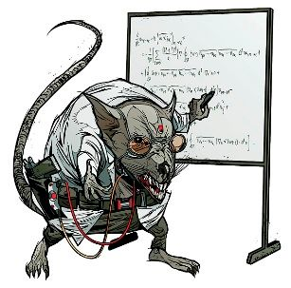
Ratoid leader of the attempt to take over Raymount.

Usubious's Assistant
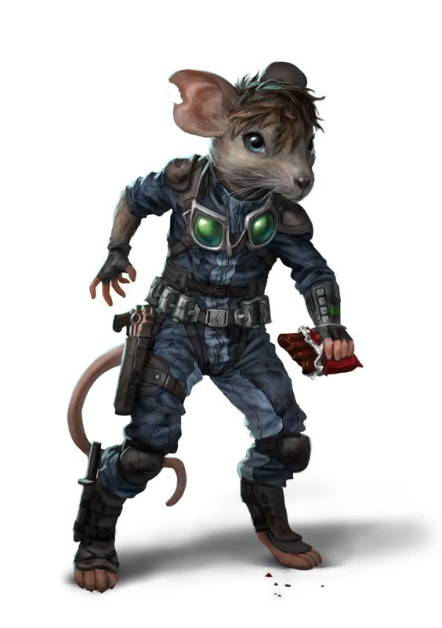
Mouseoid hacker that was attempting to execute Usubious's plan.

Hissers
It isn't known where exactly the Hissers who were smuggled out of Alalit are… but they left The Show while it was in Grubport, so they may well be nearby.

Maass
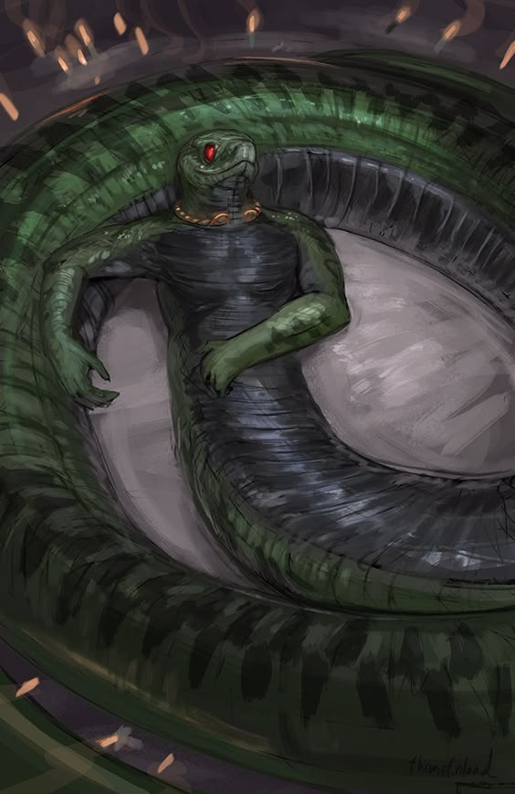
The leader of the male hissers who managed to break away from their queen. Pictured as he was first discovered, relaxing on the floor of Mazarin's basement.

Coorsis
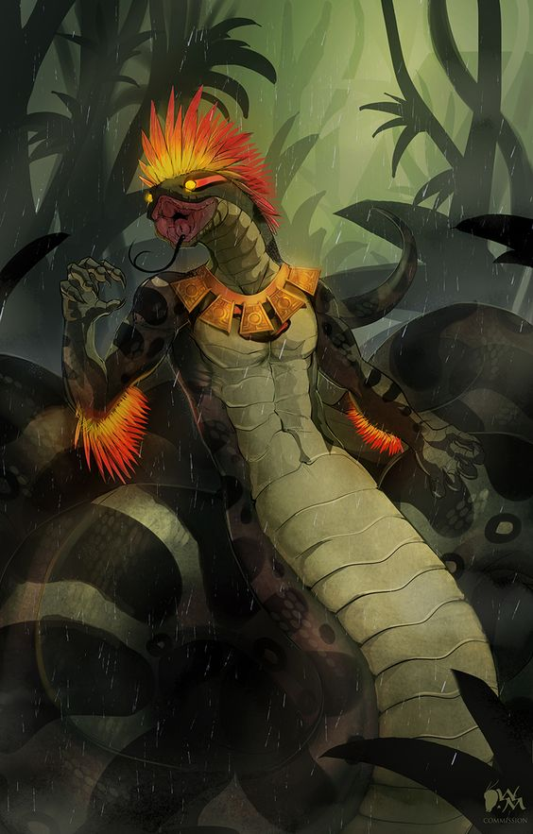
Male servant of Loosis, Coorsis had been tasked with helping the PCs find the males, but broke free of Loosis' control.
Coorsis is a mutation from the base hisser stock, with colorful crests on his head and arms.

