Basic Info  Name: Hoff  Type: Kreall, Mutant Tortoise  Pronouns: He/Him/His  Age: Seems very old  Superior Attributes, Strong Destiny, Average Mutations, Average Background, weak Tech.  Destiny (4)  Attributes (42)  - 9 Physical Strength (PS)  - 4 Dexterity (DX)  - 9 Constitution (CN)  - 6 Intelligence (IN)  - 12 Mental Strength (MS)  - 2 Charisma (CH)  Mutations (18)  - 5 ESP (The Seeking Eye)  - 5 Natural Armor  - 4 Sandcrafting (Turn sand into energized crystals)  - 4 Backshell (Natural container, can form shelter)  Background (18)  - 6 Mystic [Shaman] (The Seeking Eye)  - 6 Ranger [Scavenger] (Wanderer)  - 4 Historian [Wise Man]  - 2 Gambler  Gear (0)  Conditions  - Paranoid 1 (from failed hunting ESP roll)  - 1 Suspicious Alalit Townsfolk (who wonder if the mystic turtle is cheating)  - 4 Mystic Aura (for townsfolk)  - 1 Sand for Crystal  - 3 bonus dice, next Seeking Eye | Picture  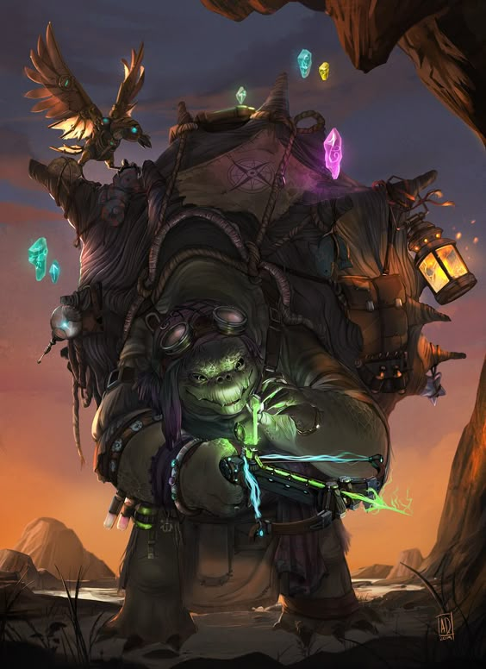  Lifepath
  What sort of beings were the character’s parents or creators?
  Where was the character born or created?
  Was the character born with mutations?
  Where was the character raised?
  Who taught the character what they know?
  What beliefs was the character taught?
  What did the character learn in order to survive?
  Did the character have any good or bad experiences with any cryptic alliances?
  Has the character ever visited any ancient ruins?
  Has the character actually ever fought anybody, and if so, how did that end?

