Horse Bay
And environs.

Alalit
The largest inhabitation on the peninsula (and it's barely on the peninsula), Alalit is the center of the Camite religion.

Cam's "Temple"
This underwater base is accessible only by means of the last remaining “bubble transport” system near some ruins on the outskirts of Alalit. When approaching this place, the Camites make a complete circumnavigation of Alalit so as to throw off those who might follow them to the transport.
Ruins near Alalit:
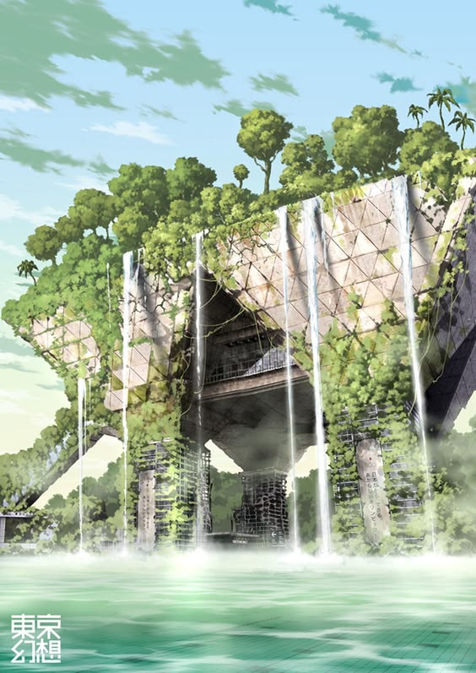
Bubble Transport Station:
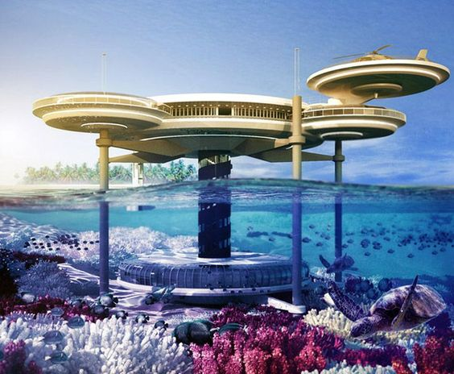
Cam's temple:
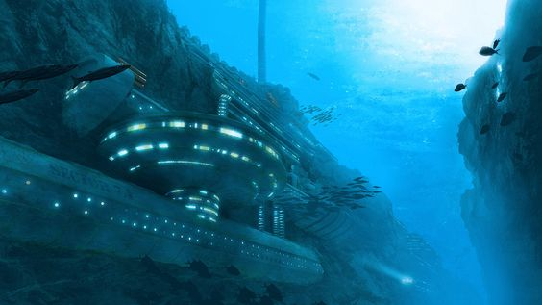
Ruined portions:
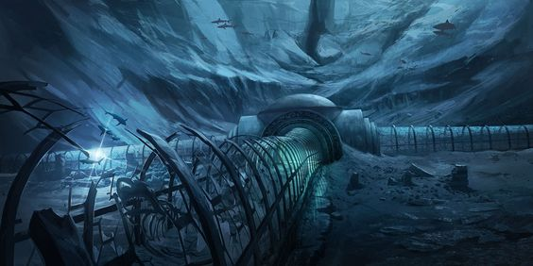
Ruined Interior:
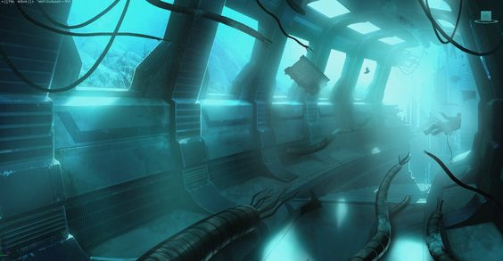
Temple interior:
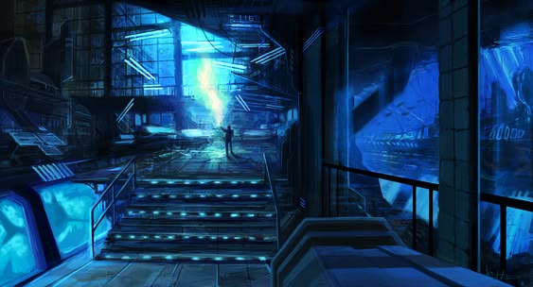
Launch Bay:
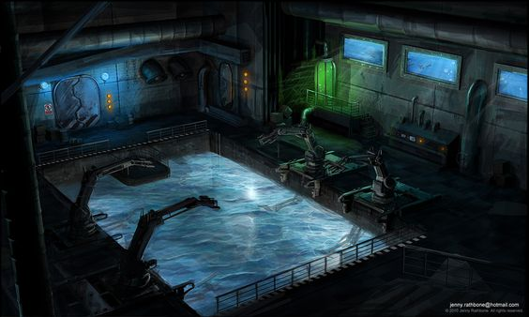
Laboratory:
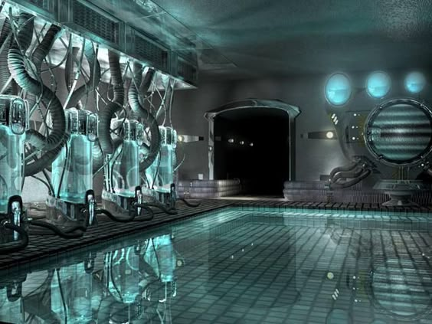
Holy of holies:


