Basic Info  Name: TBD  Type: Mutant Sparrow  Sex: Female?  Age:  Destiny 4  Attributes  - Physical Strength (PS) 1  - Dexterity (DX) 4  - Constitution (CN) 2  - Intelligence (IN) 7  - Mental Strength (MS) 5  - Charisma (CH) 5  Mutations  - Tinker Talent 10  - Density Control/Flight 8  Background  - Tinker 9  - Scavenger 6  - Hunter 3  Gear  - Tool Kit 8  - Powered Exoskeleton 8  - Jetpack 7  - Other stuff 7?  - Scrap 7  Misc  - Scavenging Roll: !25d6s  - Tinkering Roll: !38d6s  - 3 dice towards improvement | Picture  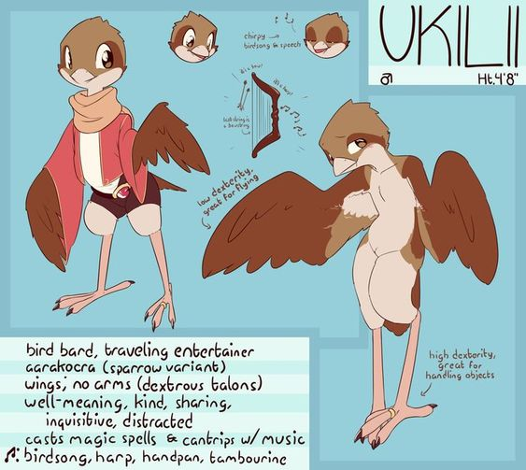  Lifepath  Also mutant birds  Born  Yes.  Nomadic family, with rare clan meets.
  What sort of beings were the character’s parents or creators?
  Where was the character born or created?
  Was the character born with mutations?
  Where was the character raised?
  Who taught the character what they know?
  What beliefs was the character taught?
  What did the character learn in order to survive?
  Did the character have any good or bad experiences with any cryptic alliances?
  Has the character ever visited any ancient ruins?
  Has the character actually ever fought anybody, and if so, how did that end?

