Basic Info  Name: Kikirikki Birb  Type: Mutant Sparrow  Sex: Female?  Age:  Destiny 4  Attributes  - Physical Strength (PS) 1  - Dexterity (DX) 4  - Constitution (CN) 2  - Intelligence (IN) 7  - Mental Strength (MS) 5  - Charisma (CH) 5  Mutations  - Tinker Talent 10  - Density Control/Flight 8  Background  - Tinker 9  - Scavenger 6  - Hunter 3  Gear  - Tool Kit 8  - Powered Exoskeleton 8  - Jetpack 7  - Death Ray 4  - Parts on hand 3  - Other permanent stuff 4?  - a working ancient detector device of some sort. After fiddling with it for a bit, she discovers that it detects life-force readings within about 300 meters, with plants showing as green, and animals as red signals.  - 5 Specific Nanotech (from Irlha)  Misc  - Scavenging Roll: !25d6s  - Tinkering Roll: !38d6s  - 3 dice towards improvement  - 2 Reckless Reputation  - 5 Learning Death Ray  - 3 Can't hide fear | Picture  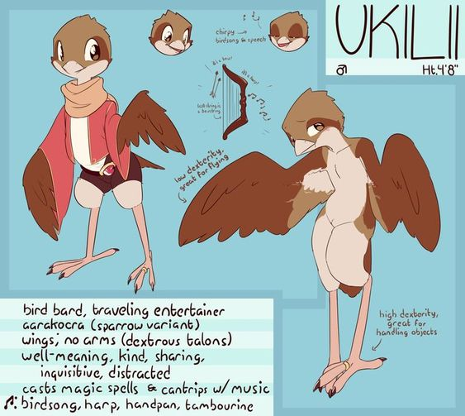  Notes  Kiki was sent by Dowin to meet the people of The Show in an old ruin and help them with her technical expertise. She quite likes them.  Unfortunately, when she went back to her family's caravan, Sorceress Irlha was attempting to kidnap them for their tinkering talents. Despite her family's and the show's valiant efforts, she managed to make off with Chirichiri (Kiki's little brother). Kiki swore to hunt them down the EVIL WITCH and PECK OUT HER EYES. The kind folks of The Show agreed to help her, and the Birb caravan is traveling with them for safety and to help hunt down the EVIL WITCH.  They recruited a bunch of people for their cause, since the EVIL WITCH is too dangerous to take on with a small group. Kiki also reprogrammed Zeebell a bit and made a Death Ray.  Following the general directions given by one of the Irlha's captured Brutes, the intrepid travelers tracked down her base, discovered a supposedly-virtuous knight defending it, and just as they were about to take him down, a cool cyber-lion named Imperos, who had escaped from his cell with the knight's love's help, asked us to let them talk to him first. We did and he agreed not to stop us, but his honor wouldn't let him help get vengeance on the EVIL WITCH. Good enough! We liberated all her prisoners (Chiri wasn't with them :( ) looted the place (especially the cybernetics lab), smashed a bunch of stuff, and stole the other flying platform. Now we're on our way to track her and Chiri down in our new flying thingy!  Lifepath  Also mutant birds  Born  Yes.  Nomadic family, with rare clan meets.  Parents, and experimenting herself  * Freedom is the most important thing, we travel because we are free.  - Old-world junk can be transformed into useful new things  - Never throw away something you can fix  - Help people and they will help you in return  - PECK OUT THEIR EYES  How to fix things for the family to trade, how to hunt and scavenge for food and useful things.  That one faction tried to recruit her, but they want to hide all the old things instead of using them.  Yes! They are the best!  Mostly not, if there's trouble the Birb family sticks together to help each other and as one of the younger members she'd been mostly protected by the older members of the clan.
  What sort of beings were the character’s parents or creators?
  Where was the character born or created?
  Was the character born with mutations?
  Where was the character raised?
  Who taught the character what they know?
  What beliefs was the character taught?
  What did the character learn in order to survive?
  Did the character have any good or bad experiences with any cryptic alliances?
  Has the character ever visited any ancient ruins?
  Has the character actually ever fought anybody, and if so, how did that end?

