General Geography of The Lands
Below are the regions of the Lands of which the PCs in the current phase have knowledge.

Central Region
Home region of the player characters, this region dominates the center of the land-mass that is generally referred to as “The Lands,” between the two great mountain ranges to the north and south (and a smaller one to the west). Because it is a cross-road, factions of all sorts have an influence on the people of the Central Region. Importantly, it is the home of the Sorcerer known as Melir, the leader of the Brotherhood of Thought, who resides in the Citadel of Thought. The citadel is located at a town called Elkir, which is the largest known inhabitation in the known Lands, comprised of close to ten thousand souls.
The central region has had a turbulent history (due in part to interference by the Restorationists), but is facing one of it's worst times now as the Arks from the Land of the Ancient Tattooed Ones have begun descending upon it's settlements more regularly and in better organized fashion than ever before, wiping out entire settlements in a few cases.

The Peninsula
The Peninsula is located to the east of the Central Region, and across a narrow sea from those that call themselves the Restorationists further east. This region is dominated by (if any can be said to dominate it) the “Peninsula Tribes” headed up by the tribe at the small town of Meadow Folk. This tribe is run mostly by Pure Strain Humans. The peninsula is also renowned for being the home of two “god pylons” that are worshiped by the peoples of the peninsula, Cam and Dowin.
Other notable settlements in the Peninsula include Grubport, Highvale and Seafort's End. Alalit is larger than any of these, but being on the west side of Horse Bay, most would call it part of the Central Region. The region is known to contain two major ancient city ruins.
Below is a map of the geography of the parts of the Peninsula, of which the PCs are aware (they arrived in Alalit by the road that comes from the west on the map, leading back to the Central Lands from which they fled): 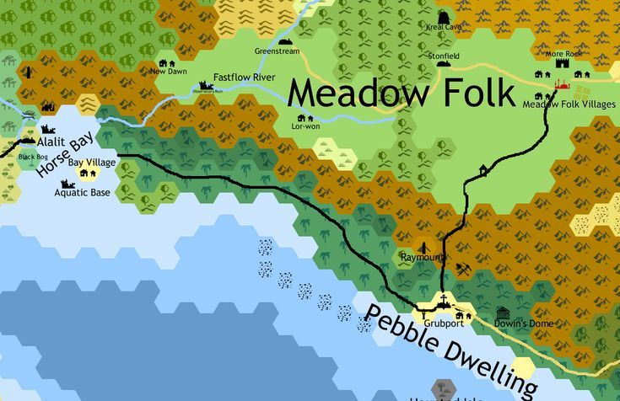

Southern Kingdoms
Situated on both sides of the Southern Range, the Southern Kingdoms are a stronghold of the Cryptic Alliance known as The Ranks of the Fit, who dominate this large region, formerly comprised of tiny city-states being taken one by one.

Land of the Ancient Tattooed Ones
A frigid wasteland inhabited by the violently organized tribes of the Arks that seem dead set on destroying everyone in their path.

