Basic Info  Name: Casimir  Type: Mutated Human  Sex: Male  Age: Yes  Destiny 10  Attributes  - Physical Strength (PS) 4  - Dexterity (DX) 6  - Constitution (CN) 5  - Intelligence (IN) 6  - Mental Strength (MS) 5  - Charisma (CH) 4  Mutations  Powers  - Electrokinesis 12  - Radiation Control 8  - Gravity Control 8  - TBD 10  Defects  - Epilepsy 10  Background  - Apothecary 6  - Scout 6  - Physician 6  Gear  - Nothing at all | Picture  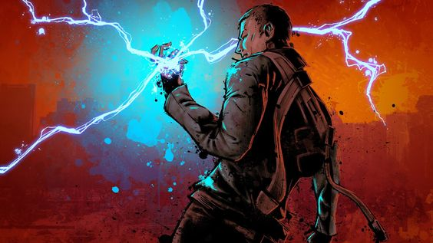  Lifepath  Father was a PSH. Mother wasn't, though she could pass. This was quite a scandal when they discovered her mutations. Father was disowned.  In the exclusive PSH colony in Meadow Valley.  Yes. Although he looks completely human. Nobody but his family and some close friends are aware of his mutation.  Highvale and Meadow Valley.  Before being ousted, his father was being trained as a doctor. He's learned doctoring from his father. His mother taught him to forage and scout.  TBD  TBD  Casimir is not very well-disposed towards the Iron Society. When his father left home with Casimir's mother, he left the protection of his people. This made a tantalizing target for the Iron Society. Casimir was six when the Society made its move. He is the reason his family lived - his reaction to the threat revealed him as an electrokinetic.  When he reached adulthood, he was approached by the Brotherhood of Thought. Their enlightened message of unity and freedom of choice appealed to him.  Appreciating his medical savviness, the Knights of Genetic Purity have tried to recruit him (not realizing he's not pure). The last time this happened, about a year ago, the Purists were more aggressive, trying to press gang him into their service. He reacted poorly, and the incident resulted in him discovering other facets of his power: gravity and radiation control. The offending Purists died. Unfortunately, this exchange was witnessed by a Radioactivist, who encouraged him to expore is radioactivity power (on her). He did, eventually killing her (all the while, she said it was okay, it was good for her - and he believed her). He still has nightmares. He's not told anyone abut this, yet.  Only the 'City ruins.'
  What sort of beings were the character’s parents or creators?
  Where was the character born or created?
  Was the character born with mutations?
  Where was the character raised?
  Who taught the character what they know?
  What beliefs was the character taught?
  What did the character learn in order to survive?
  Did the character have any good or bad experiences with any cryptic alliances?
  Has the character ever visited any ancient ruins?

