NPCs for the current campaign, the people and thinking things that the crew of The Show have encountered.
Click on pics to enlarge.

Note: Passers
When a NPC is listed as a “PSH” (Pure Strain Human, one with no mutations) this denotes that this is how they present themselves. Some mutant humans, to enjoy the privileged status that PSH individuals have in many communities may, if they have no outwardly appearing mutations, hide the fact that they have mutations, and pass as a PSH. Thus a character listed as a PSH may actually be a mutant human passing (“Passers” in the parlance of The Lands) as a PSH, or simply appear as a PSH on first contact.
The Show  The NPCs traveling with The Show.  Guards  The Show employs guards to keep everybody safe, as few of the merchant PCs or crew are particularly good at fighting.  Elkir  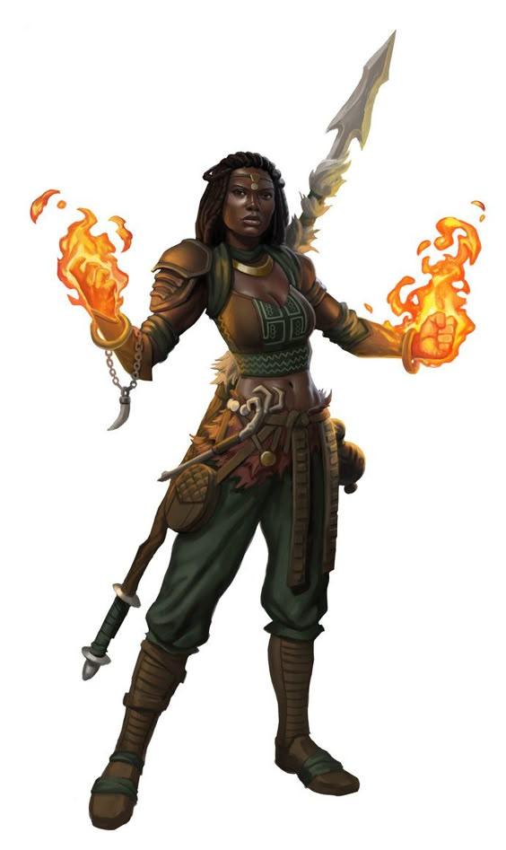  Elkir was originally a member of a community from the western reaches, but they were wiped out with few survivors who were scattered to the wind. She now uses her pyrokinetic powers and fighting skills to work as a guard for hire, and she's been with the traders for much of the current journey. She mostly keeps to herself, but has proven quite bold on the couple of occasions that the group has been threatened, clearly acting with a bit of fatality.  Forp  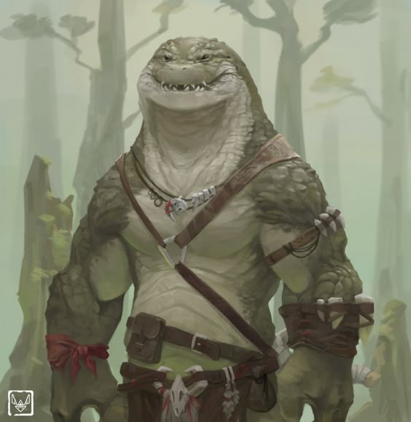  Forp is a burly gatoroid that the group picked up much more recently, hailing from one of the many villages of his kind in the southern coastal swamps. Unlike Elkir, he's quite talkative when engaged.  It's hard to say if it's a mutation, or if it's just part of the variation of his kind, but he's far tougher and stronger than his kind seem to usually be (and they tend to be pretty tough and strong). At least according to the mutant human who put you in contact with him. He currently wields a big piece of metal he found on the road (before that he used a wooden club), and he's been asking to be equipped with something better.  Forp is simply adventurous, and wants to see the world a bit and make his fortune before returning home to his swamp village to find a mate.  Crew  Most of the crew are nameless currently.  Lyeel  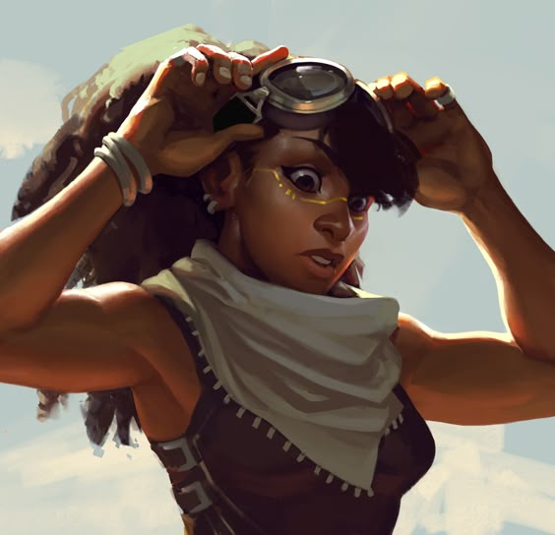  A young passewr woman from Alalit, daughter of Tavan and Mazarin, who seems to be fascinated with Digger. She has joined The Show with her mother's grudging approval as part of her Rite of Maturity.  Lallana  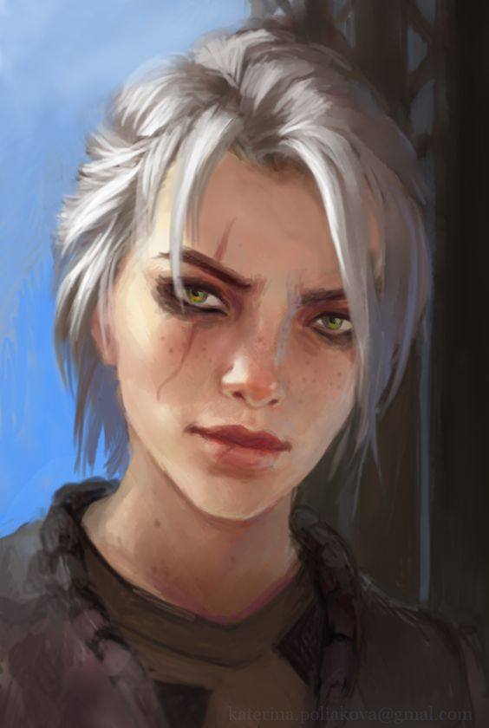  Formerly a perennial challenger for the chief position in Bay Village on Horse Bay, Lallana was convinced that her talents would be of more use as a member of the crew of The Show. She is now interested in possibly becoming leader of Khovip's mining operation outside of Grubport.  Lanu  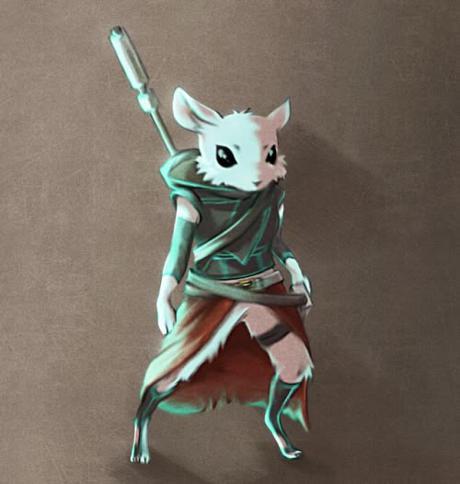  Mutant mouse-oid, likely an archivist, who followed the PCs into the aquatic base. Lanu has been convinced to travel with The Show to Grubport by Hoff. Apparently Ferid (below) is looking for Lanu for some reason.  Shorty  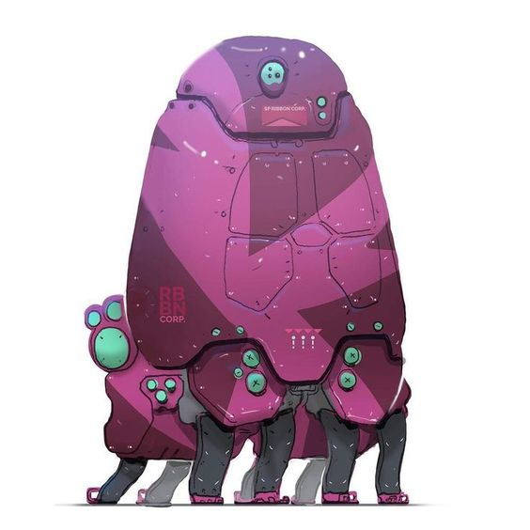  Shorty is a bot from the aquatic laboratory near Bay Village on Horse Bay (part of the overall complex formerly run by the Pylon God CAM that spans the bay).  Ilirha's Brute  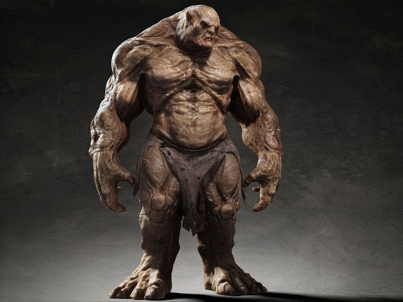  The Brute that Squiddy entranced with his lightshow in the aftermath of Ilirha's attack on Kiki's family's cart.  Passengers  Khovip  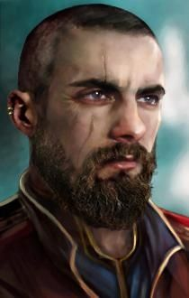  Grubport native from a formerly important family, Khovip is a mutant human. Has inherited an “ancient mine” from his father, which makes him suddenly wealthy and important. He has decided to hand over operation of the mine to Lallana, however, so that he can travel with The Show, and has removed himself from the matchmaking this year.  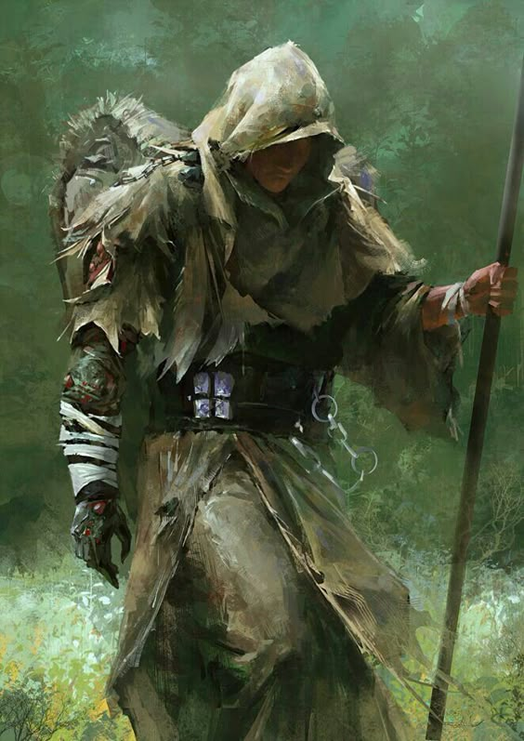  Khovip is singularly well travelled amongst the folk of the Penninsula, having been to the Citadel of Thought, and the Kreal home cave, amongst many places. The Grubport locals seem to think his soujourns in the Central Lands have made him effete, despite clearly actually being a pretty tough customer in some ways. Thankful to Hoff for guiding him with regards to the matchmaking and his estate, and getting him on board The Show.  Young Olkan  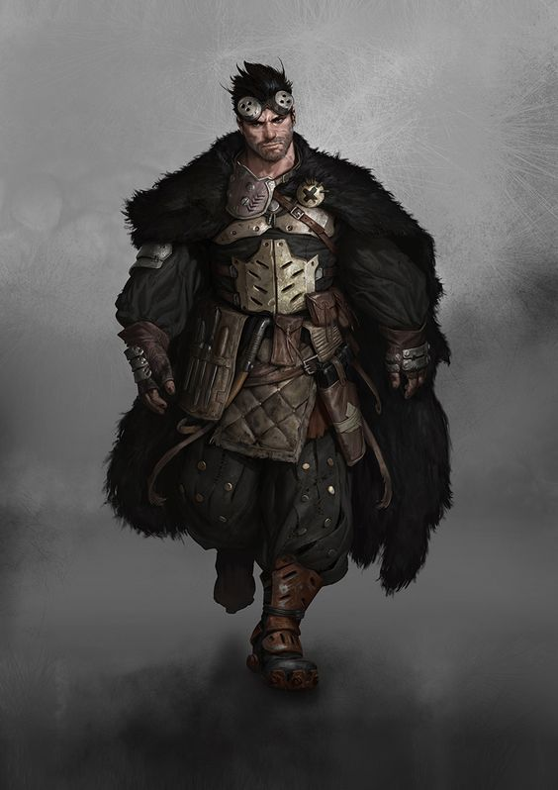  Son of Olkan, and likely next to rule it. Seems simultaneously prejudiced and provincial, and yet open-minded enough to think that maybe Kaiser Urs isn't the worst thing that could happen to the Penninsula; and also not all that interested in taking a mate. Happy that Squiddy convinced his father that he should be allowed to wait a year before marrying by taking him on The Show.  Maass  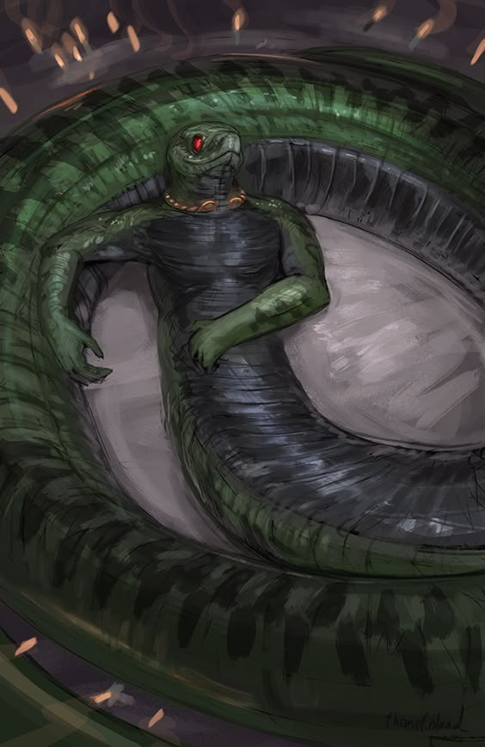  The leader of the male hissers who managed to break away from their queen. Pictured as he was first discovered, relaxing on the floor of Mazarin's basement.  Coorsis  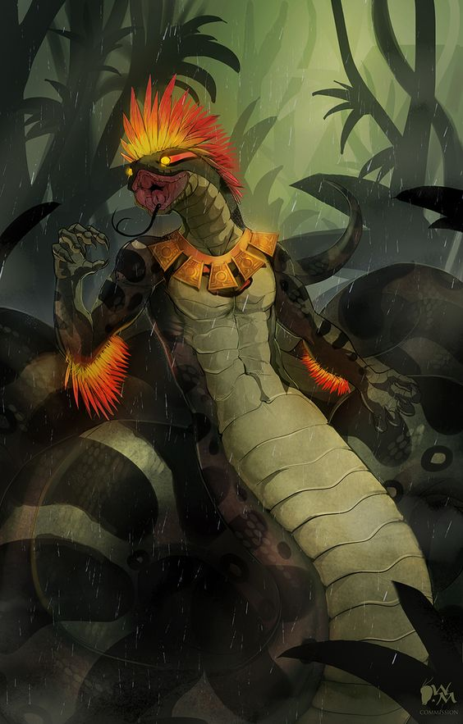  Male servant of Loosis, Coorsis had been tasked with helping the PCs find the males, but broke free of Loosis' control.  Coorsis is a mutation from the base hisser stock, with colorful crests on his head and arms.  Zeebell  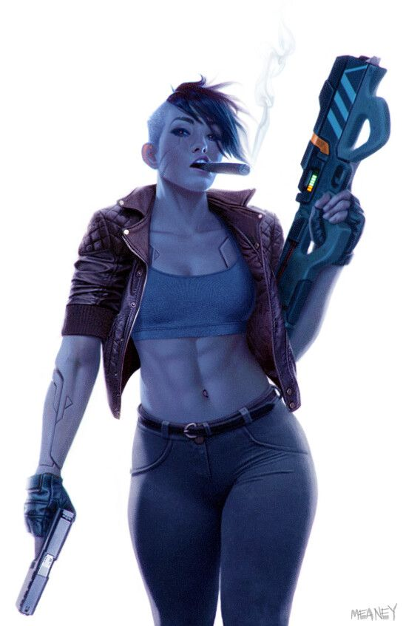  Possibly more accurately referred to as cargo than a passenger, Zeebell is a currently deactivated warrior android first encountered at the aquatic lab base near Bay Village on Horse Bay. | Grubport  Townsfolk  The townsfolk are all Pure Strain Humans (or possibly passers) unless otherwise mentioned.  Urag  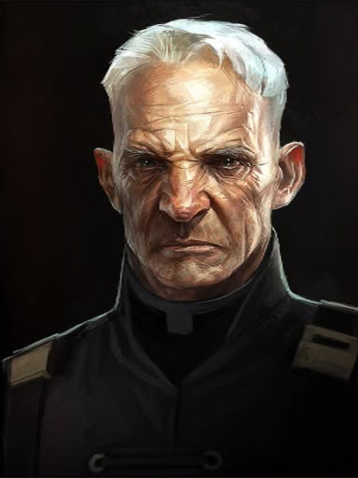  The head of the Urag family, the rulers of Grubport. While putatively run buy a council of elders of the most important families of Grubport (who make their homes upon the deck of the old ruined aircraft carrier that comprises Grubport), this family is deferred to by all of the others. According to sources, Urag is garnering weapons to create some sort of personal army.  Young Urag  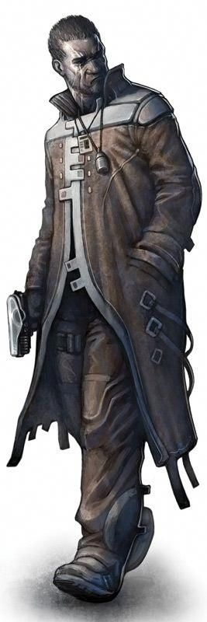  Young Urag is the son of the elder. He is clearly fond of his vices, and not a skilled gambler, having lost considerable trade chits at the gaming tables at The Famous Root and elsewhere.  Urag's Daughter  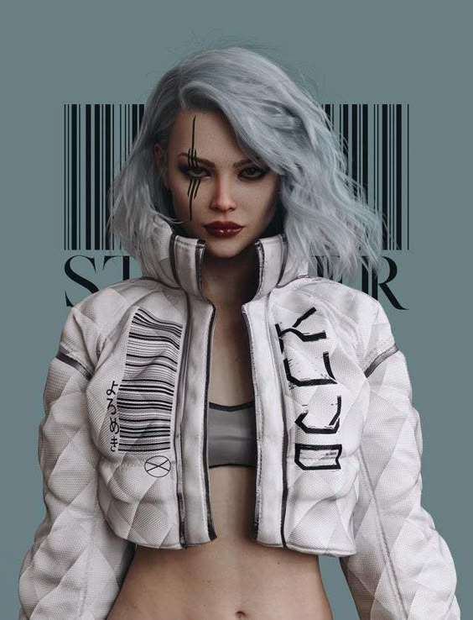  Daugher of the elder Urag, this one is cold, vapid, and grasping. Not particularly bright, her only thoughts are of her own security and comfort. She previously sought to marry Khovip to obtain the wealth of his mine.  Betsk  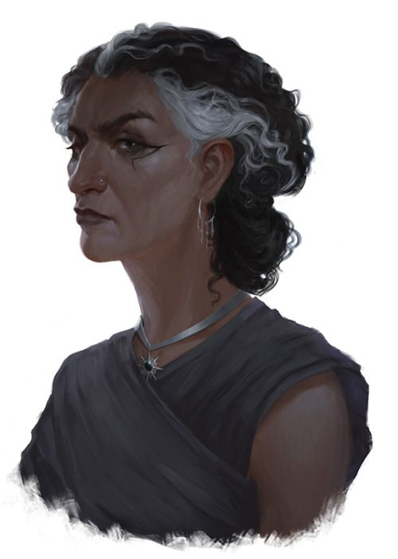  Matriarch of the Betsk clan, brought relatively low a couple of generations ago by the Urags. She is seeking help getting Urag to get Chersh to give her son a good match of a wife.  Young Betsk  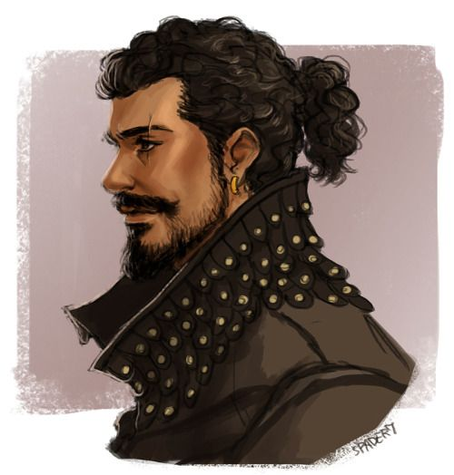  The charming son of the Betsk matriarch, he is taken a bit with Greenstream's Daughter, but worries that she may be a mutant.  Greenstream's Daughter  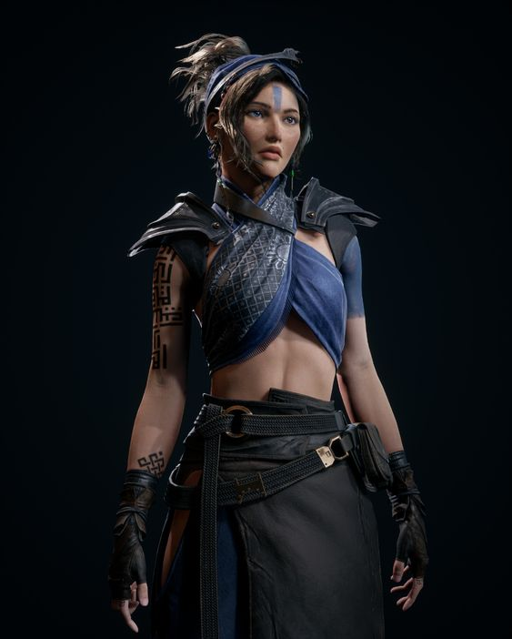  Daughter of the most important Elder of the village of Greenstream, people speculate that she may be a mutant, given that she wears paint like the painted women do.  Chersh  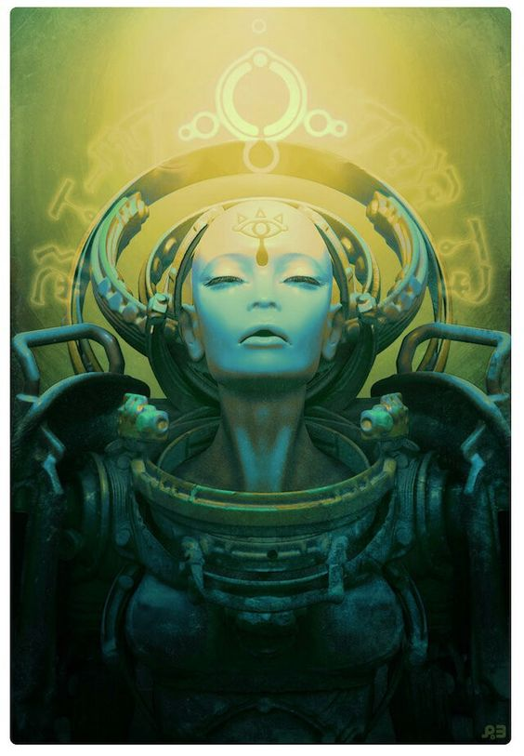  A “Sorceress” who works with Urag and the other families of Grubport to maintain order. She runs an annual matchmaking festival at which she matches members of the various families of the Peninsula Tribes together by word from Dowin. At the most recent affair she worked with the PCs to create favorable matches for a couple of families, since Dowin did not seem to be present.  A Light Keeper  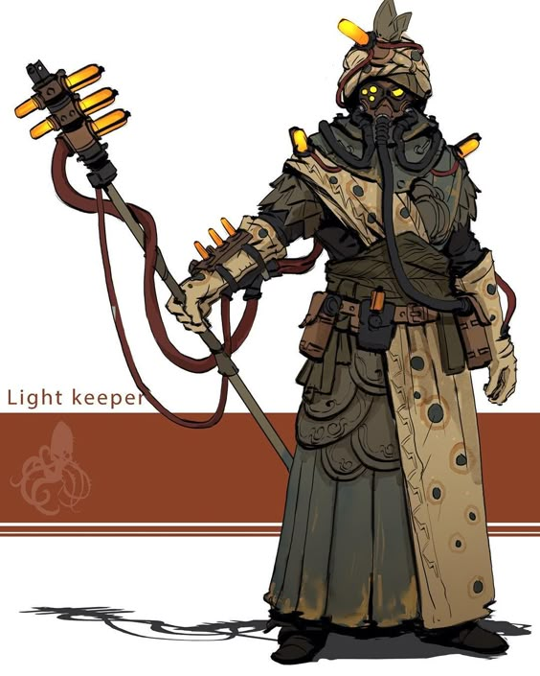  One of the priesthood of Dowin in Grubport. This one came into The Famous Root and gave a doomsaying type proclamation about the fact that Raymount's power was dwindling.  Belron  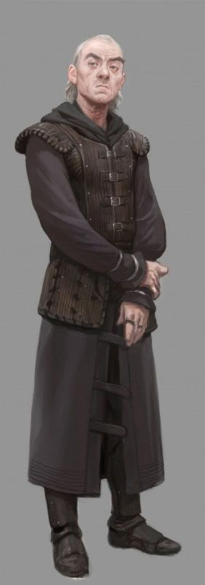  Leader of a group of Grubporters who perform religious skits at festivals and other various events. Asked if his group could play on the stage of The Show, and was manipulated by Squiddy into arguing with Herald M'kan about matters of belief. Clearly a devout Dowinite.  Alitec  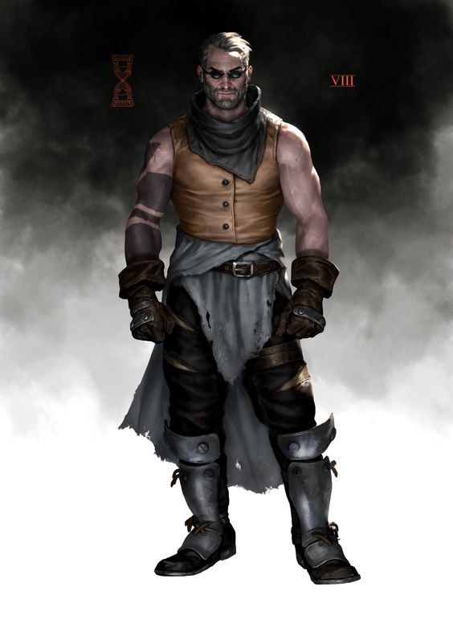  Rumored to be from Army Crossing, Alitec is suspected of being an somewhat of an agent provocatuer, or at least a criminal sent in by one of the border lords to sow chaos. Alitec is known to run games of chance, including “table-races” of small mutant animals at The Famous Root, and knows how to get in touch with Doc Potamus. Urag suspects Alitec of being involved in much more nefarious stuff than just gambling, and wants his ilk out of Grubport.  Victwor  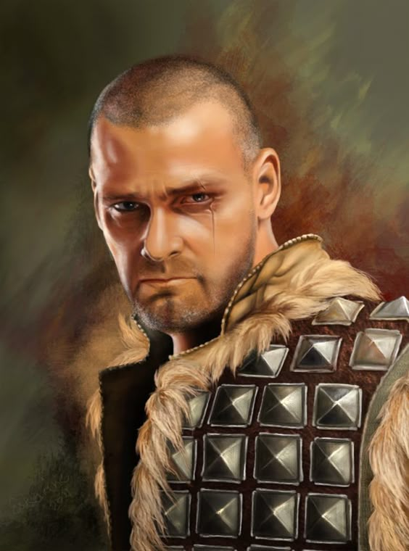  Proprietor of The Famous Root, the only drinking establishment in Grubport. Victwor's father was the only surviving member of an expedition to the ruined city in which Skybranch exists, and he returned with a huge section of root. The same root for which the bar is named, and which hangs on it's wall, dripping sap continually from which “vine wine” is made; a potent concoction that has variable effects on different drinkers, but is clearly linked to Skybranch's immense mental abilities.  Archivists  The archivists are thought to have a lair somewhere in the vicinity of Grubport.  Ferid  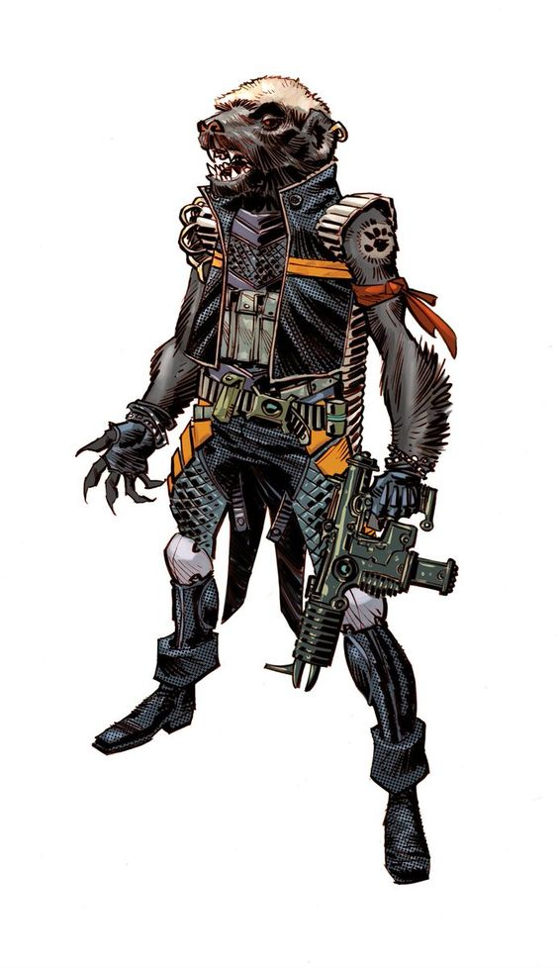  Ferid is a skunk-oid that flies a Dragonthopter, and is looking for Lanu.  Zina  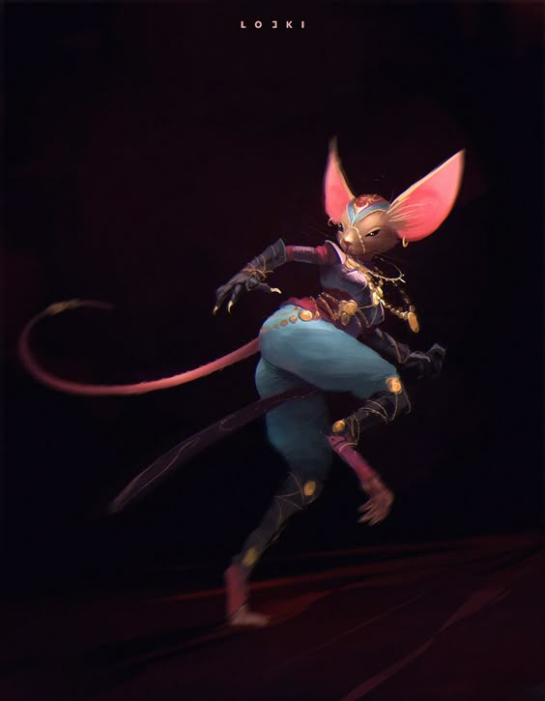  A mouse-kin (like Lanu) dancer that was looking for Lanu on the festival day near The Show while pretending to be performing for the crowd. Lanu has implied that she is very competent and even dangerous. | Peninsula Tribe  This section covers members of the tribe from outside of Grubport.  Visiting Grubport  The following Peninsula tribe folk are visiting Grubport currently, because of the festival of matchmaking that is going on there.  Takalk  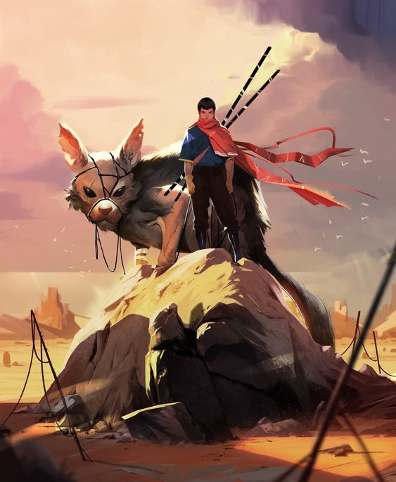  The son of the Chief of all of the “Peninsula Tribes” (which actually is a small set of the overall thinking peoples of the peninsula), Takalk is a boy of 16, and was considering his options for marriage, despite his father thinking he should wait. Taktalk is glad that the PCs gave him the push to take the plunge. He's a bit bewildered by his (much older) match, Olkan's Daughter, but willing to do what Dowin wills (he's also unaware that there was any chicanery involved or that the matches were anything but Dowin's will). One gets the feeling that he's trying to grow up very fast.  Olkan  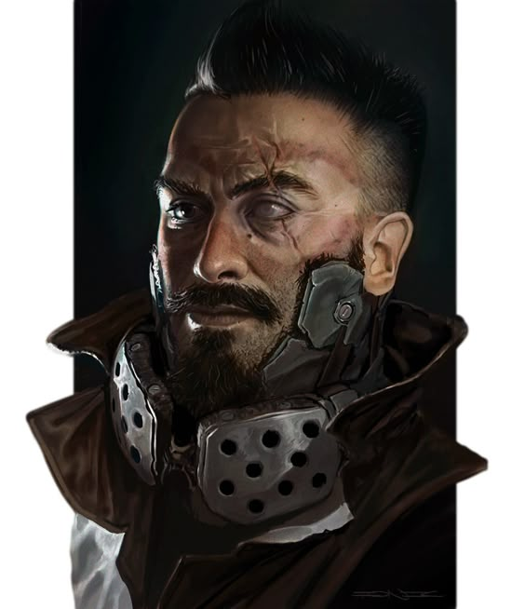  Head of the Olkan family from the village of Stonefield. A former captain of the Peninsula Guard, Olkan is fairly set in his ways. He was very interested in marrying off his children, and particularly uncaring of his daughter's desires. However, Olkan is delighted that his daughter is married off to the son of the Chief, Takalk, and the PCs convinced him, now OK that his son will wait another year to be married. He doesn't feel that he owes the PCs, but he's now generally favorably disposed towards them because of the dealings regarding his children.  Olkan's Daughter  A bit overwhelmed to now be married off to the son of the Chief, but willing to do Dowin's will, no matter what. Her words after the event peg her as being rather devout, and pleased that she at least has such a pure mate.  Greenstreams  The elder of the village of Greenstream was in the dark about… Dowin being dark… so they have no change in their opinions of the PCs as a result of the matchmaking. However they are in good spirits as their daughter has a reasonable match, and their young son has an excellent match. They were thinking it wouldn't turn out this well.  Caag AKA Breck  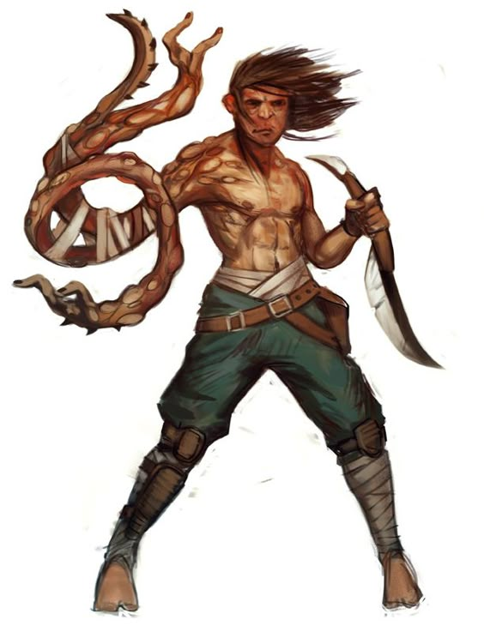  Going by the name of Breck, rumor has it that this mutant's real name is Caag, and he's been motivated by somebody to slay Herald M'kan.  Pavon  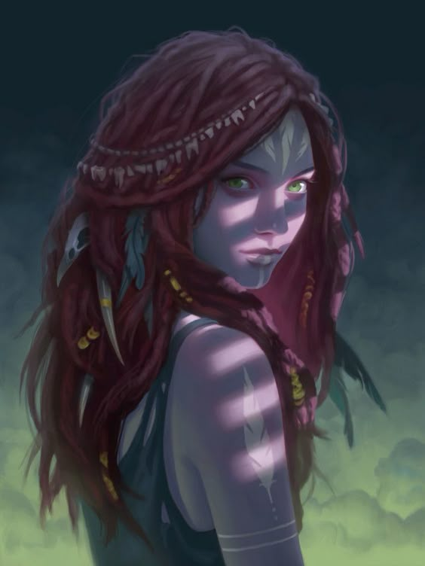  A “painted woman” mutant human encountered in Grubport.  The Patrol  Comprised, apparently, of a handful of squadrons of mounted armored pure strain humans, the unit that the PCs has met is lead by one Lieutenant Sone. They claim to protect the entirety of the Peninsula (which does not include Alalit), apparently with the seat of their government being in the center of the Peninsula, a place called Meadow Folk.  Lieutenant Sone  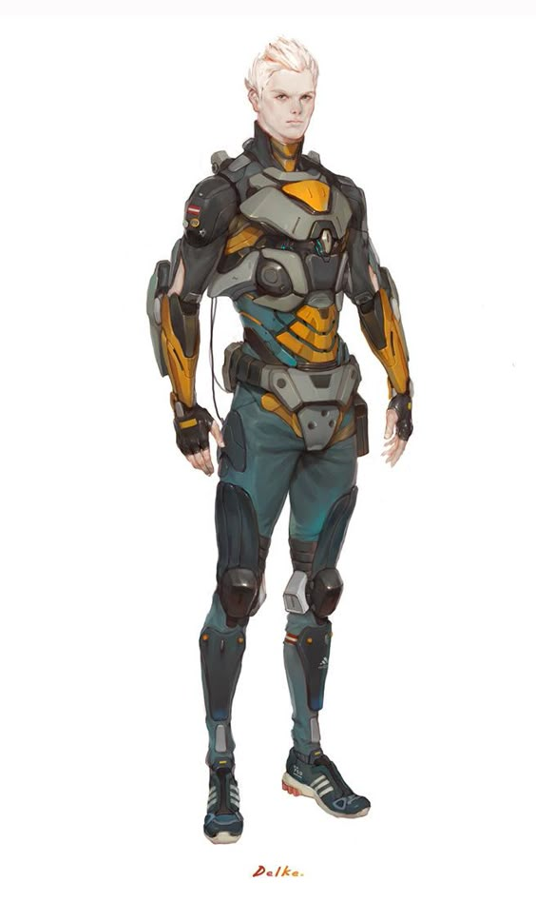  Here Sone is seen in his armor, but sans helmet as he was at Mazarin's saloon.  Peninsula at Large  The people below do not seem to be attached to one place.  Restorationist Emmisaries  Clearly seeking to gain influence in the Peninsula, this team comes to the coastal settlements regularly from the Restorationist enclaves to the East across the waters.  Marbolla  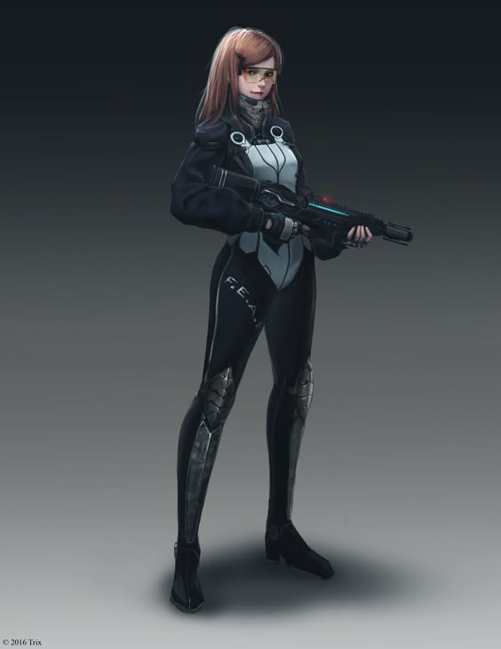  The captain of the patrol ship that carries the emmissary team, and as such, the chief emmisary, Marbolla seems fairly reasonable with the exception of a clear disdain for mutants.  Also pictured, Marbolla's ancient hover-gunboat.  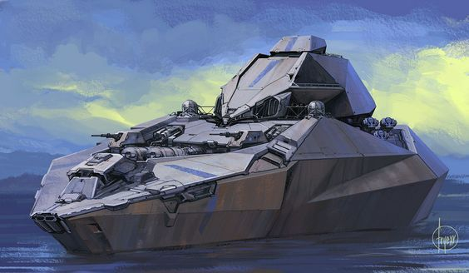  Others  These are the peoples of the Peninsula who seem to belong to no place or tribe.  Ilirha  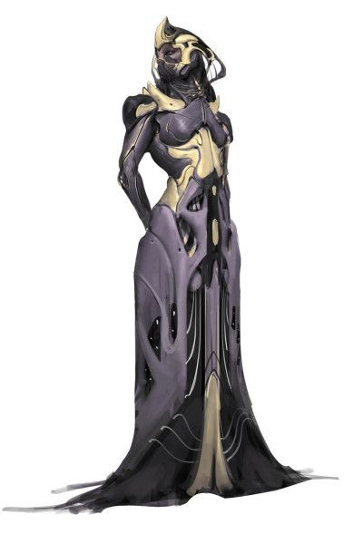  A sorcerer of renown across the Peninsula, Ilirha is said to terrorize villages from her flying temple. She was responsible for disrupting the ceremonies to determine a new chief at Bay Village, by taking the two lead competitors (leaving Lallana as the only remaining competitor, and a thorn in Kurzor's side). She now has Kiki's brother captured, last seen taken into her flying temple.  Doc Potamus  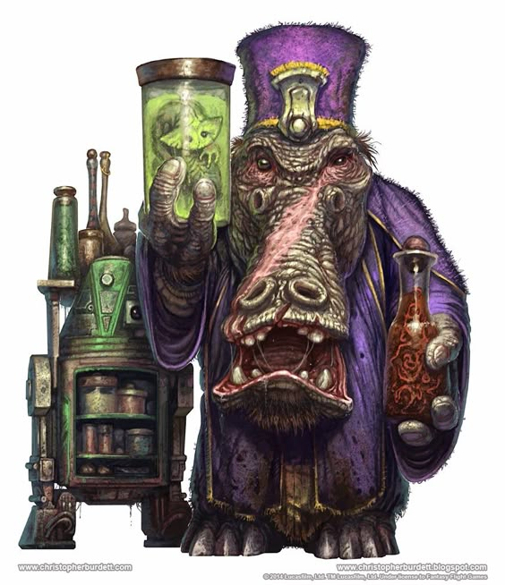  Renowned across the Peninsula for his ability to bestow cybernetic and genetic enhancements upon those who seek him out. Lyeel has confirmed that it was Potamus who bestowed her mother with cybernetics.  Serrat  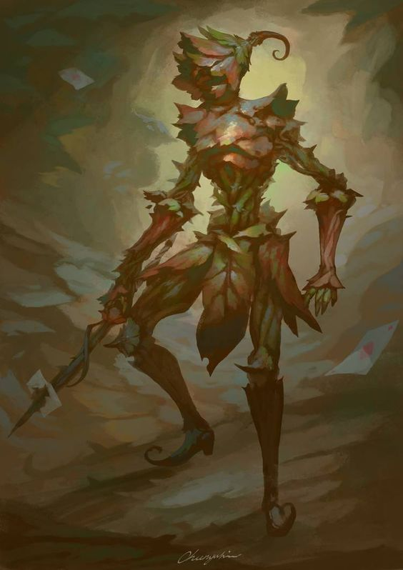  A humanoid plant that seemed very interested in Hoff's comings and goings at Dowin's Dome.  Ropp  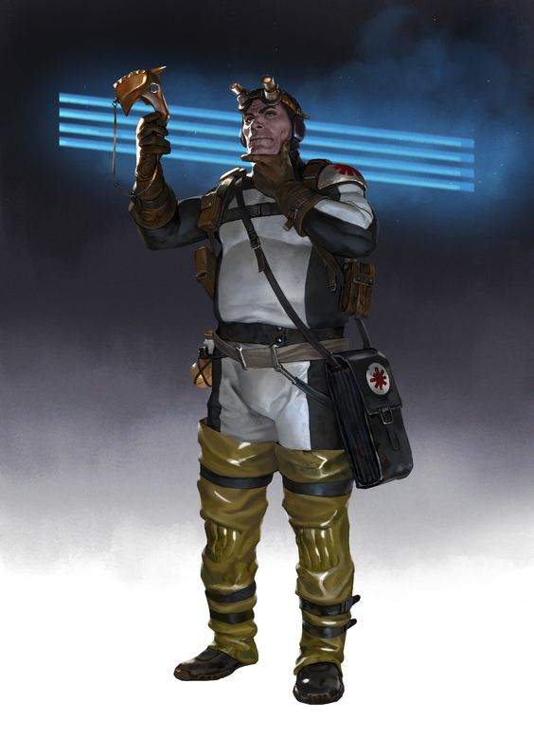  A member of a group of Healers that Hoff met at Dowin's Dome.  Lindar  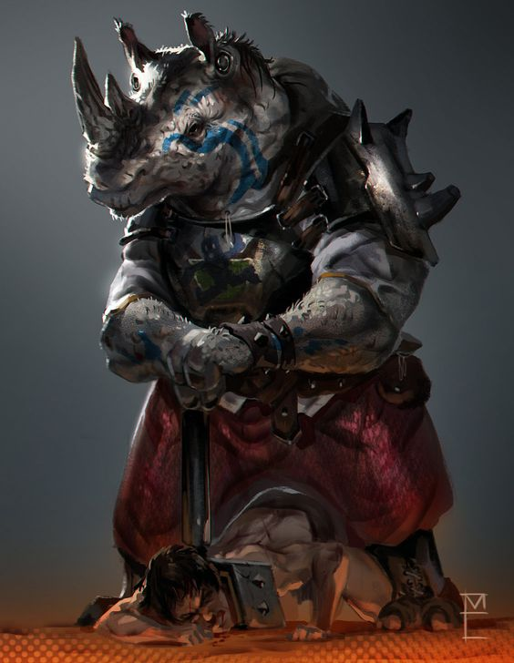  Mercenary Rhinoid, known as being a slaver, and likely a member of the Zoopremacists (or at least a sympathizer).

Previous Locales
- Alalit NPCs
- Grubport NPCs

See here for Previous Campaign NPCs.

