Pebble Dwelling
The Meadow Folk claim this region as part of their empire, and the majority PSH population of the area are just fine with that.

Grubport

Dowin’s Dome
Once the center of a park complex, this domed facility hid an embryo bank underneath. Dowin’s remaining programming (like all beings, her mind was distorted during the event).

Questions
Accept Dowin’s blessings? Accept her quest to check on Cam?

Sights
Interior of the Dome:
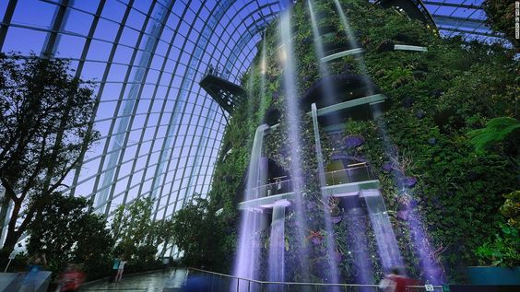

Archivist Lair
Located in a series of storm drains in what was once a park, these tunnels run under Dowin’s Dome, giving the Archivists access. They rarely enter, because the androids and borgs are on the lookout for them constantly, but once in a while a brave member will make a foray to grab whatever they can.

Questions
When it becomes clear that the Archivists have useful things tucked away intending never to use them, do the PCs liberate these items? When it becomes apparent that some of the items belong to Dowin, do they bring down wrath on the Archivists, or bring the items back to Dowin?

