City Ruins of the Peninsula
Technically within the Meadow Folk Lands, the Meadow Folk claim that these ruins belong to them, and are sacred. That said, they’re simply too big and too inhabited to belong to any one group.

Wrangler Camp
Spot where the largely PSH Meadow Folk are camped out on the outskirts of the City Ruins, as their expedition attempts to obtain as many of a herd of Brutorz as they can. Said herd being rumored to be moving through the ruins. These people fancy themselves all the “Wrangler Clan” but they are really too loosely associated to each other to be a clan. Wealth is really all that ties each individual to the group.
A couple of members of the Wrangler clan are actually bold enough to go into the City Ruins themselves. Those that do tend to be well-armed (or appear so).

Questions
The Meadow Folk leaders are PSHs, and some are with the Knights. When one tells the PCs they should go home and otherwise denigrates them, how do they react? When leaving, do the PCs let the mother and her daughters tag along?

Sights
Meadow Folk woman looks into the City Ruins with servant by her side:
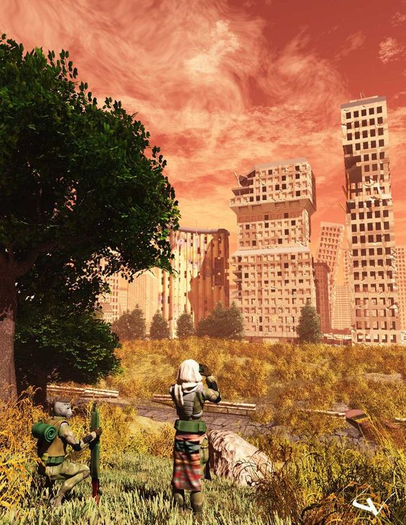
Brutorz:
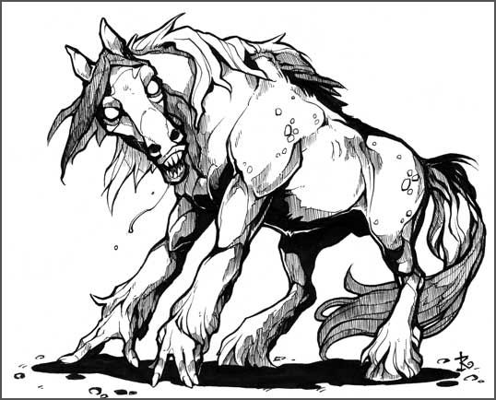
Wrangler Clan scavenger of the City Ruins:
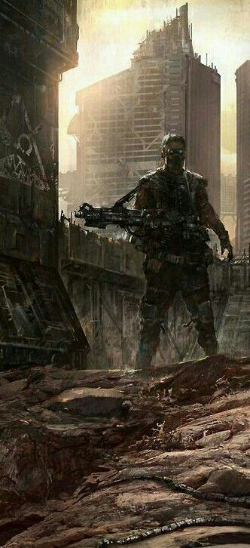

City Clan Zone
The City Clan are not numerous, nor can they claim to control a large swath of the City Ruins. But these violent mutants are a menace to those who venture into the City Ruins.

Sights
City Clan's Tower
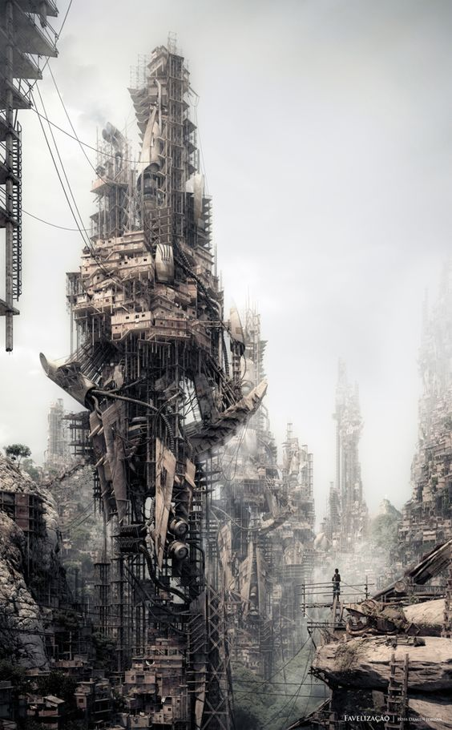

Ojico Tower
Old Tojicorp tower (with the sign missing some letters), which is relatively easily accessible from outside the city, and devoid of much danger. Used by the Highvale majority test initiation squad as a site to set challenges.
Just yesterday the Geckoids (or a PCs clan perhaps), arrived under the shadow of the tower, inhabiting the lowest levels as a new living space.

Questions
How do they react to the “thieving” geckoids?

Sights
Somebody at the base of the tower:
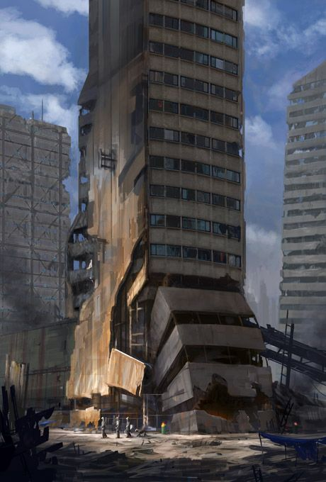

Sights from Random Parts of the City Ruins
Many buildings are overgrown:
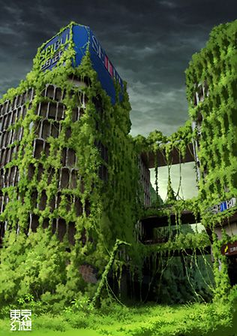
The streets between the larger buildings are often a near unpassable tangle:
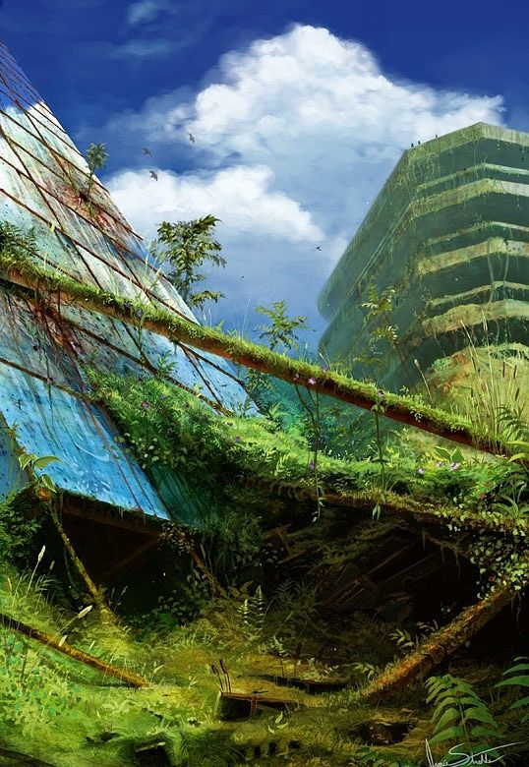
Even forests full of wildlife have grown over streets between buildings fallen together where once vehicles passed:
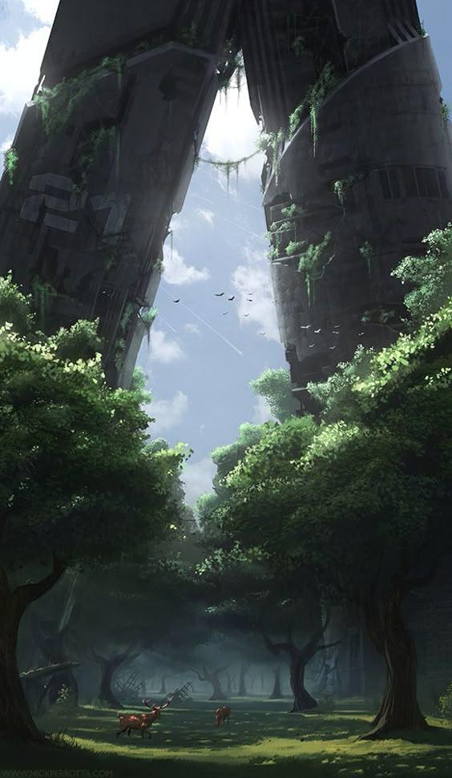
Keilah's view, showing the central tree-god of the City Ruins:
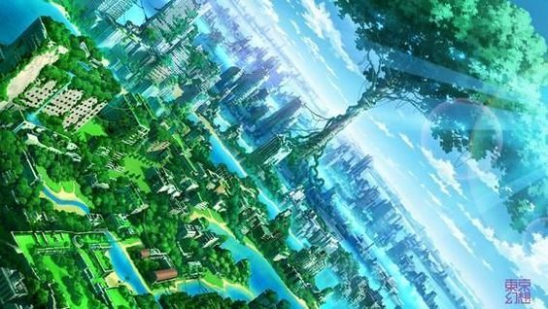
Much of the city is flooded, and has been for centuries, water features from the city having broken ages ago:
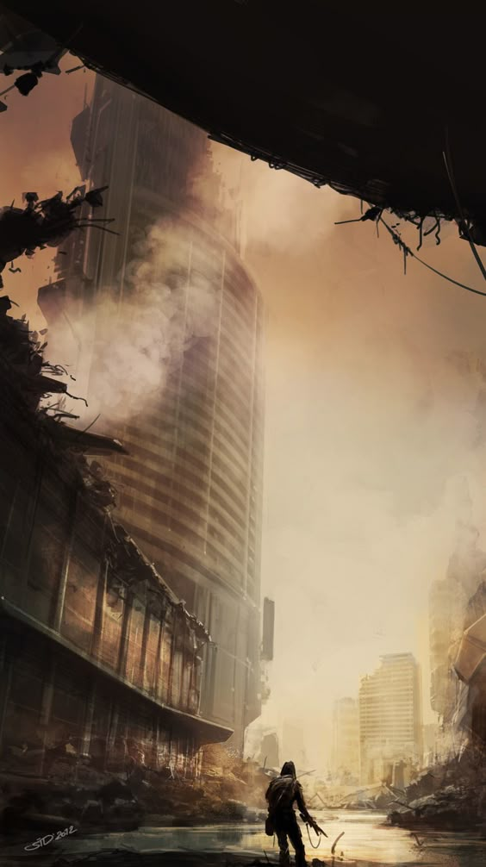
The ancients employed many different architectural styles from many different periods:
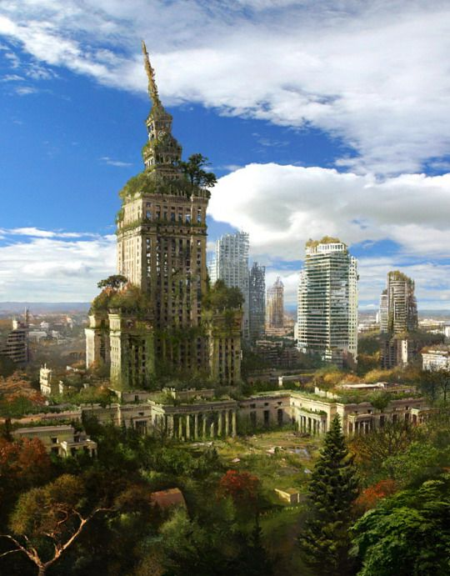
The deathbot approaches:


