City Ruins of the Peninsula
Technically within the Meadow Folk Lands, the Meadow Folk claim that these ruins belong to them, and are sacred. That said, they’re simply too big and too inhabited to belong to any one group.

Meadow Folk Camp
Spot where the largely PSH Meadow Folk are camped out on the outskirts of the City Ruins, as their expedition attempts to obtain as many of a herd of Brutorz as they can. Said herd being rumored to be moving through the ruins.

Questions
The Meadow Folk leaders are PSHs, and some are with the Knights. When one tells the PCs they should go home and otherwise denigrates them, how do they react? When leaving, do the PCs let the mother and her daughters tag along?

Sights
Meadow Folk woman looks into the City Ruins with servant by her side:
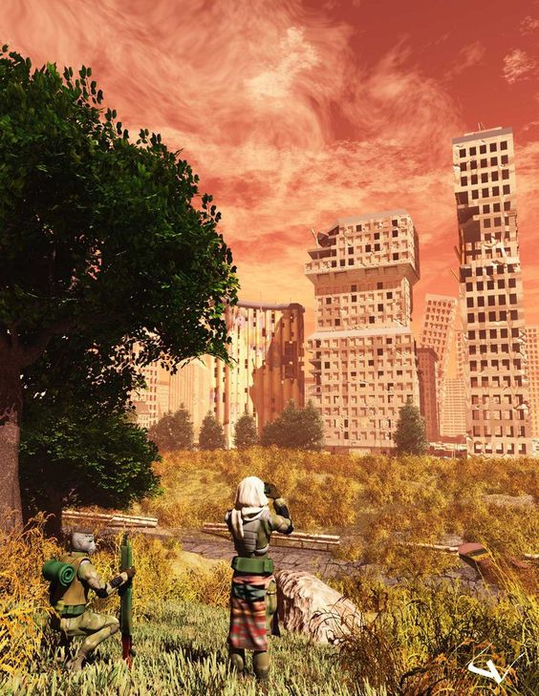
Brutorz:
{{

Ojico Tower
Old Tojicorp tower (with the sign missing some letters), which is relatively easily accessible from outside the city, and devoid of much danger. Used by the Highvale majority test initiation squad as a site to set challenges.
Just yesterday the Geckoids (or a PCs clan perhaps), arrived under the shadow of the tower, inhabiting the lowest levels as a new living space.

Questions
How do they react to the “thieving” geckoids?

