Highvale Phased Play
Details of the Highvale Adventurers phased play script.

Phase 1: Test of Majority

Overview
The settlement sets up a scenario where the PCs are to go out to the city ruins to search for something valuable, but have it rigged so that they will find something by following guidance supposedly from the Pylon God Dowin (who is being helped out by the elders concerned that the younguns learn proper respect for the god). They meet a mentor (an agent from one of their cryptic alliance associations), and are given gifts to help them on their way. Things go south when a sorceress shows up to acquire the valuables for herself, setting herself up as the chief villain of the campaign.

Stages

Stage 1: Prologue - Departure

The Empy-bug
Somebody encounters, and possibly tames, and Empy-bug. These bigger than fist sized bugs are bio-engineered by Dowin, and somebody informs that they are sacred gifts (Dowin said so). Empy bug then works a bit like Navi, pointing things out when necessary.

Taking Leave
- Before going, Crowsis gives his Machiavellian rant.
- Saying goodbye to loved ones.
- Mentor?
- Ceremony
- Tunu asks who will carry the Oracle. Keilah volunteers, but she’ll give it to a PC unless Keilah is the only one to step forward.

Leaving the Verge
Past the fishing lake, there are piles of stones that demarcate the end of the village’s official territory. Sirocco turns here, and asks if anybody wants to go back. None of the NPCs do.

Stage 2: The Journey Out
The city is a long day's hike through somewhat rough terrain. Sirocco will advise avoiding all encounters (but will change his mind suddenly on encountering the Lupines).

Entertainment Ball
This device has managed to achieve symbiosis with the local plant-life, and thus has recently become almost fully-powered again. In return, the plants are being repaired by its nanite swarm. It can run a game of “Levi-ball” for those who can successfully interface with it, and many other games in theory. Maniftests a holographic Game Master. Do they take it (denying the plants and ball of power)? Is it practical?

Loo Pers
“wandering monsters” these cunningly intelligent mutant wolves do not have manipulators, and hunt in packs. Get money for mounts. Get this from Lupines (who don’t use currency) or from a cache.

Stage 3: Entering the City Ruins

Meadow Folk Expedition
A substantial group of traders from Meadow Valley are here with a big train of mounts, having been on a long excursion to find these creatures to trade. They’ve come to the City Ruins because they’ve heard there’s a herd of Brutorz that are making their way through the area. They’re very willing to trade their mounts, but not their nice gear. The gear includes a radiation detector, and they can give hints on safe routs into the City Ruins, if somebody negotiates the info from them. One of them is snooty, considering the Highvale folks below them and primitive (despite being demonstrably primitive themselves in most ways). Does this result in friction or a fight? The others are far more open, and are the characters of the Phase 2 R-map.

The Patrol
Also with the mounts expedition is the patrol, who they’ve essentially bribed to stand with them as protection against whatever might emerge from the city. The leader of the Patrol, Captain Berboris is in the midst of trying to foment conflict between the folk of Highvale and the village of Broadbranch. He’ll be all too nice to the Highvale folk and it will come out that he is trying to get the Broadbranchersto believe that he’s helping the Highvale folk (and they hate him enough that they will take it out on the Highvale folk).

Challenges
Avoiding radiation hazards, clambering over sharp rusty stuff,

Stage 4: The Tower of OJICO

Gecks
At the base of the tower a group of geckoids have moved in (or some group lost to a PC). They are small, friendly and adorable, ingratiating themselves to the PCs to make allies. They just up and give the PCs a medkit they've found. When Ilira strikes, her attacks devastate the poor creatures.

Tower
Before that happens, however, the PCs must climb the tower of OJICO (which is not too hard as it has stairs in most places). It becomes clear that Sirocco is railroading the party at this point, and that the test is a set-piece thing. Just as they find the planted treasure, Ilira attacks with the help of her sleeth henchmen from a floating platform. She’s heard about the planted treasure from a Geck she controls through blackmail. But when she arrives she spots the Oracle, and she wants that even more. She can’t get the Oracle off Keliah easily, however, so she decides to just grab her. Challenges here involve avoiding the following bad things happening. Choices involve PCs having to decide what to try to prevent (each can go after two or three, and some might overlap).
- Sirocco dies in a valiant defense of Keliah.
- Sirocco’s vibro-blade is lost.
- Keliah being taken. If she’s saved, she loses an arm and a wing as Ilirha cuts the Oracle off her.
- More Gecks die
- Other NPCs in the testing group die

Challenges
Climbing the tower, escaping the collapsing tower

Sights
Ilira escapes in her flying palace:
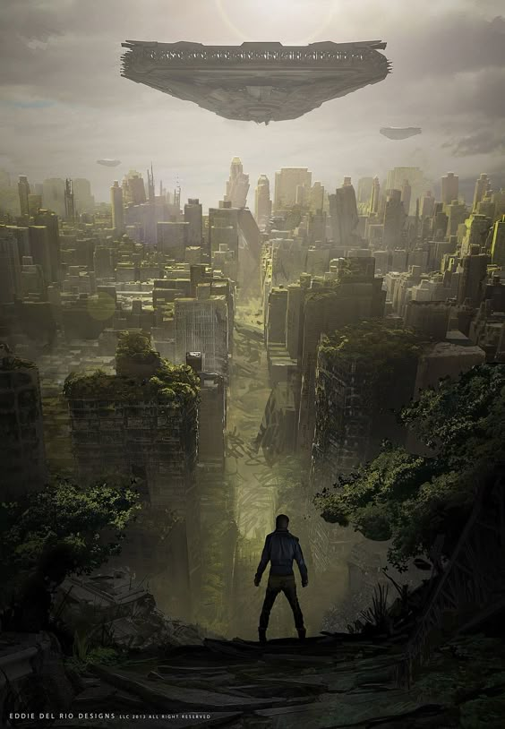

Phase 2: Chasing the Dragon

Overview
The oracle being of critical importance to the settlement, they chase the sorceress. Hints of the truth about the world emerge from the chant of some Camite cultists. “The Legacy is all.” Dowin has forgotten, or never knew the truth, but Cam did. Cam (formerly functional in an underwater laboratory) is discovered to be dead, however.

Stages

Stage 1: After Her!

Pikers Go Home
The less intrepid folk in the testing group offer to go home to report what’s happened (lose less interesting NPCs… no more cannon fodder).

Traders Redux
They encounter the traders again on their way out, and the traders, done with rounding up Brutorz, decide to follow.

Bacon!
Mutant pigs are discovered to be running a pig processing plant in a very well hidden, overgrown vale found on a shortcut. At first there’s tension, because the Pigoids don’t want the location of their operation spread around. But they can be reasoned with. Do they accept a trade deal for Highvale? What will they give as a sign of good faith? What about after they find out that the pigs they’re raising are semi-intelligent?

Ditched
They lose Ilirha’s trail in Pebble Dwelling (near enough to Grubport to take a short excursion if the PCs want), but somebody suggests going to see the wizard (Dowin) who may be able to tell where she is.

Stage 2: Meeting Dowin
Dowin wants them to investigate some things in return for data on where Ilira is. Dowin turns out to be decidedly female-ish. She smothers them with comforts and care. Lost limbs can be regrown.

Stage 3: Temptation
Dowin offers borging, including
Dowin sends them to Cam’s underwater lair by way of exotic underwater conveyance. They run into cultists who don’t appreciate them being there for some reason. But they try to tempt the PCs to join with promises of power.

Stage 4: Meeting Cam
They meet an android claiming falsely to be Cam (who displays their power in terms of controlling the facility). Eventually, however, Cam is found, and is discerned to be dead. Do they tell anybody (people will ask)? The android absolves the PCs, no matter what (by recording over the PA, even if they destroy it), saying that it’s not their fault they’re living beings, faulty, and susceptible to mistakes, and gives them a clue to the location of Legacy’s Key, saying that it’s time that somebody worthy made some decisions about the state of things. Ilira is there to gloat about this (some ally has betrayed the PCs to her), and warn off the PCs. She sets off a death-trap flooding the place, and somebody will die holding the door open while the others flee. Who makes the ultimate sacrifice?

Phase 2: R-Map
Seeing the chasing adventurers as potential sources of income, the Meadow Folk mount traders tag along.

NPCs

Anira
A PSH widow with two daughters who are mutant humans. She's looking to pawn her daughters off on folks less picky than other Meadow Valley folk.

Anit
Spends her time recounting stories, with whose heroines she closely identifies.

Aglo
Much more practical sibling.

R-Map Events

Romance on the Road
Anira reflects upon the days before she married, when she was courted by her husband but loved another. She’s trying to get the PCs into a romantic mood.

A Better Offer
An open-minded PSH who is an elder of another village or something comes along and seems interested in one of Anira’s kids (one a PC has shown interest in). She wants to take him up on the offer.

Phase 3: Off to Never-Never Land

Overview
Having faced the truth with Cam, the PCs liberate a flit car

Stages

Stage 1:Rebirth

Stage 2: Melir?

Stage 3: The Key to the Legacy

Stage 4: Ilira’s Defeat
At the starport.

Phase 4: We ARE Home

Overview
PCs go to the moon, and find the command center, and realize that the Legacy has arrived at its destination long ago, and the colonization protocols can be started. But the planet is inhabited by folks who won’t survive the terraforming.

Stages

Stage 1: To the Moon!
PCs encounter the war between the Rosoids and the Macrob-folk. Canopus Plague zombies explain what became of the crew. Nanites keep them from rotting as much as they otherwise might have, but they’re not human any more. The PCs learn that it was the Canopus Plague in cahoots with anarchists who created the apocalypse across the ship.

Stage 2: Comfort Galore
They fight their way to the command area, which is without conflict and very posh. Androids attend to every need, they not realizing the situation. Why do anything now? They can live out their lives here forever. The androids, however, do not understand mutant powers, and one of the damaged AIs in charge of mental health will attempt to “cure” any mutants of the “delusion” that they have such powers.

Stage 3: The Crew Wakes
The crew has been waking several times over the past centuries, but goes back to sleep when it they get bored of waiting for the key to show up. Now the key is here, but who is in charge?

Stage 4: Whence from Here?
Do they terraform Terra Nova? Do they look for another world? Do they go back to Earth? Do they decide that the Legacy is, in fact, their legacy?

Phase 4 R-Map
When the crew awakes, they will have varying agendas that will conflict, and inform the PCs decision-making process regarding the destiny of the Legacy.

NPCs

Marshall Orwing
Orwing is horrified by what has happened to the Legacy, and would prefer to reboot it by initiating the “Omega Protocol,” which would kill every living thing, allowing the clone banks to start again from scratch. What Orwing doesn’t realize is that he is actually a subtle form of mutant himself.
Background
R-Map Events

