An underground part of the Gamma World, Subterranea refers collectively to the areas underground occupied by the mutant humans known as the subterrans.

Locations

Riverville
The village to which Zia belongs.
One of the village elders is named Nuwzin:
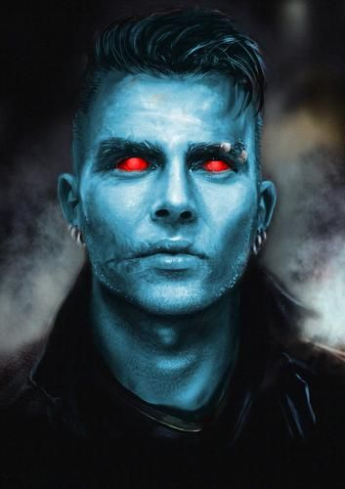

Smokey Village
The village to which Leeza belongs.
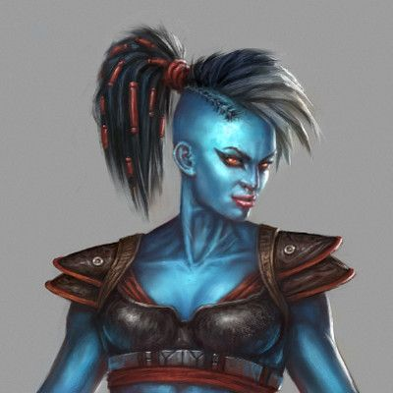

Forest Denizens
Gowtoo
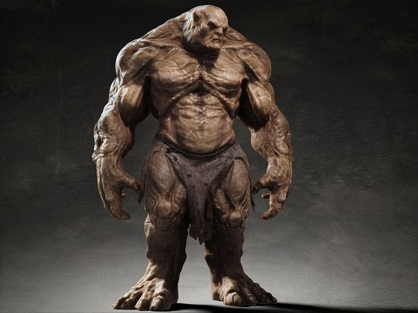
ReconBot


