Name:[Astra] Real name: ???
Sex: Female

Attributes
Abi | Ability
5 | STR
3 | INT
7 | AGI
3 | CON
2 | EDU
7 | CHA
3 | EMP
3 | WIL

Skills
Pool | Sk | Skill
 | 2 | Acrobatics
 | 4 | Act/Bluff
 | 3 | Cool
 | 1 | Demoltions
 | 2 | Disguise
 | 1 | Forgery
 | 1 | Heavy Weapons
 | 3 | Medical
 | 3 | Melee Combat
 | 2 | Observation
 | 4 | Persuasion
 | 5 | Small Arms
 | 1 | Stalking
 | 3 | Stealth
 | 1 | Thrown Weapon
 | 2 | Tracking
- | - | -
4 | 1 | Computer Empathy
8 | 5 | Dissolution
6 | 3 | Empathic Healing
7 | 4 | Human Empathy

Gear

Contacts

Hindrances
- 2 Craving Love
- 1 Low self esteem
- 4 Unstable

Benefits
- 4 Passion
- 1 Self Confidence

Careers
- Background: Wealthy but troubled kid
- School: Military Boarding School
- Career 1: Secret Experiments in School
- Career 2: Delta 7 Trainee
- Career 3: Delta 7 Operative
- Career 4: Dissolved Captive

Bonds:
- Mai - student of sorcery
- White Circle – former colleagues
- The Underground – Allies

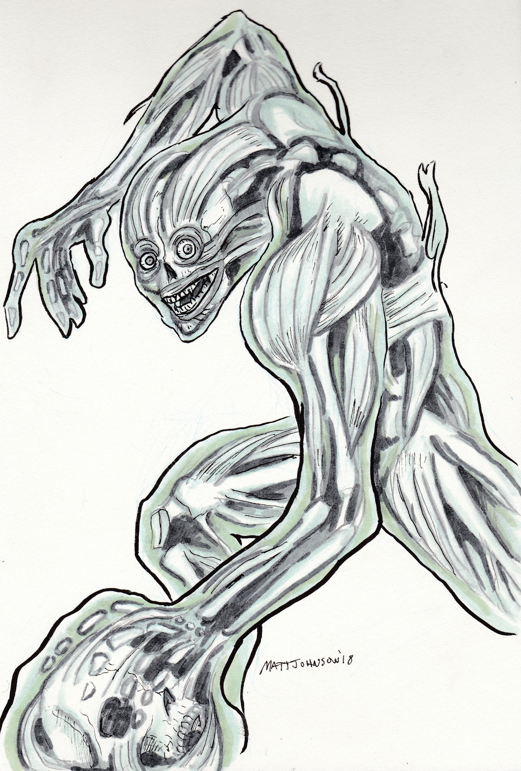 https://captrosko.tumblr.com/post/179451602515/kandra-i-found-i-hadnt-been-carrying-a-man

Recent Background
Astra was held for a couple of years, during which time Beta Three had been reassigned to the Chicago Underground and become a trusted senior member. Astra got loose from her captives somehow just a couple of months ago, and ended up in Cleveland.
Not recalling much, she did remember a couple of operatives she worked with in the Cleveland area, and tried to look them up. She found that both of them had been slain. While looking into the second of them, she ran into one “Field Agent Leonard Maxwell” and one Deputy Regional Director Frank Lime of the DEA, cleaning up the murder of the D7 agent she was looking for at a hotel room, and planting evidence to make it look like a typical murder (instead of the very bloody affair that it actually was).
Astra followed a lead on another D7 agent that went to Gary (to help the underground there deal with the BioChem situation). He was never found, and suspicion now is that he may well be dead. Further it seems likely that his mind may have been read, and that this may have lead the conspiracy to the other D7 agents in Cleveland.
After the events of Gary at BioChem with the Chicago Underground, Reba was taken to Chicago but not long afterwards she returned to Gary with her daughter.
In Gary, Astra found Reba, because she had a gun on her that Beta Three gave Reba in order to track her (the tracker on which has been going off regularly since Reba left Chicago, and Astra knew what signal to look for). Reba's mind having been wiped of the location of the base, Reba still recalled Beta Three having been with her at the Craft Bar. Astra used her empathy to get this information from Reba's mind.
Astra went to Chicago and staked out the craft bar, eventually approaching Darcy and Janessa, there trying to blow off steam in a girls night out after the events at Union Memorial Cemetery. The rest is in nar.

Links
Main:\\ Campaign Overview - Chicago: A Cold Wind Blows:
https://wiki.wishray.com/doku.php?id=chicago_-_a_cold_wind_blows#details
http://wiki.wishray.com/doku.php?id=chronica_insidea
https://wiki.wishray.com/doku.php?id=dark_conspiracy:setting
https://wiki.wishray.com/doku.php?id=dark_conspiracy:chicago_synopsis_3
ThisOneTimeAtFaeCamp
Cases:\\ The Buzz:
https://wiki.wishray.com/doku.php?id=dark_conspiracy:the_buzz
The Missing Girl:
https://wiki.wishray.com/doku.php?id=dark_conspiracy:case_of_the_missing_girl
NPCs:\\ Order of the White Circle:
https://wiki.wishray.com/doku.php?id=dark_conspiracy:order_of_the_white_circle
Empathic Underground:
https://wiki.wishray.com/doku.php?id=dark_conspiracy:empathic_underground
General NPCs:
https://wiki.wishray.com/doku.php?id=dark_conspiracy:general_npcs

https://wiki.wishray.com/doku.php?id=dark_conspiracy:panix&do=edit

