Arrival At the “Craft Bar”

From across the portal it looked like the Craft Bar, but up close, obviously not.

Not in Kansas OR Chicago:
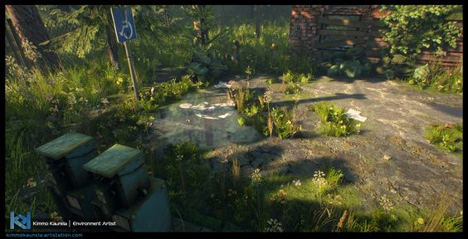
More of the Faux Chicagoland interface in Cheeseburger Paradise where it's obvious that it's not Kansas any more.

Path to the beach:
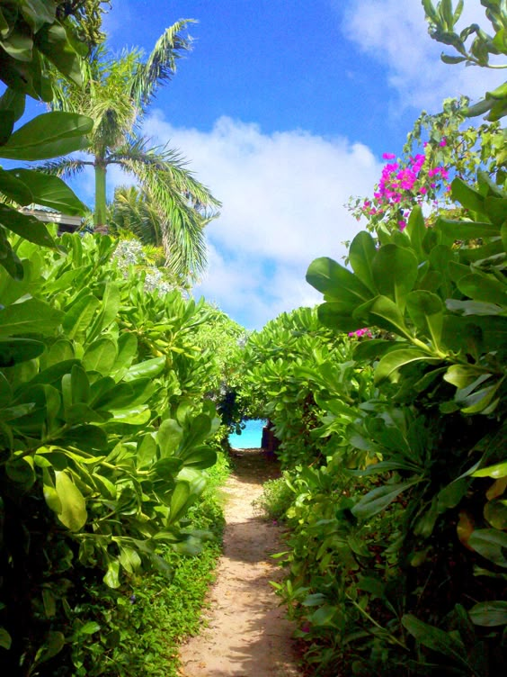

“Osaka” on the Quay:
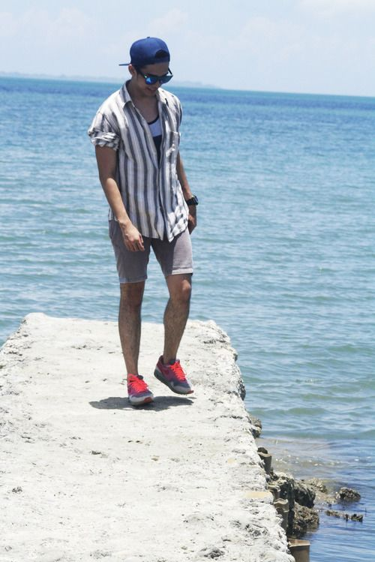
Osaka on the quay at the beech, just down a ways from the camp.

Beard
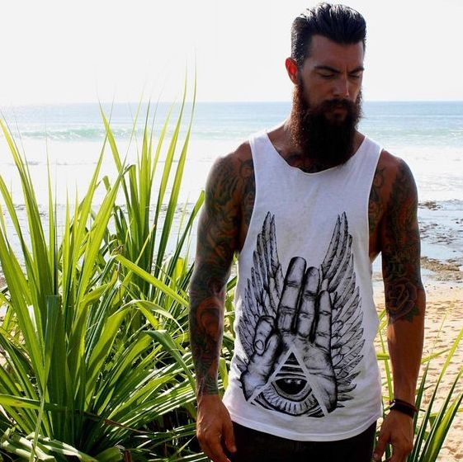
Felt like he may have possibly been the leader of the group at some point?

Pony Tail
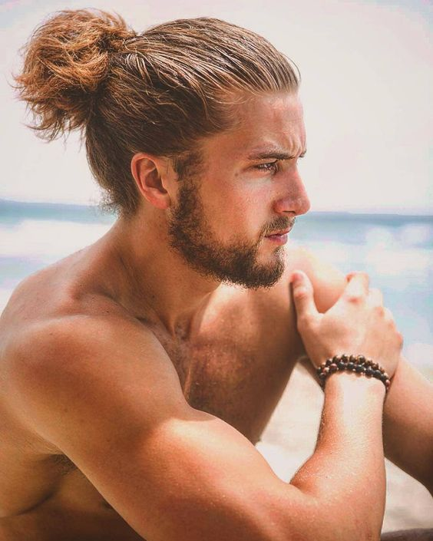
Likes to hum tunes.

Button Down


Crop Top


