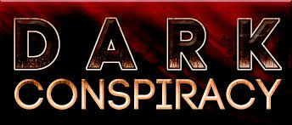

Chicago - A Cold Wind Blows
The Earth-side part of the dark_conspiracy: A Midwestern Moon campaign. Something is affecting the people of Chicago, and it's getting worse. Can it be stopped before disaster occurs?

Player Characters
Character Template

Player | Character | Codename | Description
Char | Mai Lewandon | Aurora | A good PI, who has developed very special abilities.
JP | Leonard Maxwell | Leon | Leo Maxwell, a young and headstrong DEA field agent with a strong moral compass (code of conduct).
Sabe | Janessa Iyer | Manx | Blight farmer and community defense organizer
Char | (Real name unknown) | Astra | Ex Delta-7
Andrew | Peri | Peri | A talented hacker
Pete | William "Old Bull" Lee | Quincy | Exterminator, drug connoisseur, and conspiracy theorist
Lee | Math Cornish | Antic Rash | Movie theater ticket ripper and black-mask anarchist/activist
Aaron | Alex Raiss | Deco | TojiCorp reporter.
Kirk | June Forte | Red | Research engineer, partner of the Professor
Chris | Ezra Hawthorne | Sloyd | A folklore student and radio show DJ.
Daumantas | Fred M. Lane | NA | Statistician with family problems looking into disappearances at his old employer.
JB | Maxine Moretti | Max | A youthful courier/errand girl for the mob.
Chris E | Cas Vandal | NA | A curio shop owner who gets calls from the dead. On phones.

Non-Player Character Profiles
Not a few NPCs have been shuffled off this mortal coil. To see the list of those who are no longer amongst the living (or even pretending to be), see The Graveyard.
By category:
- General NPCs - characters related to the PCs outside of the Underground
- Case of the Missing Girl - Mai's first (and still unsolved) case.
- Empathic Underground - the members of the group dedicated to fighting the darkness.
- Order of the White Circle - an order of sorcerers who had become corrupted, and are now largely defunct.
- The Destined - known members of the Destined, and those they've affected.
For an overall list of NPCs click here. This will not be updated going forward, and so the data on the page should be considered obsolete.

AP Notes

Synopses
- Synopsis 1 - play from spring of 2015 through spring of 2016.
- Chicago Synopsis 2 not yet written (need to go back to IRC logs)
- Synopsis 3 - play from Sep 2017 to Dec 2018.
- Synopsis 4 - play from Jan 2019 to Jul 2019.
- Synopsis 5 - play from Jul 2019 to present (incomplete).

Investigation Stubs
Ask the GM if you need more details on any of these.

TojiCorp/Serpent Folk Issues
- Check the basement of the Toji PR building to see if anything from the Fae world was left behind
- Follow up on finding the parents of the three metal boys whose parents are Toji execs
- Talk to the folks at the lab near Rush Medical center about the bio-computer
- Look into the COO of MAXDigital, rumored to know about the bio-computer deal parts deal with Toji
- Break into, or bribe your way into, or otherwise infiltrate the CCEHV
- Find the Toji CEO Tohiro McMasterson, who seems to have disappeared
- Talk to Ezra's mom about her last lead
- Go back to the airfield to snoop around, or take a snake-person for interrogation
- Figure out what BioChem is doing in the SoDeer marsh factory

PC and NPC Issues
- The upcoming meeting with conspiracy elements high up in the DEA (Leo)
- Check out the Vishanti facility in Burr Ridge (Alex)
- Perform more experiments at the Center for Synchotron Radiation Research (June)
- Break in to use the accellerator at Argonne National Laboratory to perform the special experiment thought up by June and the Professor (June)
- Checking in with the kids and unicorn on the farm, and checking on the weak inter-dimensional spots Faith left.

Rumors and Follow-up
- Craft Bar neighborhood: dimensional paintings by the Prophet, and the things that live under Union Cemetery Memorial Park
- Where did the thing from under the cemetery end up?
- Return to the scene of Lt. Rodriguez's attack, or grill Sahashradala about it
- Investigate Masters's lake shore home
- Find Matt, the were-bear (brother of Ann, the wear-bear killed in the park), before he finds them
- Return to the Black Chamber with promised goods
- Return to Axe's Kids for more leads
- Alien in Skokie
- The Airborne Type Two Anthrax (ATTA) epidemic
- Analyze the data from Darcy connecting to Judy, or do further experiments

Details
- Rosa's Emails
- The Buzz
- Ancient Egypt
- Jacob's Description of Life as a Ballotman

Danger Clocks

Active
- The Buzz 1/6
- Snaky Airfield 1/4
- Something Lurks 0/4

Defunct
- Sorcerous Ritual 0/5 - threat eliminated with the destruction of the mummy at the field museum
- The Bog God 0/4 - threat eliminated with the detonation of the Fuath at Volo

Visual References
Chicago downtown dreamlands skyline:
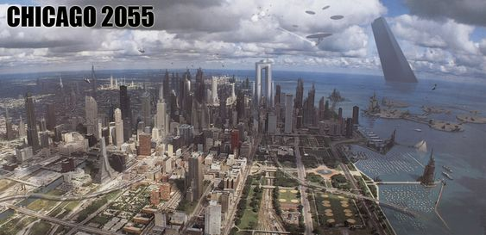
Featuring the TojiCorp North American headquarters off in Lake Michigan to the upper right.

Visual Tours
- General Visual References
- The Base
- CCEHV
- Doomsday Club
- Otherworlds
  - The Changing Lands
  - The Black Chamber
  - The Fae Realm
  - Cheeseburger Paradise

