The club is entered by going down a stairway from the Chicago Club's lobby. The stairway spills out into a dining area:
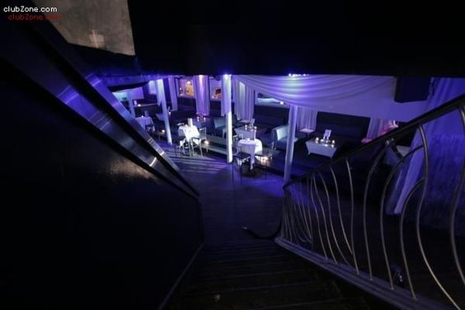

From there, one can skirt around the second balcony up from the dance floor on level 3 below to the Tropical Room:
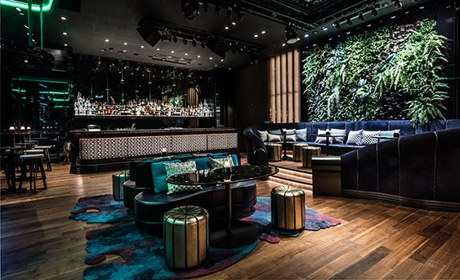

There is a stair from the the balcony on the first level to a bar on the middle balcony:
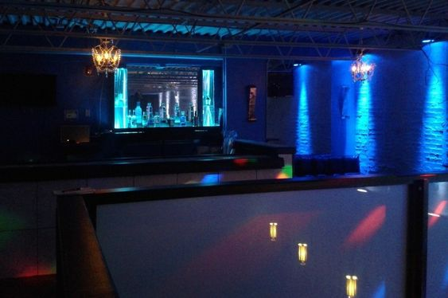Mr. Humbert, AKA Belial, likes to meet people at this bar.

The main dance floor of the club:


The Blue Lounge, a side lounge off of the dance floor, across the way from the Aqua Room:
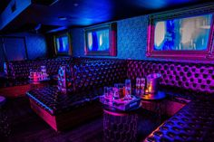

The Aqua Room, where Sahasradala tends to hang out when he is present:


