Images of Dreamlands
Pictures of dreamland areas from around the globe.

North America

Lower Manhattan Arcology Complex
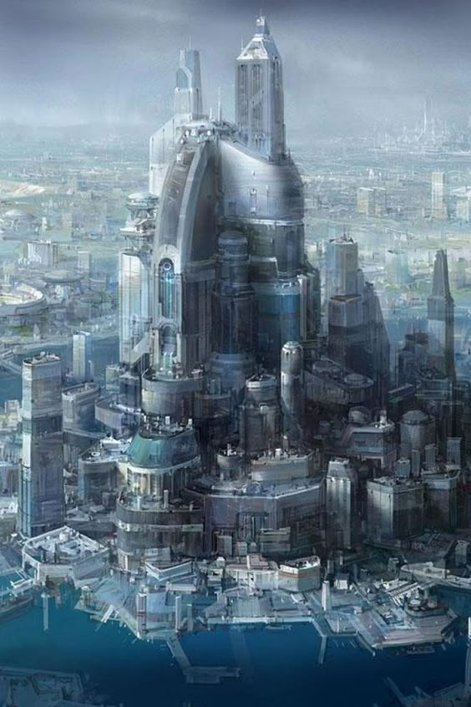

SanFran Arcology
On reclaimed land from the San Francisco Bay
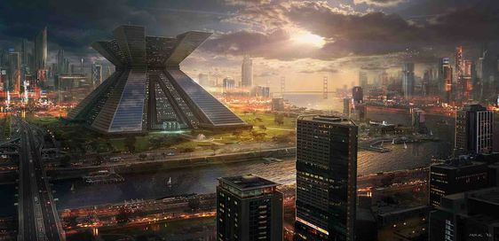

Europe

Barcelona Corporate Aquatic Park
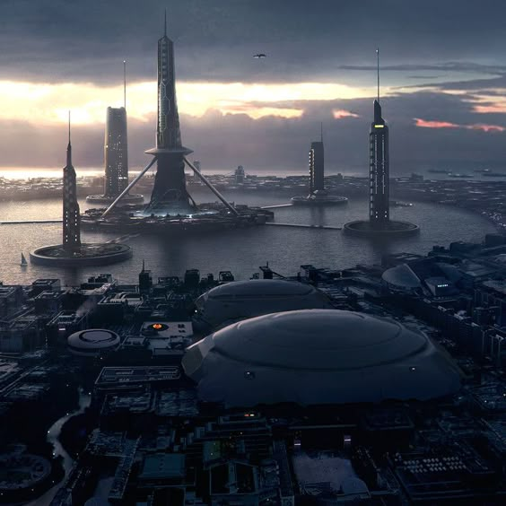

Asia

Shanghai
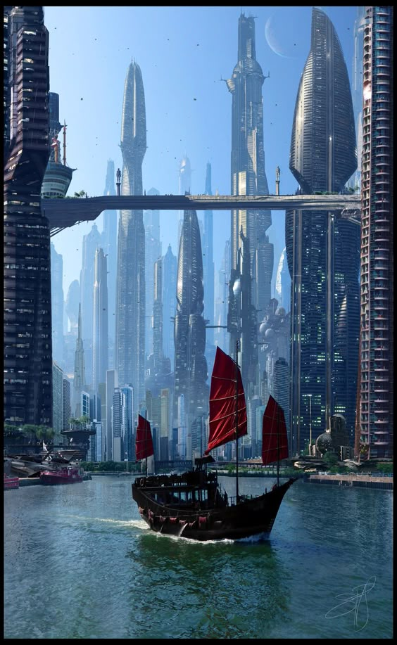

Chongquing
Yangtze Tower
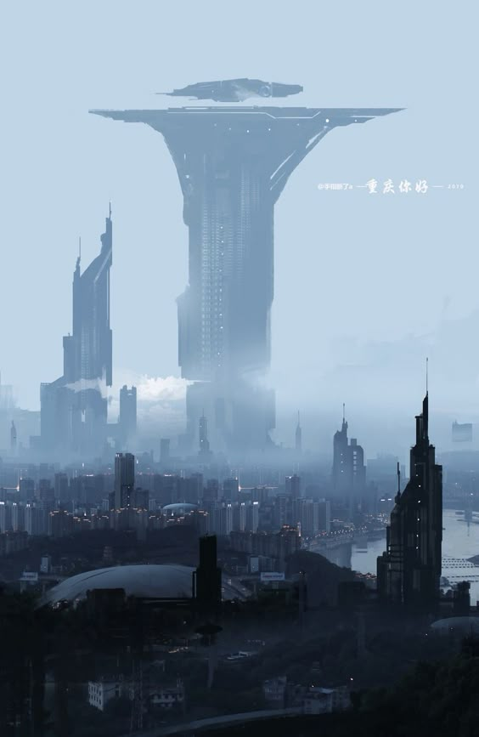

Tokyo
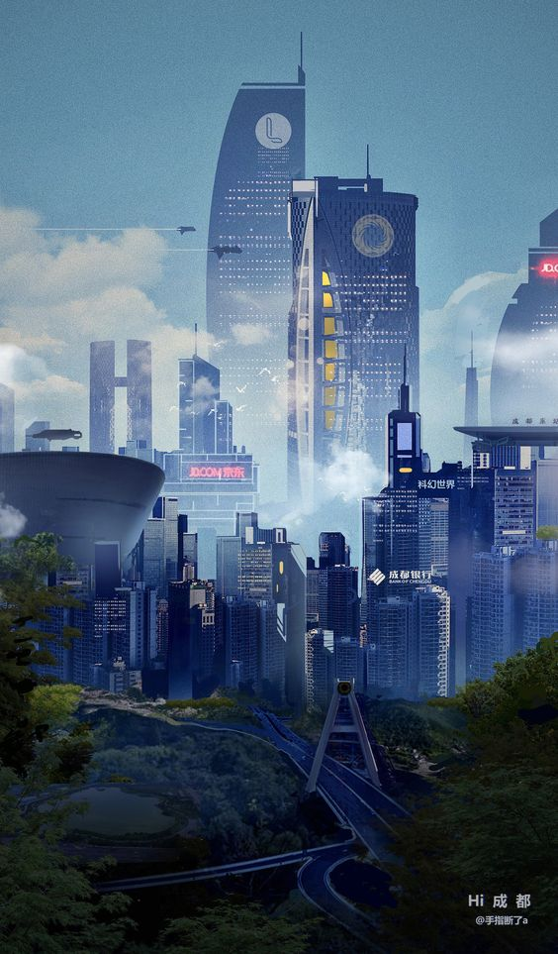

Mideast

Dubai


