"Snapshot"
Code-name of the closest thing to a leader the underground had, she now left the underground for some reason, recommending to the Underground that Leo be put in charge in her absence. Clearly a medical professional (likely a doctor), she is also pretty talented with her submachine guns.


"Beta Three"
Code-name of a member who seems to specialize in security, possessed of an arm of alien manufacture. He revealed to Mai that he's a member of an organization named Delta Seven, who he claims have an extra-dimensional base.


"Benny"
Code-name of a psion member who approached Mai to train her.
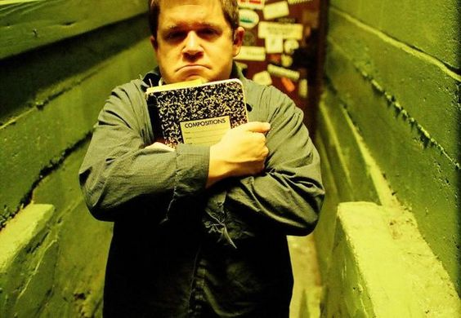

Doreen
Code-named “Veronica,” Doreen is an elderly mystic who approached Mai after Benny, and introduced everyone to the underground. As of late, Doreen has been pretty fatigued (in part as a result of a few problematic attempts to empathically heal some people) and she's showing her age.


"Axe"
Code-name of a burly shotgun-toting biker member. Axe likes to take trophies, including an ogre that he had to shoot with his shotgun many times to bring down; it is kept in an old sensory deprivation tank filled with preservative.
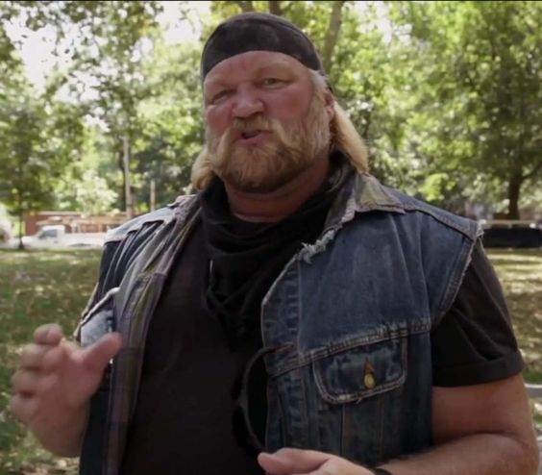
Axe's favorite toy:
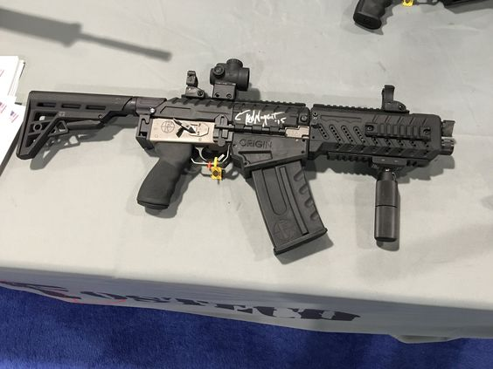

"Darcy"
Axe's daughter, cyborg escapee, and freelance freedom fighter (depicted as first seen, all shot up). Leo lead her to the underground, which Axe had been keeping a secret from her. Her relationship with her father is strained, as Axe is far from comfortable with her being a member of the Underground. That said, she's probably easily the most potent of the Underground members in a fight due to her numerous enhancements.
As Leo first saw her:
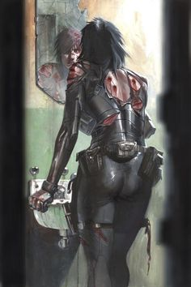
Cleaned up back at the base:


"Loris"
Code-name of an Asian male member who was nearly killed by the long-armed monster (later determined to have been a “Morrigan,” possibly the same one that Ariel Tanaka tried to summon at the industrial park showdown) that hitched a ride under the van to the base.


Dr. Pahail Farouk
Code-named “Faith”, a formerly missing empathic member who was co-opted by the “Bog God” of Volo marsh. It's clear that Loris has a relationship with Faith.


"Felix"
A small anglo guy with an officious manner who usually keeps quiet and isn't often seen at the base.


"Panix"
Code-name of a sorceress “affiliate” of the underground. Former member of the Order of the White Circle, and now a member of yet another order.
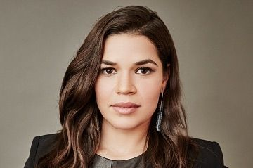

"X"
The “Grey” alien that the underground has retrieved from the Union Memorial Cemetery near the Craft bar.


Delphine
Owner of Delphine's books, and a talented sorceress. Like Panix, not technically a member of the underground, but one who is becoming more and more sympathetic. Involved in a burgeoning relationship with Ezra.


"Professor"
Code-name of a member who seems to be missing or on sabbatical, who apparently had an interest in some aspect of dimension walking.

The Van
An important member of the team. Got very beat up over time.

Replacement van stolen by Ezra when it was filled with dead dogs in plastic bags.


