Car Mai saw in her dream below the street outside of Cas' shop:
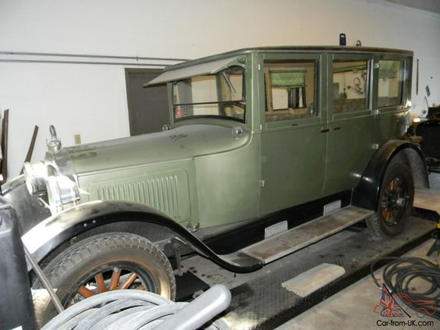

Chicago Department of Public Works (DPW) sewer workers:


