Name: Mai Lewandon

Attributes
- Str: 2
- Int: 7
- Agi: 6
- Con: 2
- Edu: 3
- Cha: 6
- Emp: 5
- Wil: 4

Skills
- 6 Persuasion (12)
- 3 Act/Bluff (9)
- 9 Small Arms (15/20)
- 3 Stealth (9)
- 6 Observation (13)
- 3 Computers (10)
- 1 Customer Service
- 2 Business
- 1 Urban Survival
- 2 Streetwise
- 7 Cool (11)
- 1 Good at Killing
- 3 Woodworking
- 3 Gambling
- 3 Human Empathy (8)
- 3 Foreboding (8)
- 2 Wind Sorcery (7)
- 2 Dimension Walk (7)
- 1 Mental Shield (6)

Gear
- 5 My favorite gun
- 1 Tranq Gun
- 3 Citadel Whiskey
- 1 lucky dice
- 3 Untraceable Cell Phone
- 2 Office computer
- 5 Surveillance equipment
- 5 Untraceable white van
- 5 Gross Fish Slime

Contacts
- Tech whiz who fixed her phone. His hacker alias is Perplex.
- Beauregard - The shady guy who always used to hang out outside the corner store, but was actually pretty nice
- The Security Coordinator at the Mega Mall

Hinderances
- 1 Bite Taken Out of Left Shoulder
- 1 Changing Lands Curse
- 1 Kids are scary
- 1 Dreams of Bees
- 1 Scratches
–
- 1 Passion
- 15 empathic crystals
- 4 empathic dice vs Janessa
- 6 empathic dice vs Faith

Careers
- Background: Urban
- School: Got her PI License online
- Private Investigator x 2
- “Security officer”
- Corner store

Bonds:
- Max - My CI
- Fred M. Lane (FML) - Drinking Buddy whom I met while investigating on behalf of his ex wife. He knows I'm a PI, but doesn't know his wife once hired me.
- Grew up: Urban. School: Got her PI Cert online. Careers: Private Investigator

Sex: Female
Background: Mai was a good PI, working cases that slipped through the cracks or just weren't big time enough for the police. Everything changed one day, when she got a package delivered by an anonymous person when she was walking home one night. She opened the box, and inside was just a simple, yet intricately folded, origami flower. That spoke to her, in her mind, about the “Empathic Underground.” And now she can hear people's thoughts and feelings. ALL THE TIME.
Things that should not be seen: There's a drug people have been taking that makes them happy (and also compliant, so it's encouraged by the corps) but the people don't seem the same afterwards, they seem to be changing… into something else, on the inside. Their brains don't feel the same as non-users.
Description: Mai is on the shorter side of average, with long black hair tied in a ponytail beneath the aforementioned hat. She holds herself with a wary confidence, the fingers of one hand dangling from the edge of the pocket of her leather jacket, the other on her hip. Her keen eyes flit around, taking in the scene, assessing the place for danger.

Links
Main:\\ Campaign Overview - Chicago: A Cold Wind Blows:
https://wiki.wishray.com/doku.php?id=chicago_-_a_cold_wind_blows#details
http://wiki.wishray.com/doku.php?id=chronica_insidea
https://wiki.wishray.com/doku.php?id=dark_conspiracy:setting
ThisOneTimeAtFaeCamp
Cases:\\ The Buzz:
https://wiki.wishray.com/doku.php?id=dark_conspiracy:the_buzz
The Missing Girl:
https://wiki.wishray.com/doku.php?id=dark_conspiracy:case_of_the_missing_girl
NPCs:\\ Order of the White Circle:
https://wiki.wishray.com/doku.php?id=dark_conspiracy:order_of_the_white_circle
Empathic Underground:
https://wiki.wishray.com/doku.php?id=dark_conspiracy:empathic_underground
General NPCs:
https://wiki.wishray.com/doku.php?id=dark_conspiracy:general_npcs

http://wiki.wishray.com/doku.php?id=dark_conspiracy&#char_s_character_-_mai_lewandon
Mai's Mug:
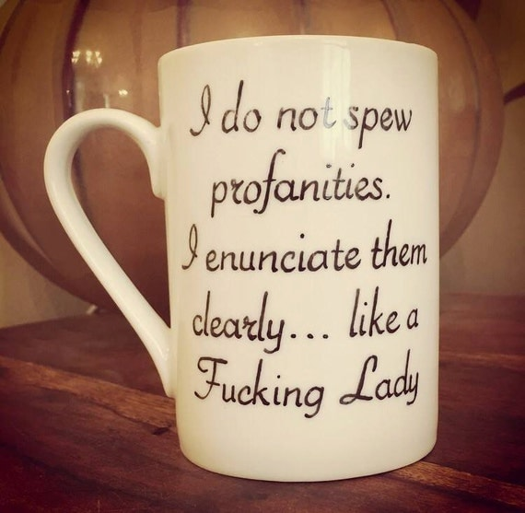
Mai:
Mai's (very overdue) costume-shop dagger: 

