A now largely defunct organization, as most of the members below are dead. These empaths all studied sorcery (mostly with a psionic bent). Panix was once a member of this order, but left when she felt they were starting to become corrupt.

Eli Caldwell
Sorcerer (from the mystic tradition) that had created an out of control Tupla, who was rampaging all over the city, and stalking Max. Now dead.
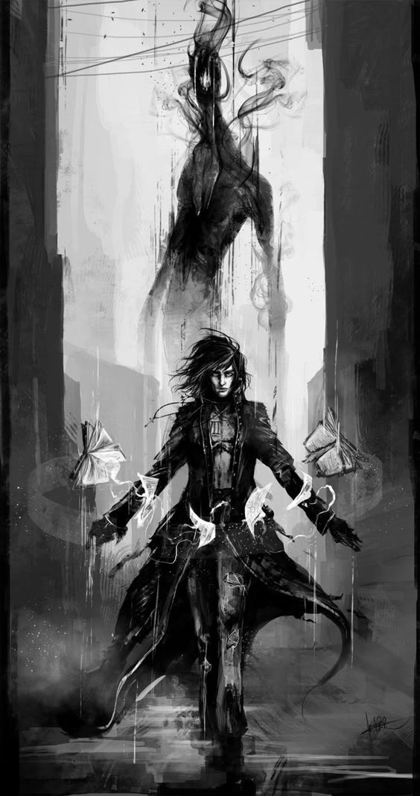

Spenser
Sorcerer who was looking for something in Eli's apartment. Later tried to recruit Mai. When Leo and Mai followed him through a graveyard, he escaped. Later defected to the Underground to avoid Ariel and Brenna (see below).
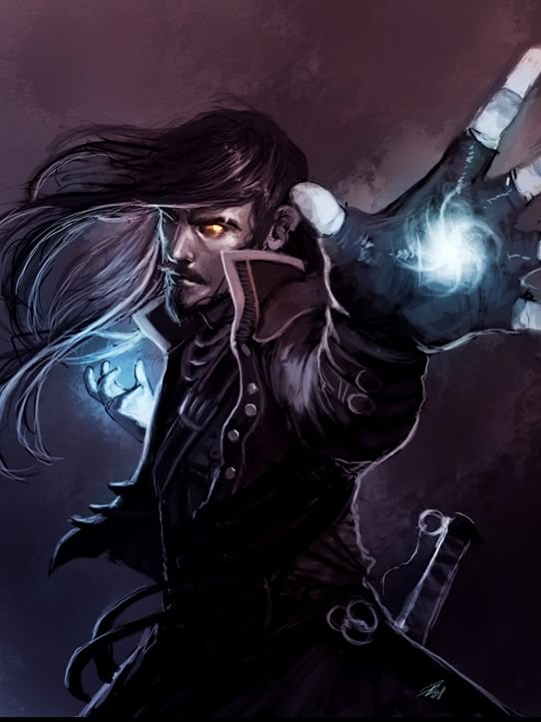

Ann & Bersk & Matt
Werebear associates of the society, killed in Union Memorial Cemetery when Leo and Mai followed Spencer. Her lover Bersk is also a member of the Order and a were-bear who was killed at Delphine's. Matt is Ann's brother, and not pleased about his sister's death.

Ariel Tamanaka
Leader of the Order of the White Circle. Rumored to be heading up a project to summon a demon and usher in some sort of new reality. Deceased.
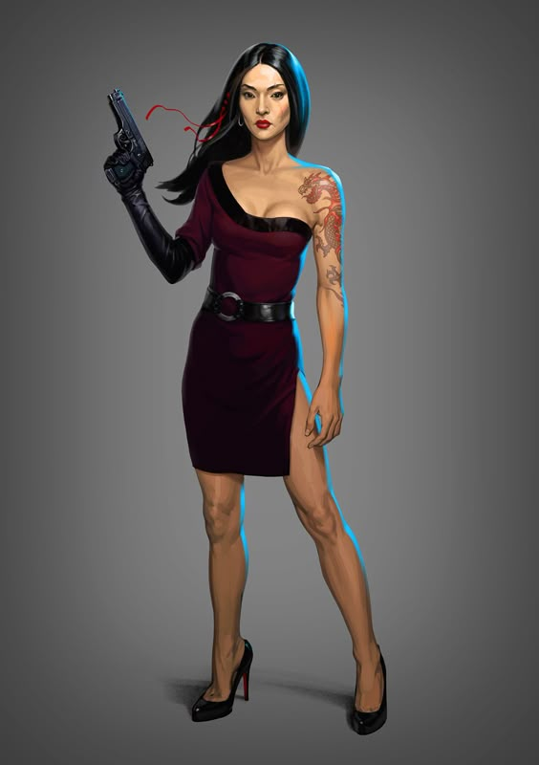

Masters
Rodrigo Masters is a sorcerer involved with Ariel Tamanaka in their current summoning project. Also an “Adept,” a member of the The Destined. Deceased.
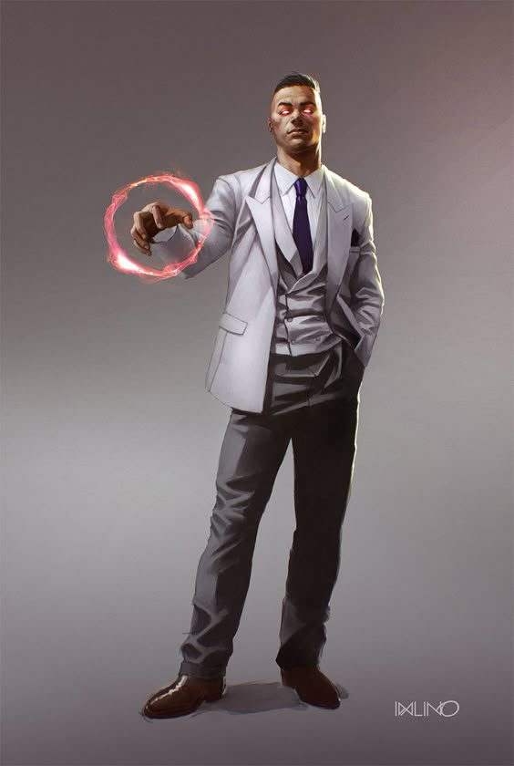

Alicia
A Dimension Walking expert, Alicia can teleport. She likes video games.
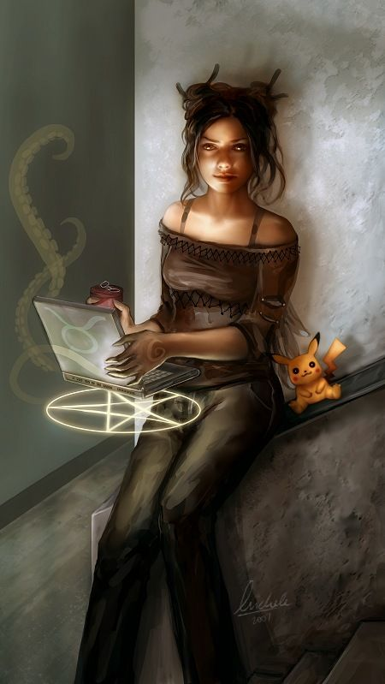

Franklin Sophretes
A wind sorcerer, and ladies man.
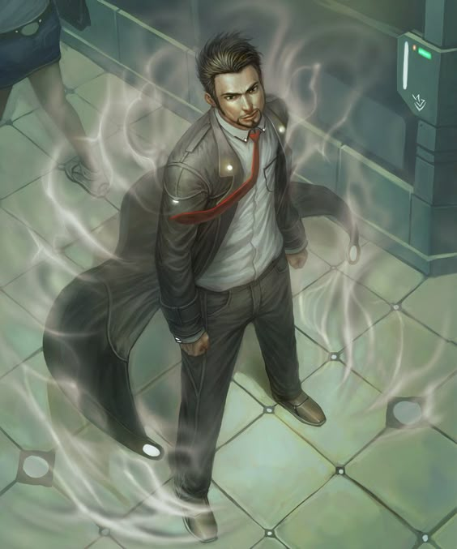

Lena
A sorcerer that deals in symbols that hang in the air.
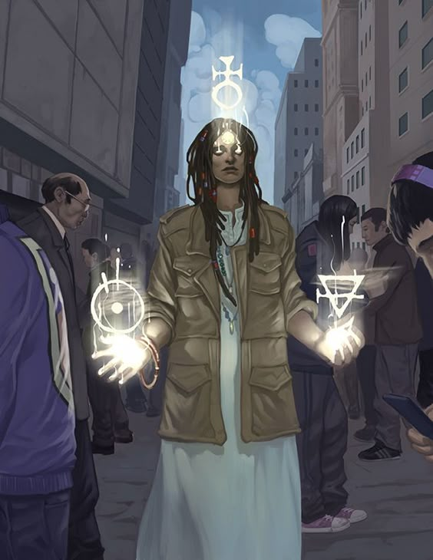

Moorman
The de facto leader of the Order after Ariel's death.


