Setting of the Dark Conspiracy
Welcome to the purgatory that is late 2055 in the USA, coming off of yet another record-setting summer of blistering high temperatures. Off on the horizon, something seems to be coming… How long can this go on?

History
Starting in the 2020s, there was an event known as The Greater Depression that made The Great Recession look like a picnic. Worldwide. Desperate for economic stability in the USA, the populace handed over control of said economy to the corporations by enacting a law that allowed people to sell their votes in 2035 (standing on the shoulders of laws from the late 2020s and 2031). Corporations soon after purchased large enough blocks of votes that they control the legislatures. In fact the federal government is a shadow of its former self, the constitution having been made a shambles. In any practical sense civil control resides with corporate interests.
They said they could fix things. This has not turned out well.
The many who have sold their votes are referred to as Ballotmen, and often their recompense is a lifetime of “free” corporate housing, food (reports of quality that leak from inside are not appealing), paper clothing, and television. These unfortunates have lost any semblance of a political will. The rest may speak, but are easily outvoted.
The corporations, having nothing to hold them in check, are close to waging open warfare between each other, all while advertising that nothing is amiss, the world is a paradise according to them.

Urban Areas
The vast majority of the population of North America lives in urban areas now, creating intense population pressures.

Dreamlands
The corporations excuse any behavior that some might complain about by pointing to the paradisical enclaves they've built that do house millions, usually in large urban centers. Over the past 30 years they have barricaded themselves in, along with enough population to serve them, while leaving most of the rest of the world to more or less fend for itself. These enclaves are referred to as Dreamlands by those who live outside, and dream of one day being let inside to the comfort behind the walls.
Inside the Dreamlands
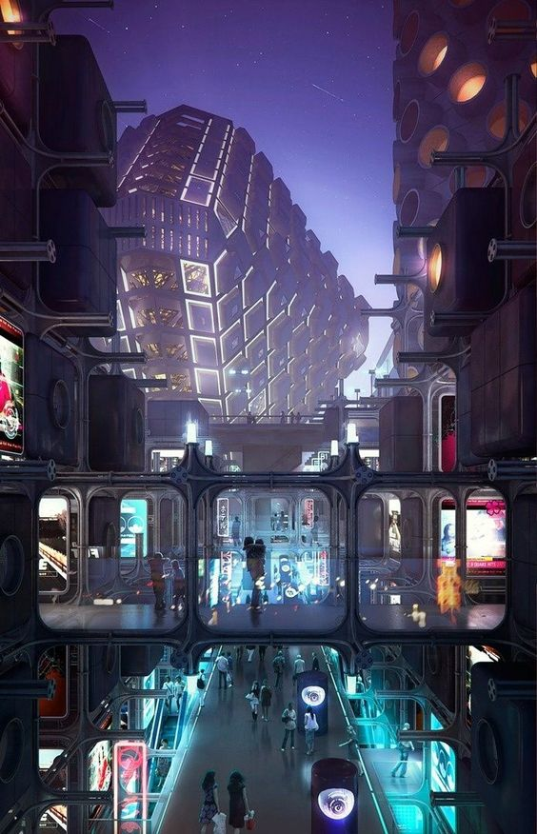 Inside the Dreamlands
That said, while those who find themselves fortunate enough to be employed by a corporation or subsidiary that results in them having a job inside the walls, the vast majority of these have to struggle to remain. Resulting in a level of services and lifestyle no better than the middle class had at the beginning of the century, if even that. Only the rich are really well-off, even here.

Example: Chicago Dreamland
Chicago boasts what it claims is the largest and most populous Dreamlands around its downtown area, and the shores of Lake Michigan north and south of it. The ring around these areas (mostly in what remains of Chicago proper outside of the Dreamlands) is somewhat civilized, as the corporate control extends a ways beyond the walls, and there is a need for some of the products and supplies from these areas.
This Dreamlands was built by a coalition of corporate interests, but TojiCorp was the leader in the operation, and their western hemisphere headquarters was built just a ways off the shore.

Other Dreamlands.

Outside the Walls
Outside of the dreamland walls, in the rest of the urban areas, the competition to get inside the walls is even higher than the competition among those already inside to remain. This is one of the only drivers that keep things from devolving into pure chaos; people know that they never let in anybody with a record as a miscreant.
Populations have been drawn to the dreamlands like butterflies to flame, creating intense population pressures around the dreamlands. Corporate arcologies of dubious construction house masses of white collar folks striving to look like they belong inside the walls. Few make it. The less fortunate often find ways to eke out a living, residing in shanty-towns or wherever they can… though when the going gets tough, many simply become ballotmen. Homeless populations seem to be declining, and the corporations tout this as one of their successes. But where are these people really going?
Clinging to the Urban Infrastructure
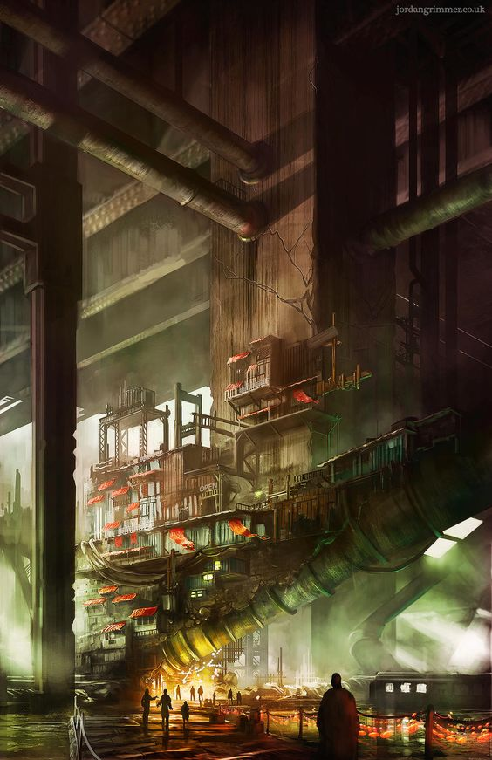
Adding to the pull of the dreamlands, lack of services (see below) including transportation (cars are a difficult thing to manage to own) and people flocking to city centers have resulted in the suburbs being largely abandoned. Shells of what were formerly the nicest parts of the cities, these zones still have scavengable material. As a result, crazed hermits and gangs of every stripe are a constant threat in these areas. Enter at your own risk!
Abandoned Suburb
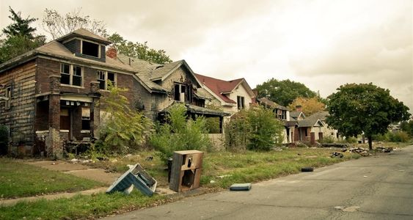

Technology and Services
Broadly speaking, technology available to humanity has advanced tremendously… but most folks don't even have the resources to get an internet connection any more (the infrastructure is attrocious). Where “internet” is available, it is a pale parody of what it once was, instead having all traffic go through, and be censored by, the local corporate-run ISPs. Where cell service exists, users assume that everything they say is monitored and subject to getting you in trouble if you kvetch.
Other basic infrastructure services have degraded to varying degrees dependent on the area. Outside of the dreamlands it's rare to find a place where every service is working fine. Some urban places no longer have garbage removal, and people make dumps out of parks. Other places may have really bad roads. Streetlights or the sewer system may not work, and electricity may be in supply only intermittently. In some suburbs there has been no maintenance done in 30 years and things are completely in ruins.
Only the very rich have access to any sort of technology that's beyond what's available in 2020. Most have technology more like the 1980s. In many places roads, streetlights, sewers, and other such infrastructre have had no maintenance for as much as three decades, leading to them being completely broken and unusable in many cases.
Railway Platform in Ruins
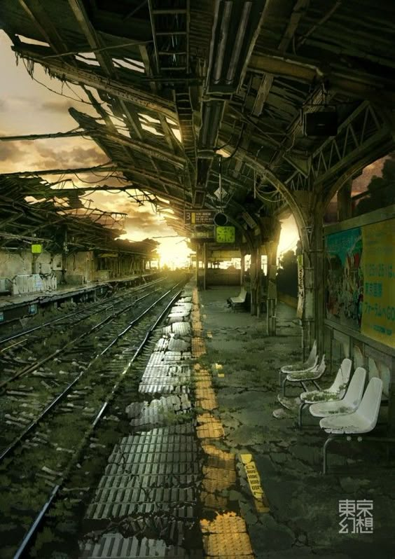
For the rich, however, even the sky no longer seems to be the limit. To whit, there are colonies on the moon where one can move if one has the wherwithal. A Mars colony is soon in the offing. Few who are not rich even understand what's possible, as those with these technologies don't bother to market them to those who can't afford them. Rumors that egotistical rich have clones of themsleves instead of children abound. Extensive cybernetic enhancement is possible, and every year new genetic manipulations become possible. Not only for curing diseases, but enhancing those few who can afford these things.
The Moonbase
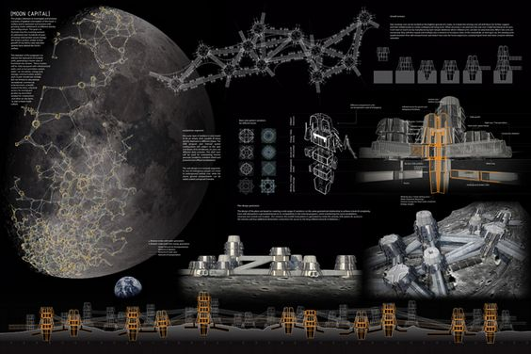 The Moonbase

The Rural Condition
Many rural places, like the suburbs, are almost or entirely abandoned. Often their population was at some point “saved” by removal to Farm Family Relocation centers, or simply forced to migrate to the cities by various forces. Or perhaps something else removed the former residents.
Rural places that manage somehow to survive, often existing in isolation entirely forgotten by the corporations who have no use for their distant and relatively tiny markets, have in some cases been thrown back to the 19th century or further. Few or no services we take for granted in 2020 are available here. Outhouses, and hunting for game as a profession are both commonplace.
Here law-enforcement is almost entirely ad hoc, where it exists at all. Warlord gangs of bandits are common, roaming between these towns, the corporations not at all caring, unless they encroach on the corporate farms.
Rare Clear Skies Over a Forgotten Town
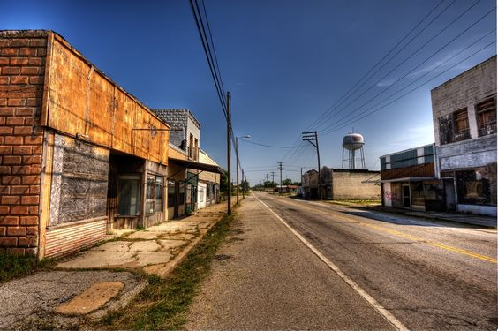

Environment
There are few regulations about pollution…. after all if you live in one of the beautiful old buildings in the Dreamlands or one of the new corporate arcologies, you have your air filtered. Unsurprisingly the environment is anywhere from bad to terrible wherever you go… like in Australia, for instance, where a limited nuclear exchange took place a few years back, and the few who haven't fled the continent have very short life-expectancies.
Parts of Africa have gone entirely dark, and nobody is bothering to see if they've all died or what is going on.
In the USA really blue skies are a rarity now. As are clear streams, woodlands that don't appear diseased, and areas that don't have dead spots. Wildlife seems to have vanished entirely in many places, though in urban areas, rats, racoons and other vermin flourish.
Mother nature, at least the version we like, seems to be on the ropes.
Automated Corporate Factories Making a Better World
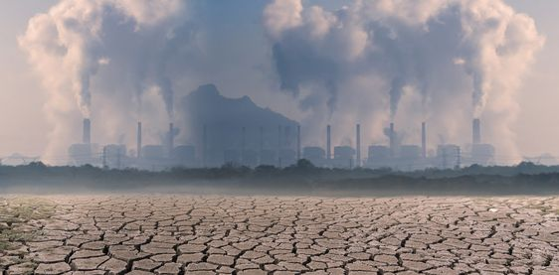

Attitudes
Everyone privately complains about the corporations, the lack of services or even products, and the crappy ecology…but few actually do anything about any of it. Many who do take action disappear. Those who look into disappearances are met with gutted law enforcement, the remainder of which either directly or indirectly work for the corporations. Some who ask also disappear. Few ask.
Most people just keep their heads down and try not to get noticed.
The cultural malaise that this all generates is in part due to the fact that the average person is inundated with messages from the corporations that things are fine, and if you just work a bit harder, you too can have the things that the rich folks in the Dreamlands have; not that anybody buys this, but everybody does buy that this is just the result of human nature and greed. Wouldn't you do the same if you had the chance? This attitude is what most folks think created the problem.
All Too Easy to Simply Despair
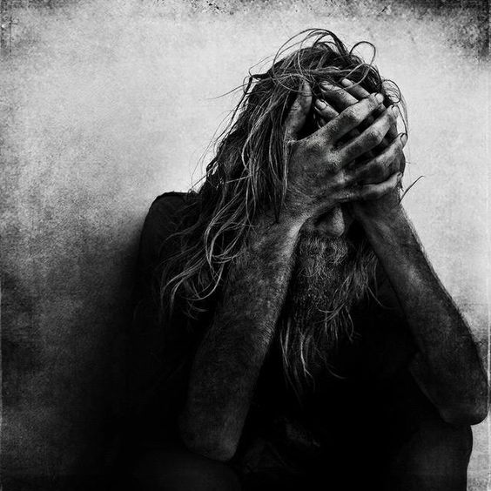
They're not entirely wrong, of course. But they're not entirely right either. They forget that things have at times been better. And they fail to question why things are so determinedly on the way down the tubes. And there seem to be things going on…
People are exposed to stories all the time that seem to be about aliens or supernatural things. Some may have a growing sense that it's not all nonsense. But like today, ask the average man on the street if they believe in Bat Boy and they'll tell you it's ludicrous. Most such reports of sightings and the like result in those making claims being discounted as loonies.
Those that are more credible tend to disappear, as mentioned above. Usually before the story gets far.

Your Character
Your character has to wonder about the state of things…because your character has SEEN something.
Something that nobody would believe if your character were to go around telling people. In fact, your character may have TRIED to tell people. But if they have, all they've met is incredulous stares and referalls to mental health professionals.
Having seen this thing, whatever it was, your character is about to take their first steps into a world they probably couldn't have believed exists, and… hopefully… is the sort that's willing to do what's right and take a stand for humanity.
Your character should have some sort of background that makes them competent or useful in dealing with this new reality… unless you want to REALLY challenge yourself and make somebody relatively mundane. Most of the mundane who encounter these things, just keep it to themselves and try to pretend for the rest of their lives that it never happened.

Kicking Ass in the Name of Humanity

