Arrival to the dimension of The Black Chamber is usually through this portal to what is mostly an arid region:
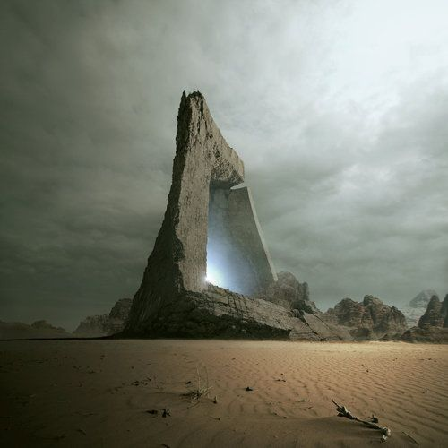

On the way to the depression, one might end up finding the forest of keys, which is the most lush place in the dimension:
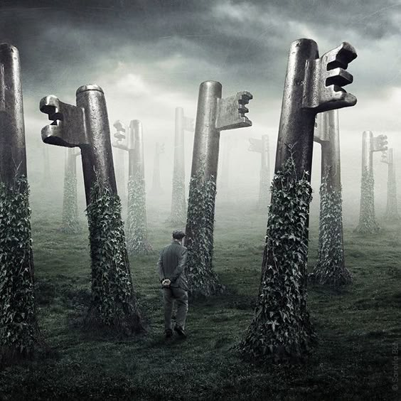

The vault of the chamber itself is located in a lake in a depression that one gets to eventually no matter which direction one goes:
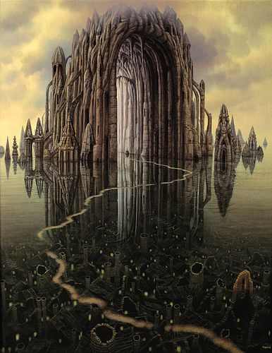

Entrance to the Black Chamber is only allowed to those who have passed the excruciatingly painful test performed by The Master of Balance:
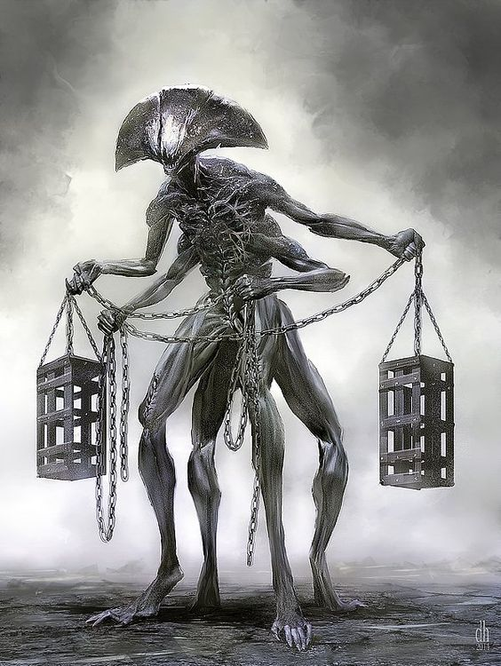

Inside one is often greeted first by this being who likes to answer questions and generally toady up to anybody who will talk to it:
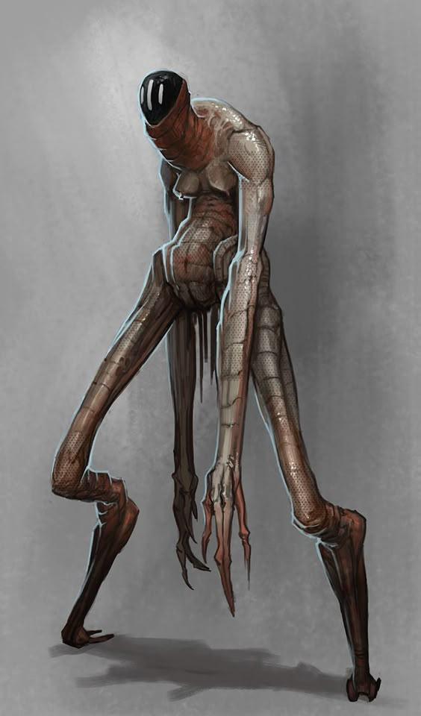
Its self-esteem is so low it doesn't even think to have a name.

The rules of the Black Chamber are related by the Seneschal, who will also answer some questions:
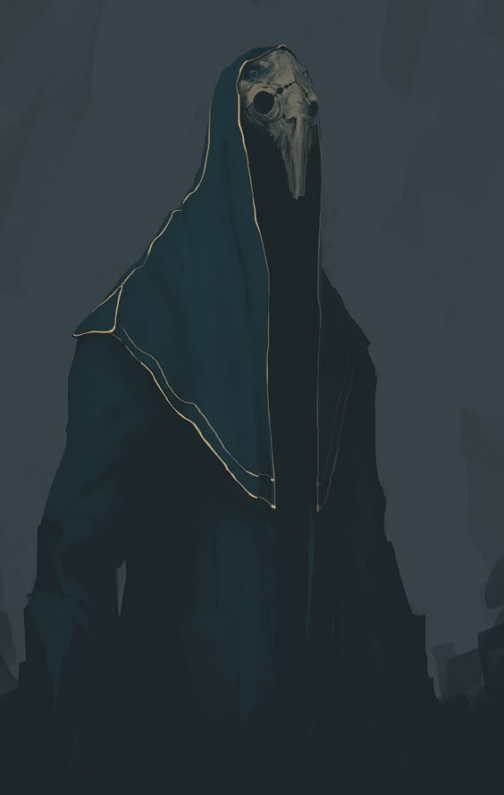

If need be, the seneschal can call upon this being to capture or kill miscreants who do not obey the rules, or follow decorum (or for whatever inscrutable reason):
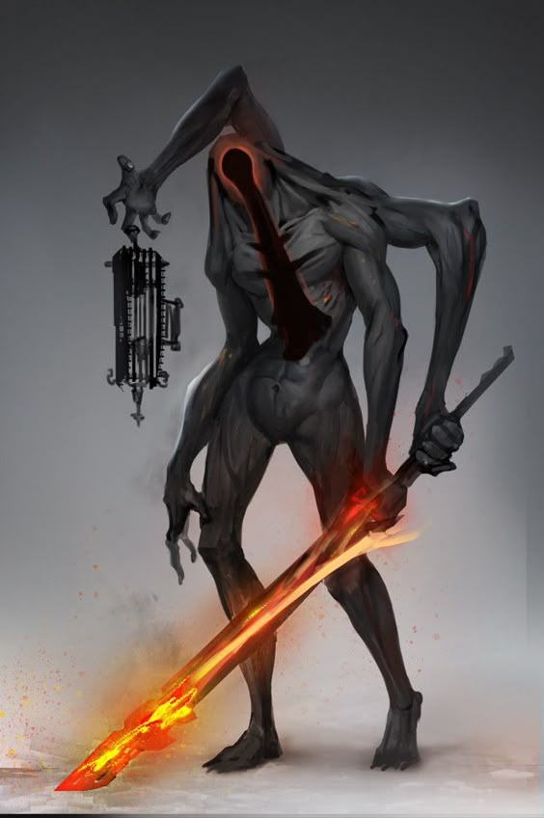
(For a sense of scale, consider that the thing it's holding in it's right hand is a cage that's big enough to hold several people. This thing might challenge the Lord of the dimension, were it not for the fact that it had it's brain removed to prevent just such a thing happening)

The Lords of the Chamber are likely to be inquisitive, but do not themselves like much to answer questions, or do anything, as they are catered to constantly:
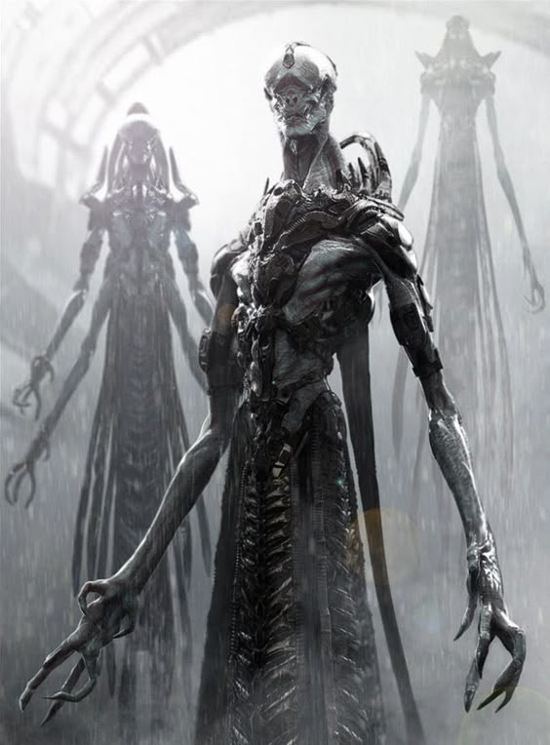

The Lords are entertained by the “singing” of the Maddening Choir, who have had their brains removed because they once deigned to think of heretical new things to sing:
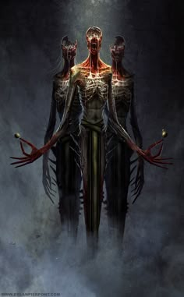

The Master of the Flesh likes to make deals to obtain flesh to work with:
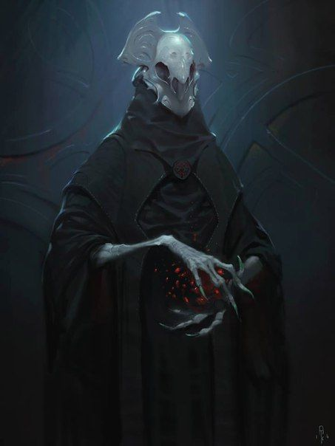

There is also a priest of an unknown god who is looking for converts:
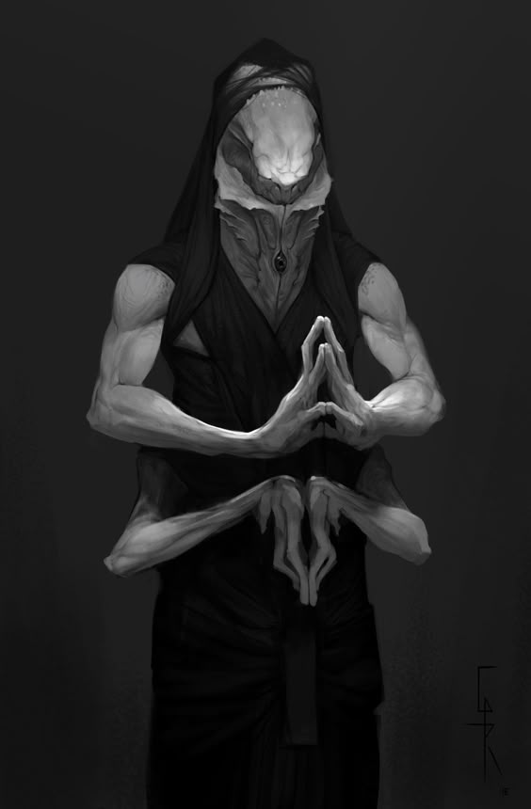

More members of the court, including the Fleshless One, who would like to get inside somebody and go to Earth:
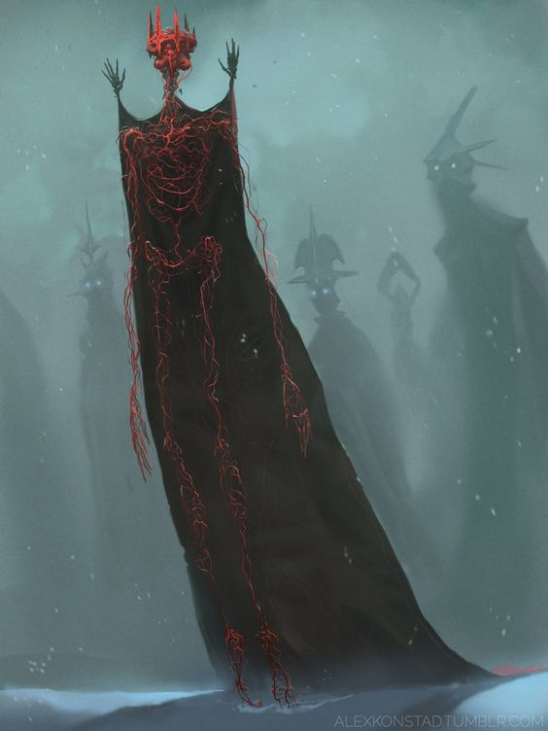

One of the most important entities of the Black Chamber, and considered to be the most beautiful in the dimension by the Lords, is the Empress:
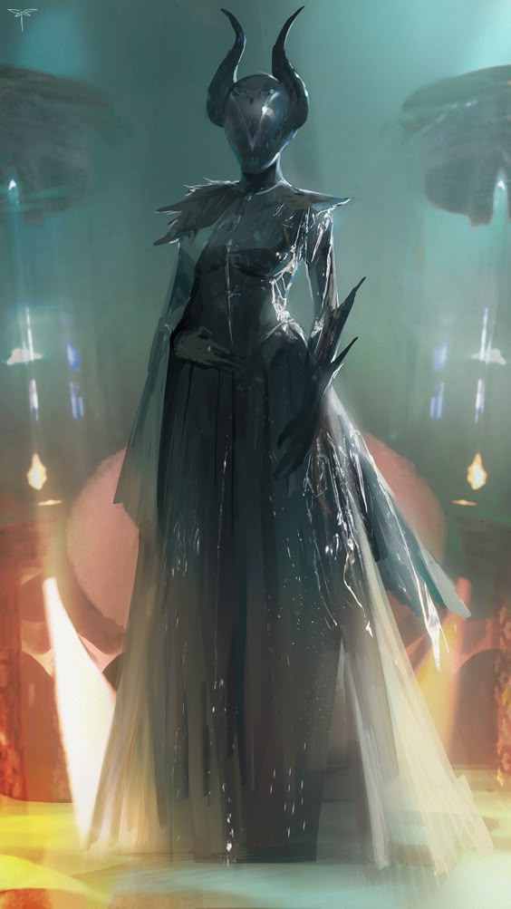

The Empress has a jester thing that she's had made for her:
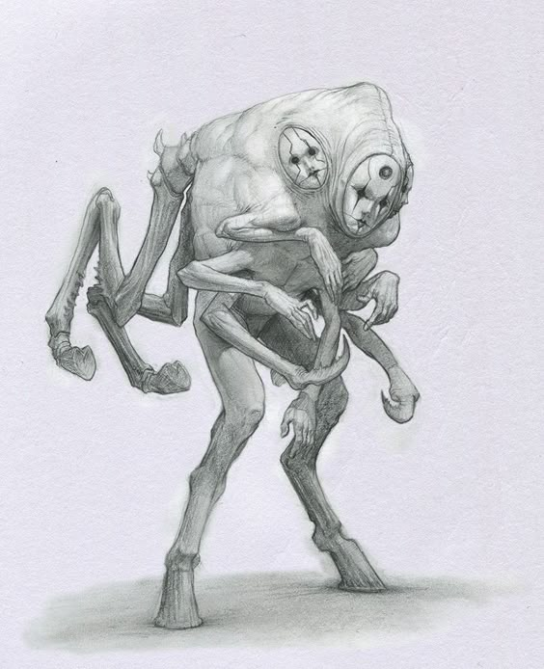

The ruler of this dimension, who usually deigns to stay back from dealing with interlopers, and this is seen only briefly in glimpses when the mists of the chamber swirl just the wrong way. His horns nearly brush the top of the vault of The Black Chamber, which is about 100 feet above. Much of the behavior of the denizens of the Chamber can be seen to simply be keeping things from becoming loud or noticeable, so the Lord remains in the dark.
The Lord of Lies: 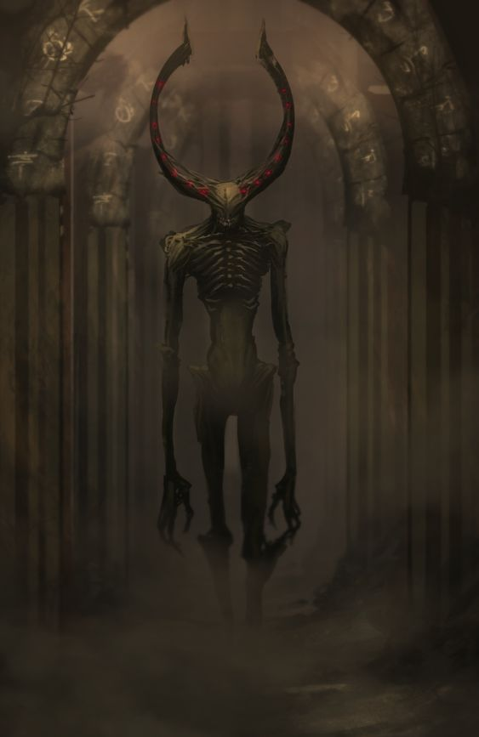

When one leaves the Black Chamber it's often “night time” outside, and the moons pour down fire into the lakes that one cannot reach.
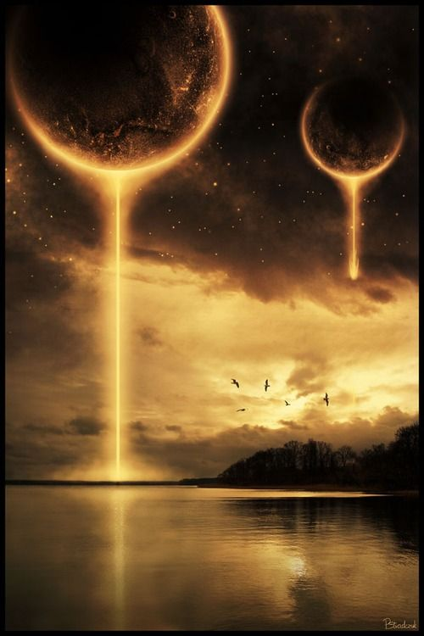

Far off, banished gods that feel like elder relatives of the Tall Ones hover in the sky and suck the life from many planets:


