These images were from Mai's first trip to the Changing Lands.
The painting created by The Prophet, which first made Mai aware of the existence of the Changing Lands:
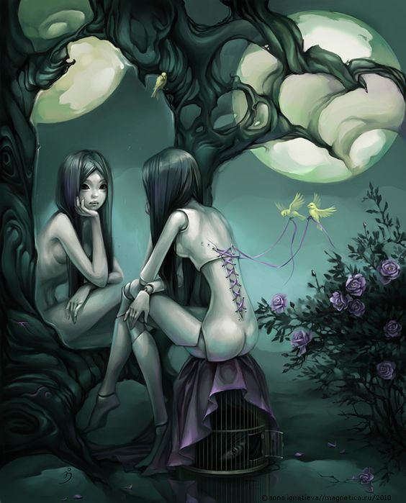
Castle near the lake where Mai splashed down:
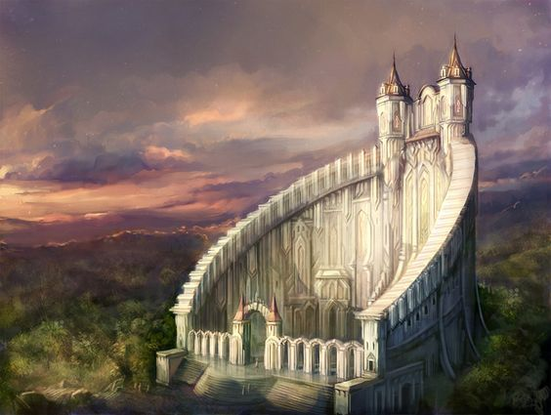
Strange flying things swooped at Mai, and she ended up flying to the top of some very odd “mountains”:
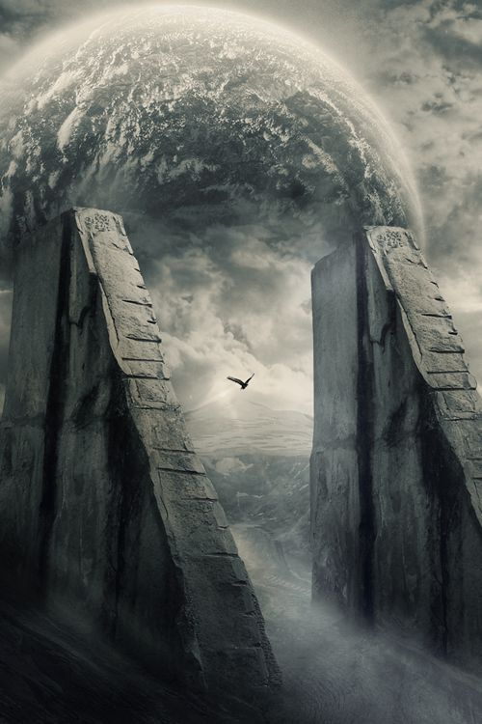
In a cave there she met a threatening being, but overcame it. Like most things in the Changing Lands, the below was but one of many appearances it took during their encounter:
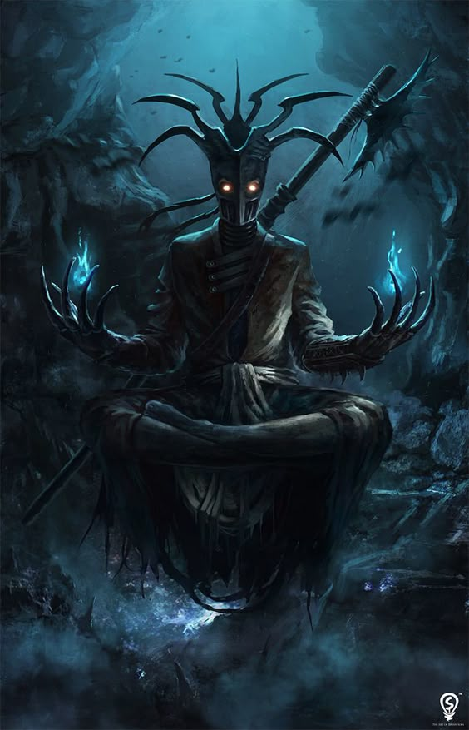
dark_conspiracy

