High Being of the Fae Realm, The Earth Mother:
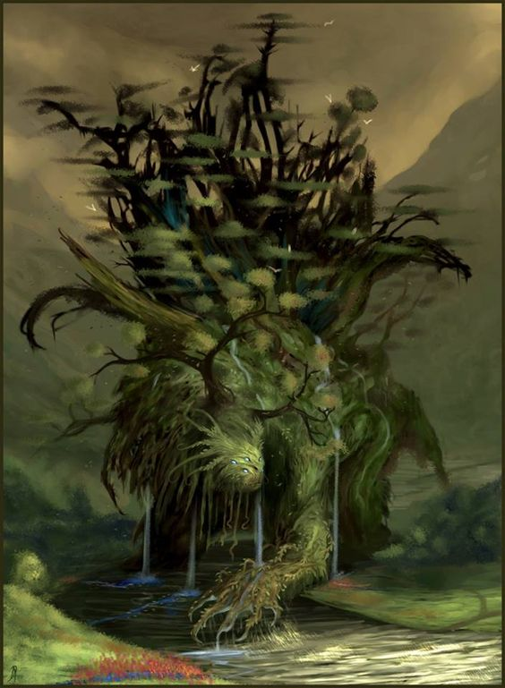
As seen in the interdimensional space below the TojiCorp PR building, Downtown Dreamlands, Chicago.

Ogre Escort
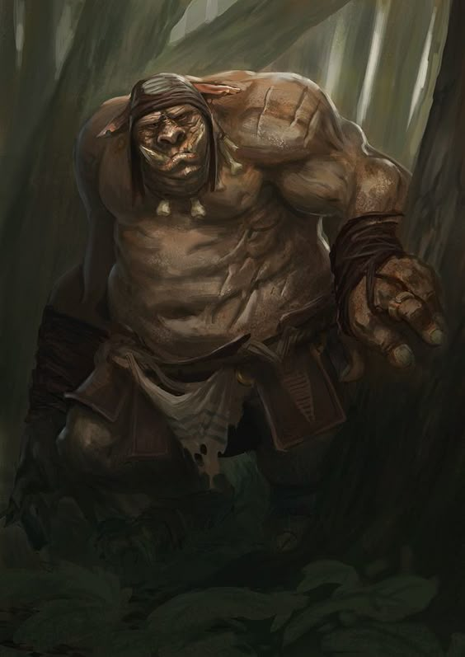
The ogre the elves set out with to escort themselves and Mai to their village.

Sons of the Earth Mother:
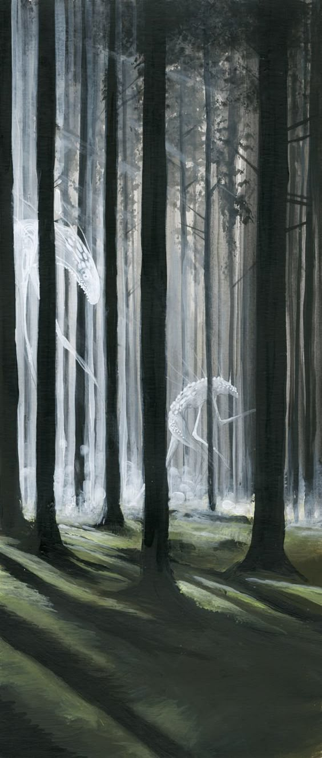
Phantom creatures that pulled apart the ogre.

Changeling and Unicorn:
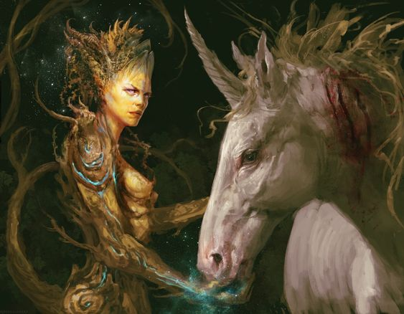
The changeling takes on a fair form to seduce the unicorn.

