High Being of the Fae Realm, The Earth Mother:
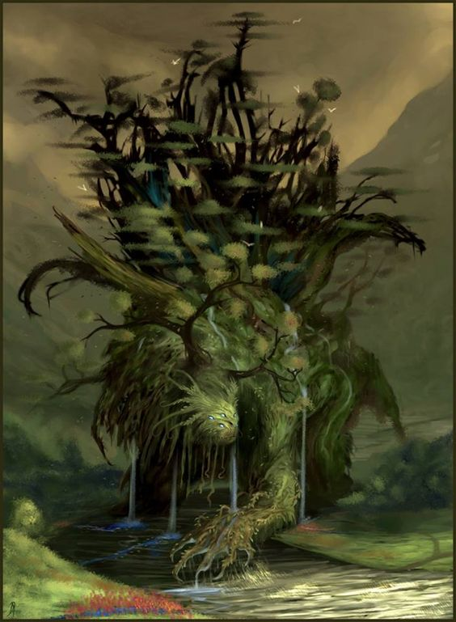
As seen in the interdimensional space below the TojiCorp PR building, Downtown Dreamlands, Chicago.

