Pipes: Skins: Default
The default skin of the client, created for The Game of Shadows by JasonP.

Modes
Modes for the fills of each zone
- Window = fill
- Bar = fill

Colors
Colors for the fills of each zone (set mode to: color)
- Window = A0A0A0
- Bar = 000000

Fills
Image fills for each zone (set mode to: fill)
- Window = 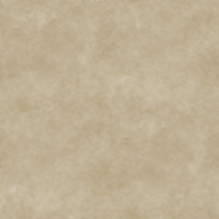
- Bar = 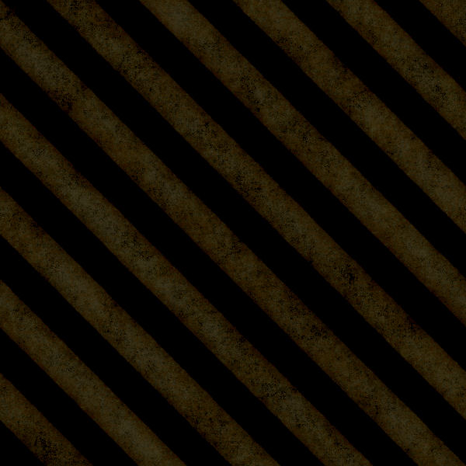

Fonts
Default fonts for each zone
- Window = droidserif-regular.ttf
- Bar = crystal_deco.ttf

Scaling
Scaling of the text for each zone
- Window = 100
- Bar = 100

Window Scheme
Color scheme of window text
- Shadow = 707070
- Foreground = 000000

Bar Scheme
Color scheme of bar text
- Shadow = 707070
- Foreground = FFFFFF

