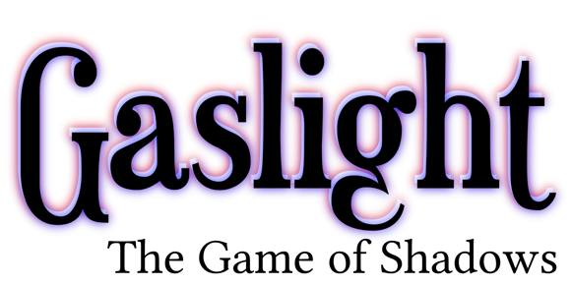

The Game of Shadows
The game of shadows is a roleplaying game created by JasonP with the help of Mike Holmes. Its can be played in either of two modes: offline or online, where the latter of which is backed by gaslight and science!.

