Baron Sabos Benbornt
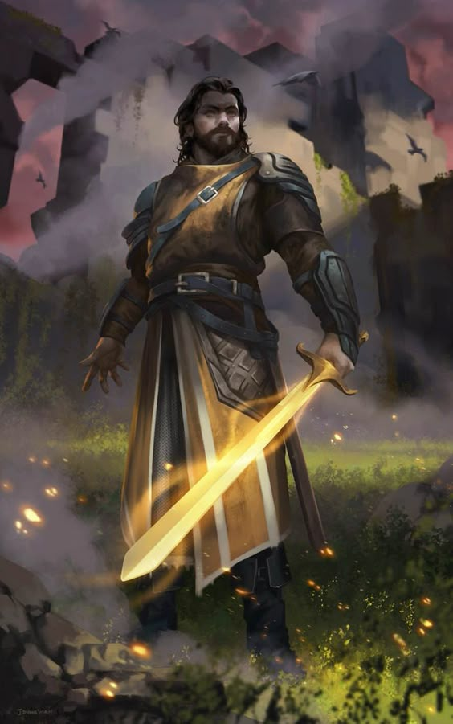
Benbornt has a Sheriff's position in this county because of the tension between the King and the Count of Abliqua. The King appointed Benbornt because he is a childhood friend of the Count. And so literally helps keep the peace here. Few Barons take the position of Sheriff, but the Benbornt family was brought somewhat low in previous generations when they were found to be demon cultists. To Benbornt's credit he takes the job very seriously, however, and tries to do as good a job as possible.

