Temple of the Four Faced God
This title refers to the organized religion that worships the Four Faced God at temples across several kingdoms (not just one single temple).
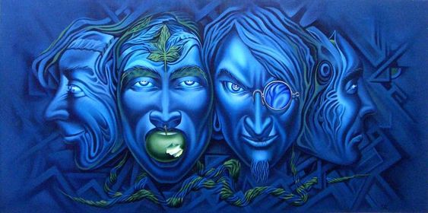

The Four Faced God
The deity this religion worships is a god that is something like an amalgam of four other gods combined, who each take turns as the dominant aspect. The Temples keep track of which aspect of the God is ascendant at any one time on calendars that are distrubuted from the Temple of the Four Faced God at Morghee Chasm, where the High Auspex communes with the God to determine the schedule.
Temple at Morghee Chasm
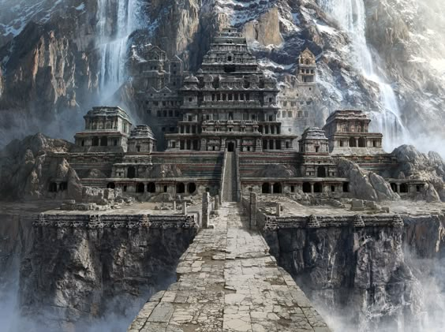

Aspects
Each of the four aspects of the Four Faced God have a single primary virtue associated with them.

Warrior/Courage
This is the aspect worshipped by most knights, especially those who belong to orders, which typically are promulgated by the temple. The warrior teaches courage in the face of evil that would destroy the temples.

Augurer/Wisdom
This is the aspect worshipped by the Priests, and other members of the temple heirarchy. the augerer teaches wisdom to know right from wrong, and the proper ways to commune with the heavenly host.

Homemaker/Devotion
This is the aspect worshipped by those that care for children and take care of households. The homemaker teaches devotion to family, lord and country, and the perseverance to see that the daily tasks of life are accomplished to sustain all.

Singer/Joy
This aspect is worshipped by most everyone else across the land. The Singer teaches everyone to accept their lot with joy, to create a more harmonious culture.

