The Inquisition
Known officially as the Grand Order of the Knights of the Inquisition of the Church of The Holy Square, this order of knights has chapterhouses all over Vopror and in other kingdoms where the people follow the religion of the Temple of the Four Faced God, who sanction this order. Generally their goals are to root out demon-worshippers and others who violate the dictates of the temple. To help achieve these goals, the knights of the order generally take a number of oaths to help them focus on their tasks, including vows of chastity.

Greylin Chapter
Below are the details of the chapterhouse just outside of Greylin, located just off the road that follows the river inland from Greylin.

Knights

Captain Romuntow
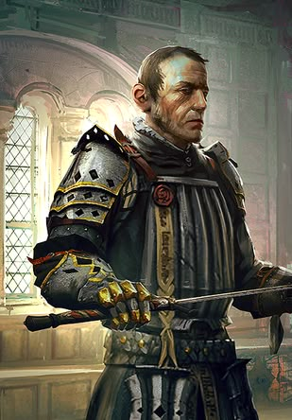

Lieutenant Sanay
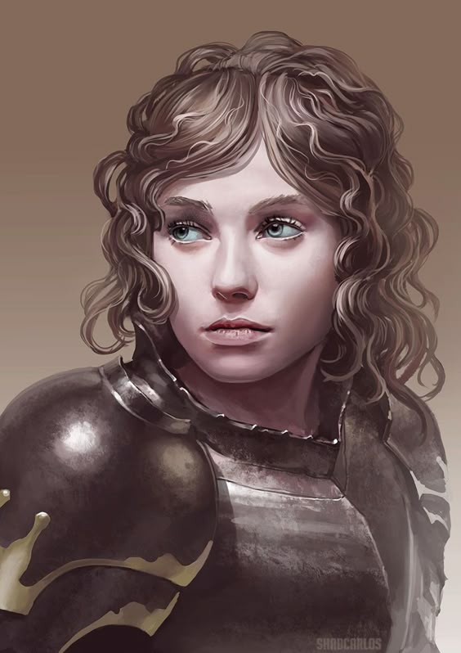

Knight Garin
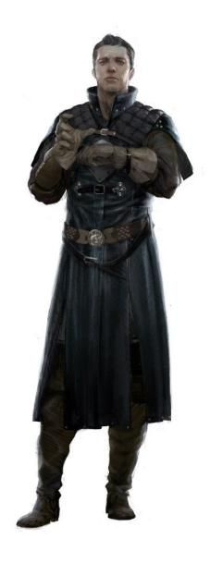

Knight Erok
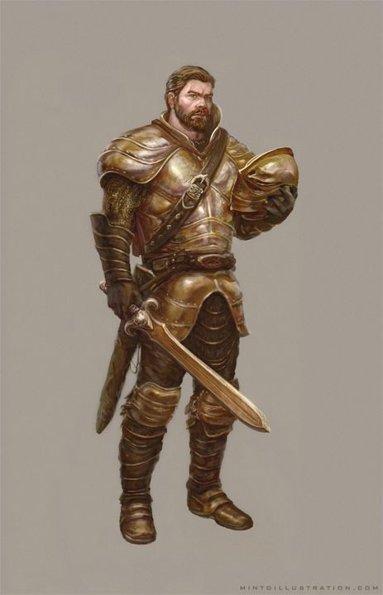

Knight Lassoin
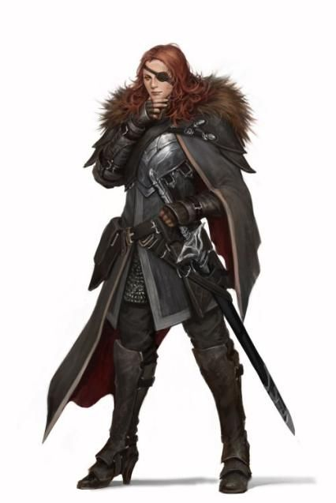

Squires

Kuwerra
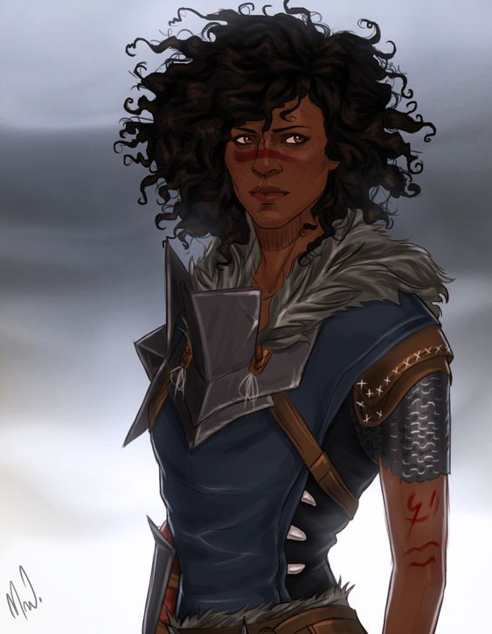
Squier of Romuntow

Rini

Squire of Garin

Shent
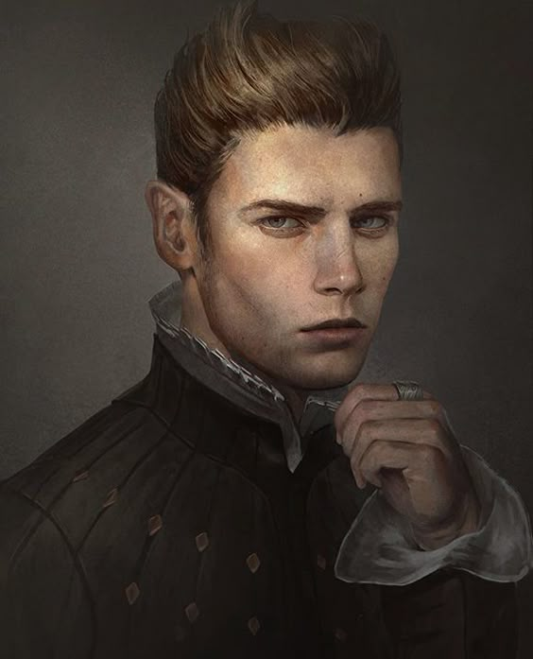
Squire of Lassoin

Mosira
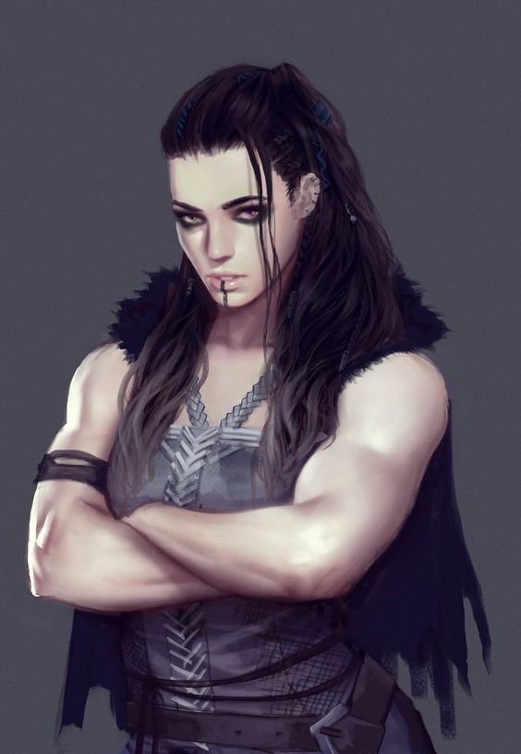
Squire of Erok

Facility
The chapterhouse is a veritable small fortress set off of the road inland from Greylin along the river.
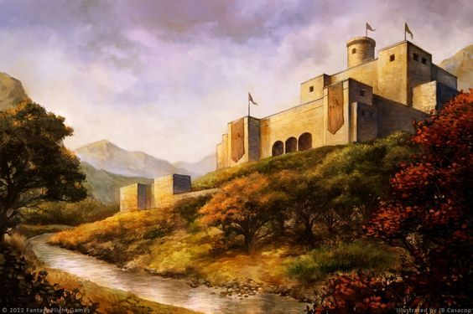
The main hall, set for dining


