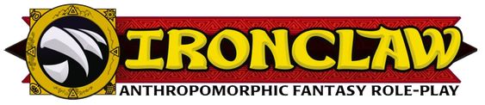  (Marks:One=d4,Two=d6,Three=d8,Four=d10,Five=d12,Six=d12,d4,etc.)  * Encumbered skill (affected by encumbrance)  Money:  - Orichalks: (x 1/12Ð)  - Denarii: 8 (x 1Ð)  - Quincunx: (x 3Ð)  - Aureals: (x 24Ð)  Experience: 5 / 15  Spend 4 to buy +1 Skill Mark. Spend 10 to buy a new Gift.  Gear:  Staff, cloth armor, hooded shroud, strange jewelry,  pistol x2, fusil, bullet-mold making kit, gun repair kit, bandolier,  Daopao robe, Jingang wand, As-One-Wishes rod, counting beads Talisman  Notes:  - Ambidexterity Gift makes your Prehensile Feet as good as main hands, so Fusil-Feet are go!  - Fusileer's Trappings provides a fusil and two pistols. Grenades will probably need to be bought on a per-job basis.  Alba's LifePath | Name: Alba  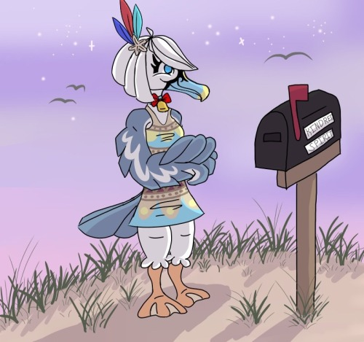  Traits  Personal Motto: You Make Your OWN Luck  Goals (up to three)  - a  - b  - Prove that Albatross does not mean bad luck  Battle  Initiative: d8,d6 (Speed & Mind Dice)  Movement  Attacks  Defense  Damage & Other Status  Healing Quota:
   |  |  | Dice
  Favorite Use | Marks | Skills | Marks | Species | Career
  Ancient Texts | 1 | Academics | d4 |  | d8
   |  | Brawling
   |  | Climbing*
   |  | Craft
   |  | Deceit
   |  | Digging
   | 2 | Dodge* | d6
   |  | Endurance*
   |  | Gossip
   | 1 | Inquiry | d4
   |  | Jumping*
   |  | Leadership
   |  | Melee Combat
   | 1 | Negotiation | d4
  From the Air | 2 | Observation | d6
   |  | Presence |  |  | d8
   | 3 | Ranged Combat | d8
   |  | Riding
   |  | Searching
   |  | Stealth*
   | 1 | Supernatural | d4 | d6 | d8
   |  | Swimming* |  | d6
   |  | Tactics
   | 1 | Throwing | d4
   |  | Vehicles
   | 1 | Weather Sense | d4 | d6
  Gifts | Effect | Page | X | Refresh?
  Personality: Earnest | X for bonus d12 | 66 |  | Respite
  Language: Calabrese | Speak common | 55 | – | –
  Local Knowledge: Triskellian | bonus d12 for local stuff | 58 | – | –
  Combat Save | X to negate Dying or Dead | 63 |  | Respite
  Flight | Extra action usable for flight; flying Stunts | 66 |  | Battle
  Luck | Get two extra rolls on one die | 65 |  | Chapter
  Prehensile Feet | Use feet as extra hands, extra save vs failed Climb | 68 | – | –
  Changes Magic Trappings | Start with fate mage gear, exhaust to replace if lost | 510¥ |  | Session
  Oratory | Bonus d12 for public speaking | 59 | – | –
  Research | Bonus d12 to look things up, full successes for research by rote | 76 | – | –
  Ambidexterity | All hands are main hands | 71 | – | –
  Fusileer's Trappings | Start with sniper gear, exhaust to replace if lost | 61 |  | Session
  Way of Changes | Exhaust to ready fate magic spell | 510¥ |  | Battle
  Way of Changes | Stunt to Reason/Scare/Taunt/Trick with bonus d12 | 510¥ | – | –
  Blessings of the Changing Way | Assist any action with Supernatural | – | – | –
  Blessings of the Changing Way | Long action to boost a future task | – |  | Respite
  Species | Die |  | Career | Die
  Albatross | d6 |  | Seer | d8
  Detail | Description |  | Detail | Description
  Habitat | Shore |  | Age
  Senses | Spot |  | Gender | ♀
  Diet | Omnivore |  | Height
  Weapons | Beak |  | Weight
  Weapons | Claws |  | Eyes
  Cycle | Day |  | Pelt
  Distinguishing Characteristics
  Trait | Die
  Body | d4
  Speed | d8
  Mind | d6
  Will | d6
  Pace | Calc | Speed
  Stride | 1 | 1
  Dash | ½ Max Speed, +1 if Body>Speed | 4
  Sprint | Speed die | d8
  Run | Max Body + Max Speed + Dash | 16
  Flying Stride | Stride+3 | 4
  Flying Dash | Dash | 4
  Flying Sprint | Speed and Weather Sense | d8,d6,d4
  Flying Run | Max Body + Max Flying Sprint + Flying Dash + 12 | 38
  Attack | Dice | Effect
  Fusil | 2d8 | Damage +3 Slaying, Spark d10
  Pistol | 2d8 | Damage +2 Slaying, Spark d10
  Rod | d4 | Damage +2, Parry d12
  Wand | d4 | Damage +0, Weak, Can't Parry
  Beak | d6,d4 | +1 Impaling
  Claws | d6,d4 | +1 Critical
  Defense | Calc | Dice
  Dodge | Speed + Dodge | d8,d6
  Parry | Body + Melee | d4
  Counter | Body + Melee | d4
  Soak | Body | d4
  Armor (cloth) |  | d4
  Cause | Status | Effects | X
  any hit | Reeling | penalty d8; no Counters
  1 hit | Hurt | +1 damage
  2 hits | Afraid | cannot attack or rally
  3 hits | Injured | +1 damage
  4 hits | Dying | get first aid!
  5 hits | Dead | beyond mortal help
  6 hits | Overkilled | allies become Afraid
   | Knockdown | disadvantaged, cant retreat
   | Burdened | Dash is zero, limit of d8 to Action Skills
   | Over-Burdened | Burdened, cant run, disadvantaged
   | Unconscious | helpless
   | Sick | Reeling causes Knockdown

