Back to Ironclaw

Dramatis Personae of Triskellian and Environs

Lystragones
An otter magus of some stripe, or at least bearing the affectations thereof. Showed up in town with Fabrizio (below) in tow, referring to the young fox as his “patron”.
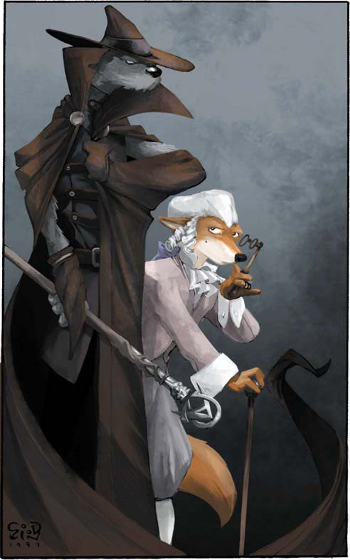

Fabrizio
A bashful high-society fox bearing the name of the Great House Rinaldi's missing heir.

Élan de Gauss
A fox trained in the fortune magic known as the Changing Way, uncommon in Calabria. He's prone to philosophical rambling, and bears a wind sigil on his brow.

(Character art by apricotjackal on Weasyl; sigil by power-of-three on Tumblr)

Belgrave
Once muscle for the crew that pulled off a heist on the Cathedrale de Temoin, this enormous wolf now keeps himself occupied hunting monsters, slavers, and other troublesome targets. He speaks in awkward, clipped phrases, giving the impression that he's weak of Mind, though underestimating him would likely prove fatal.

Malthus
Bookkeeper for the dockmaster in Triskellian. Commissioned Shadow to retrieve a buried box from ruins just outside Palingene Monastery. Loves tea. Appears to have something of a liquidity problem, due to accounts with the moneylender Tamurello being frozen. Whereabouts currently unknown.

Sundry Associates
Anujua (jaguar): A savvy, ambitious sex worker, one of Quentin DuVarge's contacts
The Bursar (rhino): “Collection agent” for underworld types in Dock Town
Gammon (goat): Chatty, superstitious rogue who keeps an eye out for jobs for Jean-Matthieu
Lena (dhole): An easy-going, likeable sex worker and acquaintance of Quentin's
Oakoten (goat): Gruff proprietor of Oakoten's Bend, Quentin's favored watering-hole

