
A game set in the world of Talislanta, using a simple system known as The Loop.

Player Characters

Afazan
A Zandir Seer

Afazan

Palandro
A Zandir Duelist
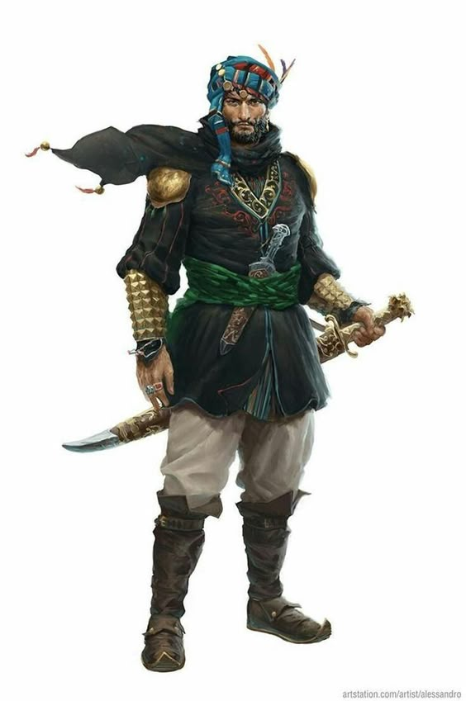
Palandro

Resources

References
- 2E Handbook: http://peedeepages.com/talislanta/pdf/2e/final/optimized/handbook_and_campaign_guide.pdf
- Chronicles: http://peedeepages.com/talislanta/pdf/1e/final/optimized/chronicles_of_talislanta.pdf

Map
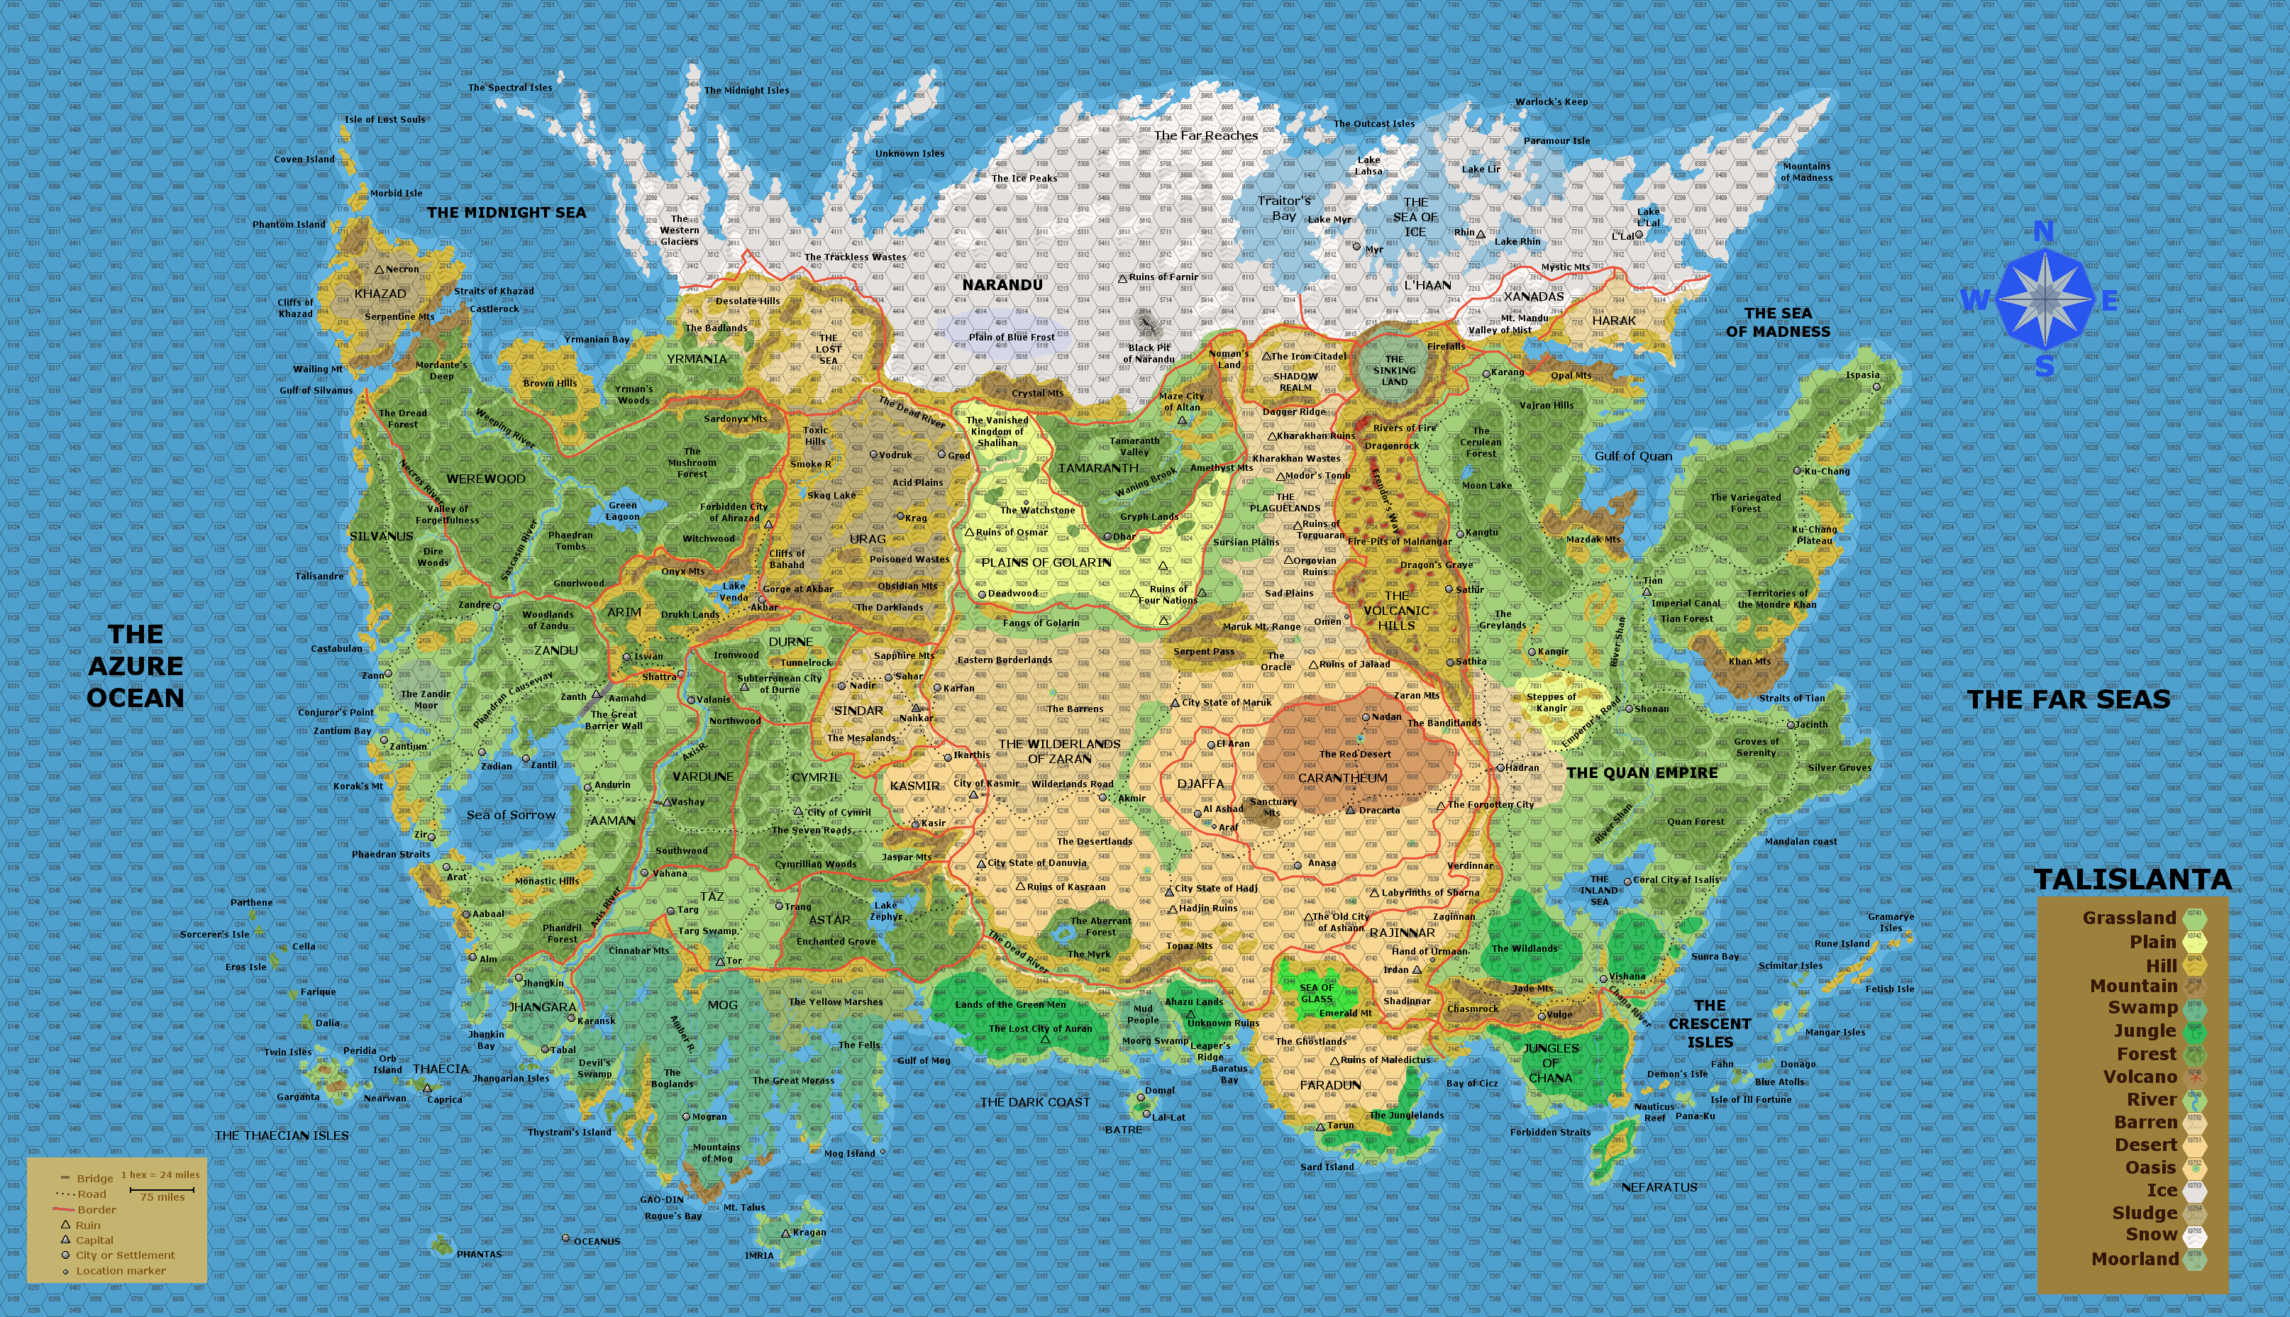
List of names for various races: http://arosslaw.tripod.com/id95.htm
Zodar Deck (by Ed Heil): http://peedeepages.com/talislanta/legacy_site/gallery/zodareh.htm

