Sorcerer-Kings
Sorcerer-Kings is a dark sword & sorcery setting, where the lands are dominated by city-states run by the eponymous rulers who hold iron sway over the lands through their dark magic.
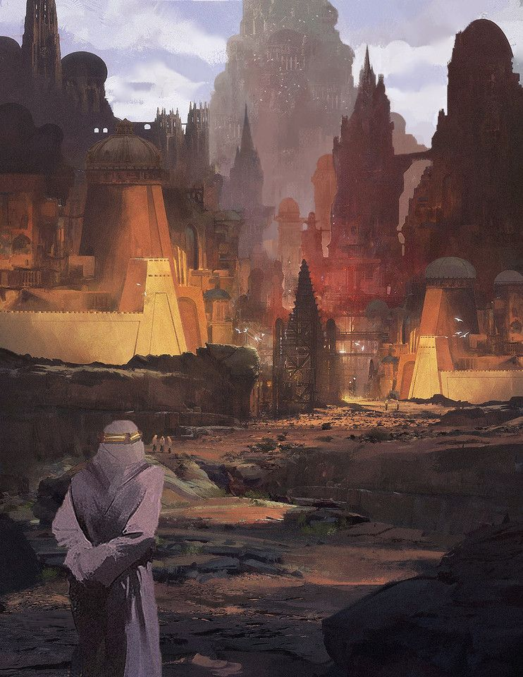The City of Baan Tash
The City of Baan Tash

Characters
Huruzin - Mike Holmes' heretic sorcerer, looking to understand a measure of the Sorcerer-kings' power.
Ithamon - Shreyas's traveling inquisitor from a fascinating neutral order.
Ariesixia - Char's murderous order member, betrothed of Huruzin

