Basic Info  Name: Costentyn Talarath  Order: Magician  Game: northern lights  Circle: 3  Reward:  Spirit: 6d  Attributes and Abilities  - Strength 2d  - Brawl  - Endurance  - Might  - Run  - Swim  - Dexterity 7d  - Aim +1d  - Pilot  - Ride +1d  - Stunt +1d  - Throw +1d  - Perception 1d  - Bluff  - Command  - Intimidate  - Notice  - Persuade  - Knowledge 3d  - Languages  - Lore  - Kingdoms  - Markets  - Trivia  - Brilliance 6d  - Hide  - Investigate +1d  - Science  - Search  - Trick +2d  - Sorcery 3d  - Ancient +1d  - Astrology +1d  - Enchantment  - Illusion +2d  - Necromancy  Portrait  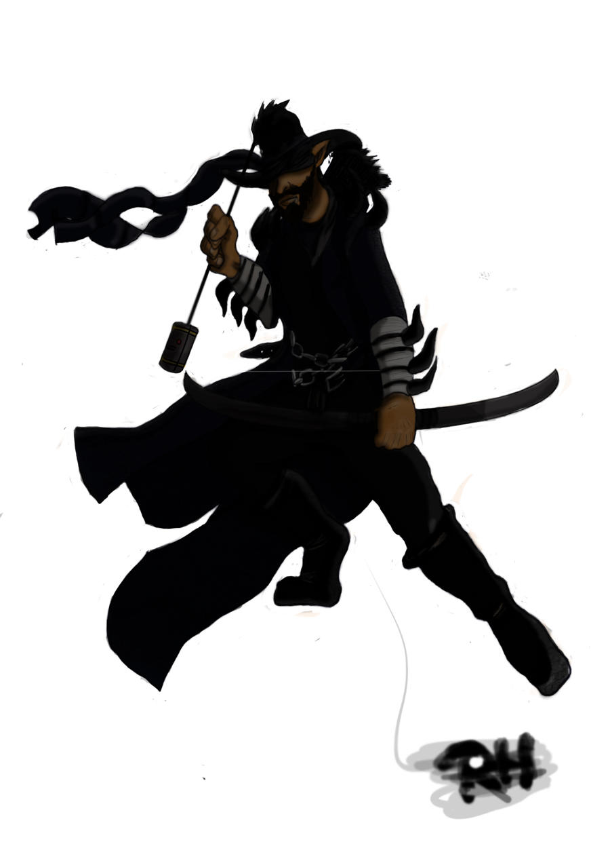 | Aspects  - Curse: Blindsight  - Heroic: Sixth Sense  - Heroic: Survivor  Starfire  - +1d slot  - +1d slot  Quirks  - Show-off 1d  - Always readies his bow 1d  Gravitas  - 1  - 2  - 3  Runes  - Deep Rune of Agitation: Fly (3, VSM), Feather Fall (1, VM), Unseen Servant (1, VSM), Levitate (2, VSM), Push (1, VSM), Jump (1, VM)  - Weird Rune of Momentum: Haste (3, VSM), Hold Person (3, V), Slow (3, VSM)  - Weird Rune of Vitality: Water Breathing (3, VSM), Strength (2, VSM), Infravision (3, VSM), Spider Climb (1, VSM)  - Deep Rune of Uncertainty: Invisibility (2, VSM), Mirror Image (2, VS), Blur (2, VS), Blink (3, VS)  - Celestial Rune of Combustion: Flame Arrow (3, VSM), Fireball (3, VSM), Burning Hands (1, VS), Pyrotechnics (2, VS)  - Deep Rune of Sympathy: Clairvoyance (3, VSM), Clairaudience (3, VSM), ESP (2, VSM), Find Familiar (1, VSM)  Charms  - Moonlight Eyes  - The Ember with Moonlight Eyes has had magic done to their eyes. Now, in the moonlight, they charge their eyes with essence making them glow bright blue. For every three essence in their eyes they count their Notice ability as 1d higher, and for every five essence they count their Power as 1d higher. The essence surges back into the Ember once they fail any roll or check, and they earn one spirit die back for each three essence in their eyes at that time.  Baubles  - Familiar (found, owl, named Foggy)  Gear  - Leather Armor  - Short Bow  - large quiver holding 2 dozen arrows  - Sling  - 2 dozen sling bullets  - Satchel  - Wineskin  - 20 GP

