High Rainvale
The County of High Rainvale is, as it's name suggests, a rainy plateau land high in the mountains. It stops raining on occasion so it can hail.
Despite it's weather, however, the land was recently recolonized, after having been abandoned for over a century. The people who fled the area all went west, to where, nobody knew. All that anyone from the east knew was that if you went up in these highlands, usually you didn't come back. So people stopped going for a long time. Only recently a couple of adventurers went back up into the highlands, and discovered that it seems safe… and that the former inhabitants of the land left a lot of stuff behind. This lead to a big wave of colonization, and those who live in the bright, shiny new settlements of the area are typically pretty well off.
The land is famous for it's wonderful barley, from which marvelous beer is made. The grain is traded far and wide.

Government
Things would be great pretty much all around if it weren't for the lord of the land, Lord John Lodwick, Count of High Rainvale, who was assigned to rule this area by his older brother. Lodwick has some odd ideas about how to rule, and punishes even minor infractions in some case with drowning. He seems to have some sort of perverted desire to drown people, and uses this as his only form of execution.
The only other problem is that there have been reports of bandits coming up the other side of the mountains into the highlands. But nobody is really sure if they're here to stay or just passing through or what.
The mystery of why the folk who used to live in the higlands persists till this day, and Lord Lodwick has sworn to give a reward to any who can figure it out.

Geography
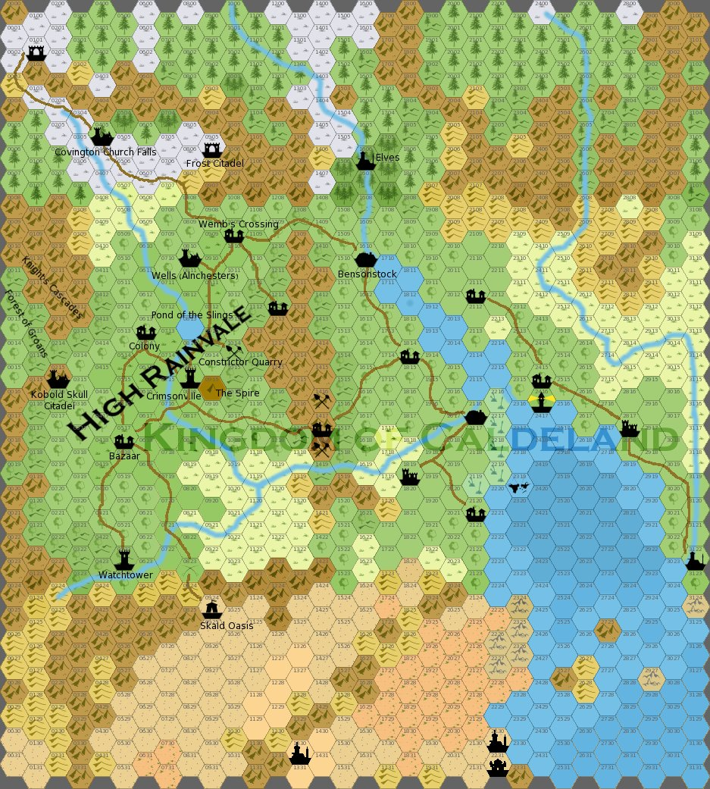

Settlements
There are no towns in High Rainvale… there simply hasn't been any time for any to have grown up yet. There is one, however, just down the mountains from the highland realm called Bensonstock Woods.
There is an important point for adventurers, Wemb Crossing, which is simply a crossroads near a major farmstead that happens to have an inn adjacent.
Lord Lodwick rules the area from The Earthworks at Old Crimsonville.

Other Small Settlements
In addition to the many small villages made of a couple of huddled farmsteads, there are the following small settlements:
- Verdamont Ridge - A nearly-empty homestead in the hills.
- Hencastval - A prosperous bazaar in the countryside near the ruins of a castle.
- Warley - A run-down watchtower in the hills overlooks a new village.
- Wiggenmereford - A rugged crossroads in the mountains, on the shores of a tiny lake.
- Nottiling - A run-down colony in the woodlands.
Hencastlevale Warley Wiggenmereford Nottingling

Places of Interest in the Region
- Talanor's Gully
- Wells of the Alnchesters
- Prince's Flats
- Devil Vale
- Archon Pinnacles
- Constrictor Quarry
- Skald Oasis
- Ruin of Kobold Skull Citadel
- Dale of the Islingiam
- Frost Citadel
- Knight's Cascades
- Covingchurch Falls
- Dale of the Owlbears
- Hippogriff Bridge
- Pond of the Slings

