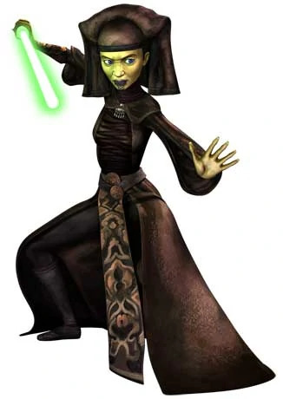

Mirialans were a species of near-Humans[5] native to the planet Mirial. Their appearance varied from yellow-green skin to paler skin very similar to many Humans. Mirialans were very flexible and agile, making them fast and formidable foes. See https://starwars.fandom.com/wiki/Mirialan/Legends

