Rays of Hope, A Star Wars Story
Join our adventurers, bringing hope back to the galaxy! Set after the fall of the empire in Return of the Jedi, where the power vacuum leads the driven and corrupt to scramble at the remaining threads, while the rumors of a new republic are still just whispers, an amazing discovery creates an opportunity for hope! These rays will spread across the galaxy and enrich all… or will they!?
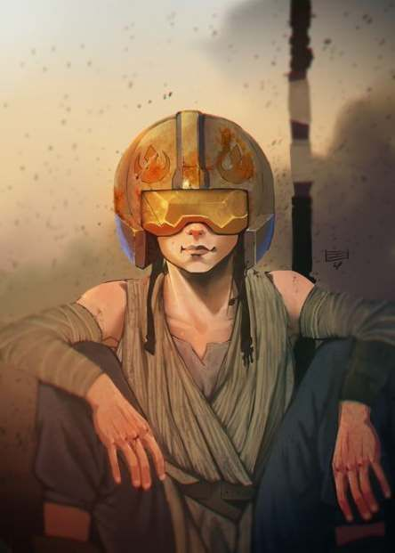

Adventurers
Adventurer | Species | At a Glance | Player
Zoe | Human | Hotshot Pilot | Char
Para | Alien/Verpine | Scientist Adventurer | Char
ZX-3 | Droid, Unknown Model | Security Bot | Nate
Kathrri | Alien/Togorian | Tech-specialist Adventurer | Sabe
Mar Godo | Alien/Mirialan | Force User | Shreyas
Tronce Porto | Human | Information Afficianado | Mike
Adventurer Template
Skill Rating | Description | Skill Rating | Description
1 | Unskilled | 6 | Expert
2 | Familiarized | 7 | Awesome
3 | OK | 8 | Incredible
4 | Good | 9 | Legendary
5 | Great | 11+ | Mythical

Opening Scroll For The Adventure
A long time ago, in a galaxy far far away…
The galaxy is in a state of turmoil after the loss of the second Death Star and eventual collapse of Palpatine's Empire entirely.
In this dark time, heroes have emerged to stand against the corrupt that seek to exploit the people across the galaxy.
Near the edge of the rim, a new discovery is made that might change the course of society as the galaxy knows it.
Deep inside the void of the mirror nebula, which had eluded all exploration because hyperdrives can't pierce it, has
been found a world once inhabited by an long gone advanced civilization.
Calling it New Alderaan, a group has taken it under their control, and intends to leverage it's
wonders to issue in a new era of hope for the entire galaxy.
??? But can they ???
(To be replaced after first session of play establishes more)

Points of Interest
- Galactic Void 1138 - Located inside the mirror nebula, a new world is discovered thanks to the Sky Bridge.
- Sky Bridge - A 600m wide ring with a 500m wide opening that can form a bridge to another such device. A star gate!
  - Bridge One - Found at the edge of the Savareen system.
  - Bridge Two - Found by exiting it, in orbit of what is now known as New Alderaan.
- New Alderaan - Has one of the two known Sky Bridges, a world inside Galactic Void 1138. It has a multitude of ruins left by a lost gone advanced civilization.
  - The Tomb - A wreckage of a large alien ship of unknown type in long orbit of New Alderaan.
  - Ellipse - A small ice moon of New Alderaan with a pronounced elliptical shape.
  - Diamond Trail - Uncharted asteroid belt in the New Alderaan system, early surveys say has promising resources.
- The Tomac Alliance - A fast growing alliance of corrupt local lords in the outer rim, funded and overseen by Savoy Tomac from his own city at Bespin.
  - Savoy Tomac - An elderly mirror spectacled man with pitch black complexion and the yellowest hair.
  - Neywell Moonshadow - Upcoming super-smart pale gender-hidden/ungendered commander in the Tomac security section.
- The Wolverine Crew - A small band of capable mercs known for their Robin Hood like antics, led by a famous pilot Charity Darkmire.
  - Charity Darkmire - Lovable Rascal with a heart of gold. Well that is what she tells herself, anyway.
  - ZX-11 - Brother by production run to ZX-3 above, much smaller than ZX-3 though and only sports a repeating blaster rifle.
- The Mothma Protectorate - Organization operating the port in the Savareen system, yes it's that Mon Mothma. Usually goes by the term the MP for short.
  - Cait Mothma - Daughter of Mon Mothma, currently managing the Savareen port.
  - Dash Pavan - Old veteran Elomin fighter, with graying brown-purple skin, turned security commander of the Savareen port.
  - Sule Kinall - Young force user training Mar Godo.
  - Deng Typho - Tronce's low level contact in the MP.
- Others
  - Ancient Alien - A force ghost of an ancient alien, haunting Mar Godo.
  - Unit 402 - A force golem with amber shell discovered in the lowlands of New Alderaan.
  - Light of the Moon - Savarian elder that met with Tronce and Mar.
  - Rix Tane - Neti pharma expert living on the station.
- The Gate - Nickname for the Savareen orbital port station, it is at it's core a Mandator III class dreadnought (barely functional) with many docking ports forming a docking ring around it.

What Matters
- General Premise A: “Keeping the secret of the way to the new world from the bad guys.”

Session Story Summaries
- [20-04-16] Savoy Tomac sends Moonshadow to The Gate to find Sule Kinall. Mar Godo and Sule have have a short Force training session, Mar sees her abduction in the near future. Later, Mar and Tronce go on an exploratory mission to the lowlands of New Alderaan. There they encounter a force golem droid thing in a cave.
  - Introduction of a lot, including the Ancient Alien force ghost that haunts Mar.
- [20-04-19] Mar uses his 'mark of the overlord' and Deep Sensing talent to gain control of the awakening force golem, Unit 402. It is told to remain still and ignore all input. Returning to the under-construction primary landing deck of the downport on Savareen, Dash Pavan has a talk with Tronce Porto about his role in this station and expectations. Tronce learns Sule wants lodging planetside and agrees to house her. Tronce gets permission for droids he vets to break Pavan's “no droid” rule, and he is gifted three imperial bars of Beskar steel. At the end, he is suddenly called away to space, for what?
  - Tronce is introduced, Mar Godo wanders off on the downport to an unknown location for what?
- [20-04-23] Tronce, Mar Godo, and ZX-3 visit a small village of Savarian elders near the downport. They discuss possible issues with the newcomers and what areas the Savarian claim as theirs (the woodland groves) on Savareen. Savarian ways and symbols seem very… jedi-like? They also seem to have their own effective but primitive tech.
- [20-04-27] Kathrri is introduced, lives on the station and gets invited to a game of slicer skill which eventually we realize is Deng scouting her out. Deng eventually introduces her to Tronce, and she joins that crew.
- [20-05-03] Mar takes his Deep-X explorer to scout out The Tomb with an astromech droid known just as R6. He discovers a field of immense, hidden, but powerful energy around the wreck. It reacts to his entrance, becoming unstable, and he escapes before it does damage to the Deep-X. Mar gets the sense of something moving in the wreck just as he escapes, something force adjacent?
  - Later Mar chills with friends at “The Spot” (Not unlike ten-forward, if it was epic-scaled Imperial style). Chat breaks down, and a Kallack beetle ruins the fun for everyone.
- [20-05-11] Tronce, Zoe, ZX-3, and Kathrri take his explorer to investigate squads of TIE advanced operating at the edge of sensor range from the station - taking Charity and the Wolverine crew along for support. They discover the TIE are automated and running diversion to let smugglers pass in undetected. At the end, a lone corellian stock light freighter is detected by the crew.
- [20-05-17]
- []

Resources
- Google Doc for currency tracking in Rays of Hope.
- SimpleSix - The Game Draft Rules.

