The Gate
Part of Rays of Hope.
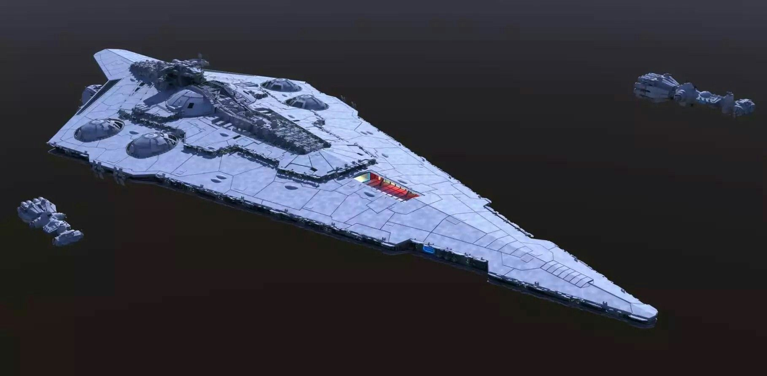
Nickname for the Savareen orbital port station, it is at it's core a Mandator III class dreadnought (barely functional) with many docking ports forming a docking ring around it.
- https://starwars.fandom.com/wiki/Mandator_III-class_dreadnought

