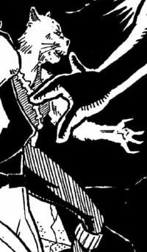

The Togorian people were a feline warrior species native to the planet Togoria. They were known for their association with the Mandalorians, and the unique cultural divisions between their sexes. Both male and female Togorians were also noted for their strong sense of honor. https://starwars.fandom.com/wiki/Togorian/Legends

