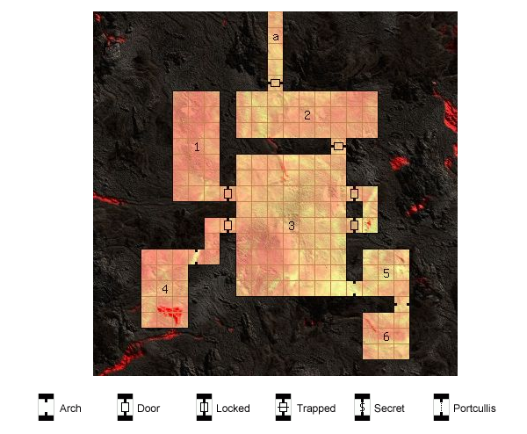

General
* Dungeon Walls Reinforced Masonry
* Dungeon Floor Sand
* Temperature Warm
* Illumination Shadowy (phosphorescent fungus or candles every 20 ft.)

Corridors
a The scent of urine fills the corridor
===== Wandering Monsters

* 1 1 x Wererat (lycanthrope), scavenging for food and treasure
* 2 1 x Ghoul, consumed by disease and madness
* 3 5 x Dire Rat, trying to lure the party into an ambush
* 4 10 x Rat (animal), tracking the party
* 5 10 x Rat (animal), lost and desperate
* 6 9 x Bat (animal), investigating a strange noise

Rooms

Room #1
- East Entry Stuck Simple Wooden Door → Leads to room #3, inhabited by 1 x Ghoul

Room Features
Several square holes are cut into the ceiling and floor, The scent of ozone fills the south-east corner of the room

Room #2
- North Entry Stuck Good Wooden Door
- South Entry Stuck Simple Wooden Door → Leads to room #3, inhabited by 1 x Ghoul

Room Features
A magical mural on the south wall depicts the hideous death of whomever views it, A stack of barrels filled with rotting fruit stands against the south wall

Room #3
- North Entry Stuck Simple Wooden Door → Leads to room #2
- West Entry #1 Stuck Simple Wooden Door → Leads to room #1
- West Entry #2 Stuck Simple Wooden Door
- East Entry #1 Stuck Strong Wooden Door
- East Entry #2 Stuck Simple Wooden Door
- East Entry #3 Archway → Leads to room #5

Room Features
A mural of a legendary battle covers the ceiling, Someone has scrawled "Frakun was here" on the east wall.

Monster
1 x Ghoul

Room #4
- East Entry Archway

Room Features
Someone has scrawled "Ran out of swords" on the south wall, The floor is covered with mold.

Monster
1 x Rat Swarm

Room #5
- West Entry Archway→ Leads to room #3, inhabited by 1 x Ghoul
- South Entry Archway → Leads to room #6, inhabited by 1 x Ghoul

Room Features
Several square holes are cut into the north and east walls, A creaking sound can be faintly heard near the south wall.

Trap
Ceiling Pendulum

Hidden Treasure
Hidden Locked Iron Chest
3 Tanglefoot Bags

Room #6
- North Entry Archway → Leads to room #5

Monster
1 x Ghoul

Treasure
Bag with “Bitter Tail” herbal cure to Jango Iofurrssin's disease.

