Character Name: Dujan | Character Picture: 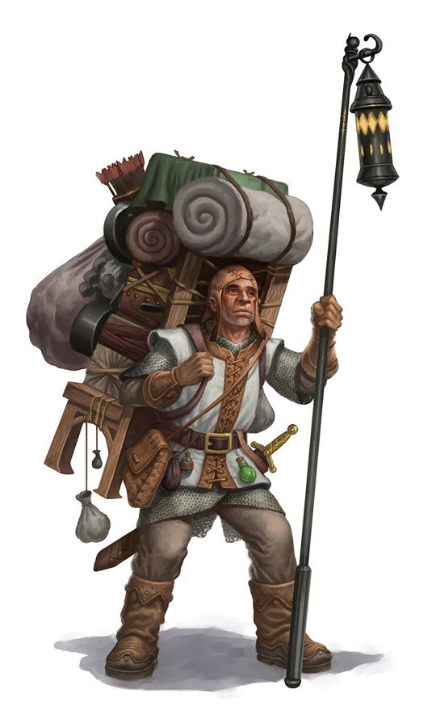
METHOD | Rating | STYLES
VIOLENCE | 1 | Commoner
CHARISMA | 4 | Charmer
SKILL | 3 | Merchant
SORCERY | 7 | Enchanter, Alchemist
MOTIVATIONS | TYPE
Find Minor Magic | Moderate
X | Moderate
Find Potent Magic | Major
X | Major
WILL | 1

