Lorwarith  Race: Half-elf  Sex: Male  Age: 48  Height: 5' 3“  Weight: 137 lbs.  Class: Cleric/Ranger/Magic-User  Level: 5/7/6  AC: -1  HP: 34  Attributes  - Str: 18/62  - Int: 15  - Wis: 17  - Dex: 16  - Con: 16  - Cha: 12  Lanugages  - Common  - elvish  - gnome  - halfling  - goblin  - hobgoblin  - orcish  - gnoll | 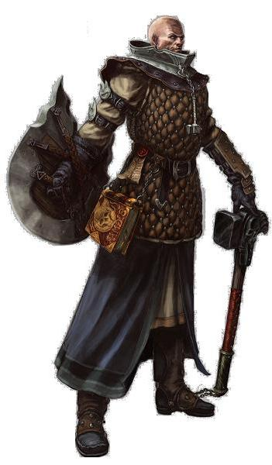  Gear  - +2 chain mall  - +1 shield  - levitation boots  - +1 mace (functionally, but appears as a warhammer, the weapon preferred by Ulaa)
Spells  Magic User  Level 1  - Feather Fall x2  - Magic Missile x2  Level 2  - Web  - Rope Trick  Level 3  - Fireball  - Pro. From Normal Missiles  Spellbook | Cleric  Domains for Ulaa: Earth, Mountains, Gems, Goodness, Fertility  Level 1  - Cure Light Wounds x3  Level 2  - find traps  - snake charm  - slow poison  Level 3  - Remove Curse  - X

Appearance
Lorwarith has a mohawk, or sometimes shaves his head completely bald. He favors the latest fashions and spends lavishly on the best clothing, though because of his adventuring, and time spent outdoors, his clothing is often ragged. He appears to be in his 30s, despite being nearly 50. His size doesn't tell of his strength, a boon from his Goddess.

Background

Origins
Lorwarith was born in the wild lands, beyond the bounds of what most consider civilization, in the furthest north reaches of the Principality of Ulek. He was raised by his birth parents, who were royalty by blood, exiles from Celene further north. They are dead, having succumbed to a mysterious illness along with Lorwarith's brother Walnan. Lorwarith was raised to understand the law of Ulaa, Godess of the Hills and Mountains, and has since become an extremely faithful devotee of her worship.

Siblings
Lorwarith has the following siblings:
- An older brother named Halorin that he has lost touch with.
- An older sister named Brenbellis that he is very close to.
- An older brother named Walnan that is dead, having died under mysterious circumstances.
- An older brother named Ubranbeyr that he hates because of some past transgression.

Important Events
- Lorwarith made an enemy, someone that worked for him. She started a physical altercation with him. They are part of a tribe or other small group and can call on other members in need. The dislike is the result of a personal relationship.
- Blind luck provided Lorwarith with a trove of gold, enabling him to fund his adventures. He's never become really rich, despite this find. Details
- Lorwarith inherited his Boots of Levitation from his father.
- Lorwarith spent several months engaged in formal study, sharpening his wits (gained a point of Int).

Personality
Lorwarith tends to be helpful to others and uphold laws he sees are proper ones, and follows the dictates of his Goddess with extreme rigor. He's fairly stable, having seen a lot of things and lived through them, and generally has an optimistic outlook. He's friendly, but careful who he makes friends with. He's pretty sensitive about others, and acts in a compassionate manner. His mind is active, always thinking about this or that, especially about his collection of small porcelain figures.
If Lorwarith has a fault it's that he's sometimes jealous of things others have, and sometimes wishes he had those things for himself. He doesn't act on these urges, but they occasionally make him a bit surly, especially if he feels that the individual owning the things in question doesn't deserve them. Because he doesn't have a great deal of money, he tends to save what he has for the future or a rainy day.
Lorwarith is also conflicted by a strong sense of honor to do the right thing, and the fact that he's really not very brave. His honor and sense of fair play are such that they sometimes conflict with his somewhat strong desire to court women, both elves and humans, that he comes across.

