My character for the game

Saaderwawetha
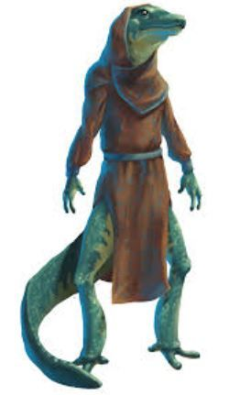
Species: Bwap
Homeworld: Daddash

Stat Block
2428B7
Skills: Animals - 0, Computers - 0, Social Sciences - 0, Admin - 2, Liaison - 2, Advocate - 1, Steward - 2, Vehicle - 1, Bribery - 1, Broker - 1, Comms - 1

Terms
Bureaucrat 4 - Rank 3 (Manager)
Merchant 1 - Rank 2 (Fourth Officer)

Belongings
5450cr, Low Passage, Mid Passage, High Passage, Snub Pistol

Notes
Play starts at: https://travellermap.com/?p=-63.928!-26.859!7
Saaderwawetha's Snub Pistol (very utilitarian, bought for self-defense on Daddash): 

